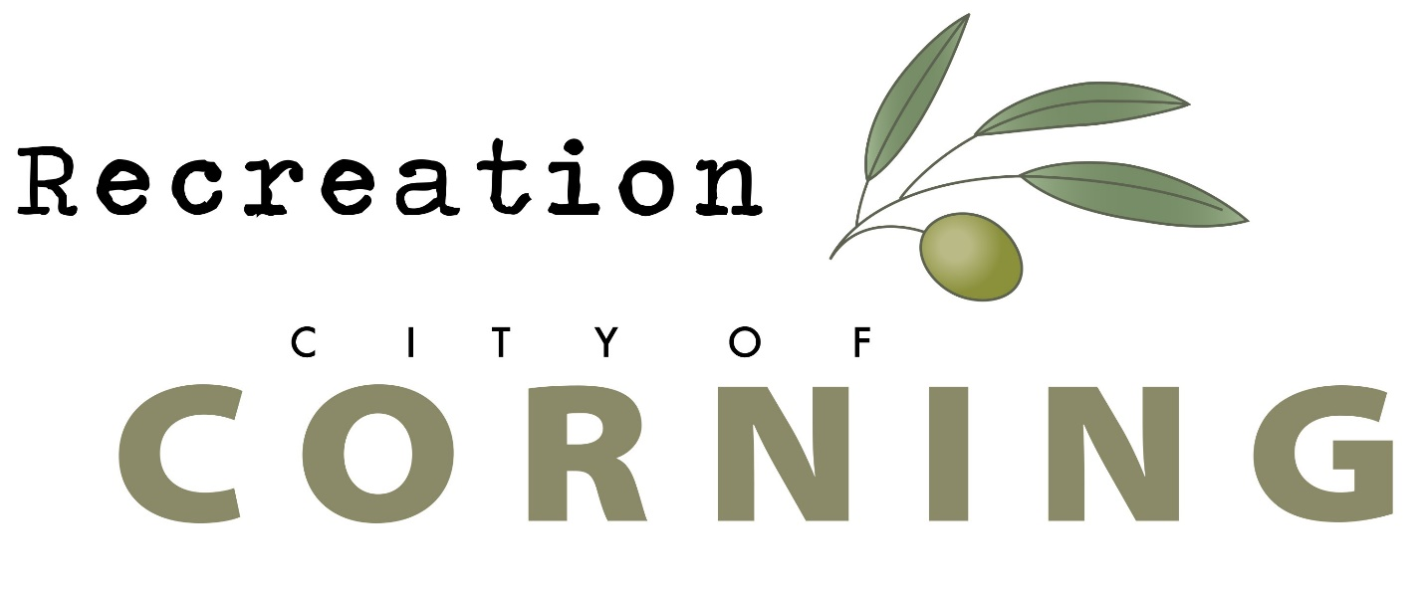

Call for Local Artists
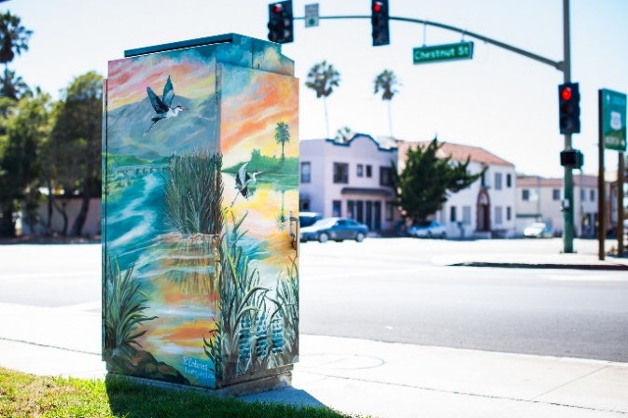
Utility Box/Trash Can Mural Project

DATE ISSUED
September 16, 2022
APPLICATION DEADLINE
October 17, 2022

Imagine how your art can transform a street
The City of Corning invites artists to participate in the City’s Utility Box/Trash Can Mural Project.
The City is seeking artists to showcase their work by painting a mural on a utility box or a Trash Can. The goals of the program are to enhance the beauty and vibrancy of Corning, deter unsightly graffiti and bring art to unexpected places.

Applications must be submitted online at
Applications will not be accepted after the deadline. Artists will receive $200.00 for each project
Eligibility: This “Call for Artists” is open to all Corning City and surrounding communities’ adults and students. All entries must be an original design and artwork of the entrant and must be suitable for all ages.
Description and location of Utility Boxes and Trash Cans:
The utility boxes and trash cans vary in size (see application) To complete the project, the artist will need to sand, prime, and paint with acrylic paint. City staff will apply an anti-graffiti clear coat.
Locations:
Signal Control Cabinets x 5
- South Ave. / Highway 99W (by Petro)
- Solano St / Edith Ave. (By Taco Bell)
- Solano St / Toomes Ave. (Northwest Corner)
- Solano St / Sixth Ave. (By Edward Jones
- Solano St / Marguerite Ave. (Southeast Corner)
Backflow Boxes x 2
- Both Backflow Cabinets are at the skatepark.
Trash Cans
- Concrete trash cans x 10 at the skatepark and x 5 at the soccer field.

Artwork:
The art should enliven the area, transform the street, and reflect the neighborhood or area where the project is located. They should be visible from a distance; therefore, you may choose to utilize bold colors and designs. Additional consideration can be given to a project that showcases Corning’s City culture diversity, historical heritage, or acknowledges a key activity that takes place in the community. The artwork should be apolitical.
Artists can submit more than one concept for the same location. If you are proposing your art for a specific location, please make sure to put the specific location in your application form. But please be aware that the City Council will make the final decision.
The art/mural cannot restrict any vents or airflow and or locks and handles. City maintenance crew members must be able to always have full access.
The artist will provide all art supplies to complete the project. Artists are responsible for prepping and painting their project. An anti-graffiti clear coat to protect the art upon completion will be applied by the City. Paint type will need to be approved by the city.
The art project must be completed by December 30, 2022 (pending weather). The artists may enlist assistants to help them complete their project. An art teach may also mentor a group of students.
The artist cannot begin the installation on the selected project until all liability and contract forms are completed and submitted to the City, and the design has been approved. If you are under the age of 18, a parent or guardian is required to sign all forms.
The art may include the name of the artist and their sponsor (if they have one) no larger than 3” x 5” near the bottom of the project.
Entries that use a copyrighted or trademarked image will not be accepted. In addition, the art must not be plagiarized, stolen, or copied from any other source. Entries must not defame or invade the rights of any person, living or dead.
The artwork is a long-term installation and will become the property of the City of Corning.
How to Apply for this Project:
Please go to www.corning.org to apply online for the Utility Box/Trash Can Mural Project. There you will see the application.
Application:
All requirements listed below must be met or the application will be removed from consideration.
- Full application completed.
- A concept drawing that shows the front, sides and top (for utility boxes) must be included in the application, please note that the boxes/well houses do differ in size, so we are asking for full color concept drawing, but it doesn’t have to be to scale.
- Submissions may be hand drawn or computer generated.
- An artist statement that describes why the artist is interested in painting one of the projects, previous experience working on art projects, and how the artist believes the art will transform the area.
- A minimum of 3 examples of previous artwork with brief descriptions.

Selection Criteria:
The selection process will consist of:
- Review by the Project Manager.
- Review by the City Manager and Public Works Director.
- Final review by the Corning City Council.
When making the artists selections, the following will be considered.
- Artistic originality and innovation.
- Does the artist have the experience to complete the project in the time frame.
- Does the art meet the goals of the project?
- Transform the area
- Relate to the area
- Show the City’s cultural diversity, historical heritage, or a key activity.
If you are selected to complete one of the Utility Box/Trash Can Mural Projects
All artists must sign a City of Corning liability release and complete agreement before beginning work on the selected project.

