CITY OF CORNING
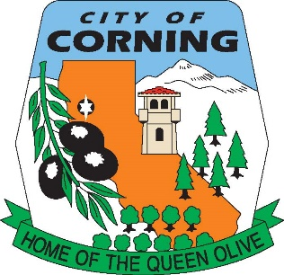

NOTICE OF CANCELLATION
OF THE
WEDNESDAY, JANUARY 4, 2023
LIBRARY COMMISSION MEETING
DUE TO LACK OF AGENDA

The Corning Library Commission serves as an advisory body to the Corning City Council and the Tehama County Library Director on Public Library issues including recommendations for building improvements, improvements to the literary, music and film collection and planning for future library service to the Community of Corning. The Commission provides a public forum for the proposal and discussion of public library services that benefit the Community. Ideally the Commission would encourage community volunteers to work together in the planning for current and future library facility and program needs.

POSTED WEDNESDAY, DECEMBER 28, 2022

