CITY OF CORNING
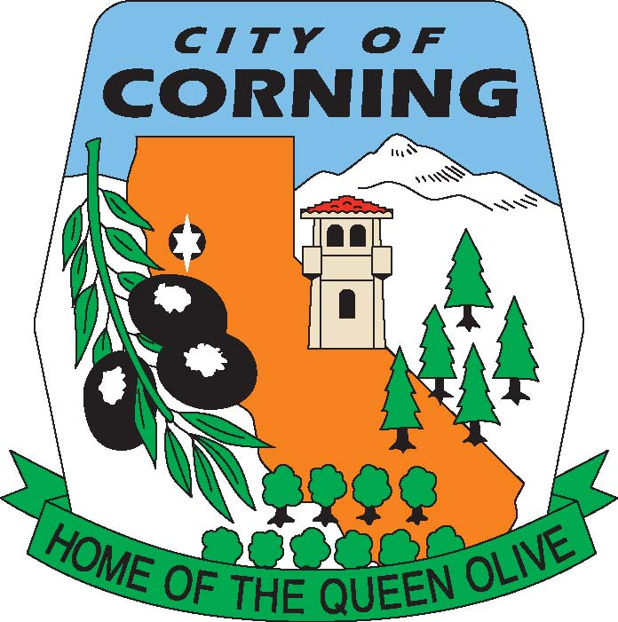

NOTICE OF CANCELLATION
OF THE
TUESDAY, JULY 4, 2023
RECREATION COMMISSION MEETING
DUE TO JULY 4TH HOLIDAY

The Corning Recreation Commission serves as an advisory body to the Corning City Council on Public Parks and Recreation issues including park use, master planning, acquisition and development, beautification, improvement, and maintenance of City Parks. The Commission provides a public forum for the proposal and discussion of public recreation services that benefit the Community. Ideally the Commission would encourage community volunteers and youth/adult volunteer sports groups to work together in the planning for current and future facility and program needs.

POSTED: FRIDAY, JUNE 30, 2023

