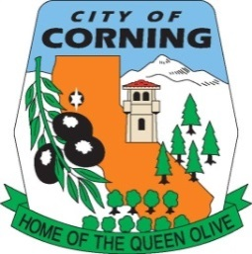

CITY OF CORNING
SPECIAL COMMUNITY MEETING
DISCUSSION OF THE
CORNING CITY PLAZA AND RECREATION CENTER
CONCEPT DESIGN

TUESDAY, AUGUST 29, 2023
CITY COUNCIL CHAMBERS
794 THIRD STREET
6:00 p.m.

The City of Corning welcomes you to our meetings. Your participation and interest is encouraged and appreciated.

In compliance with the Americans with Disabilities Act, the City of Corning will make available to members of the public any special assistance necessary to participate in this meeting. The public should contact the City Clerk’s office (530/824-7033) to make such a request. Notification at least 72 hours prior to the meeting will enable the City to make reasonable arrangements to ensure accessibility to this meeting.

This is an Equal Opportunity Program. Discrimination is prohibited by Federal Law. Complaints of discrimination may be filed with the Secretary of Agriculture, Washington, D.C. 20250.

DISCUSSION: Concept design for the Corning City Plaza and Recreation Center.

600 p.m.: I. Presentation of Concept Design and accept Public Comments.

POSTED: FRIDAY, AUGUST 25, 2023

