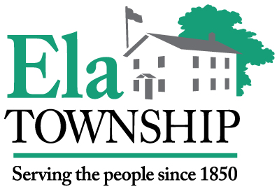
Town Hall: 1155 East Route 22 • Lake Zurich, IL 60047
Phone: 847-438-7823 Fax: 847-438-9269
E-mail: info@elatownship.org
Clerk’s Office
Lucy A. Prouty

Annual Town Meeting 2022

This meeting will be conducted by audio or video conference and may not have a physically present quorum of the Ela Township Board because of a disaster declaration related to COVID-19 public health concerns affecting the Township. Pursuant to Section 7(e)(2) of the Open Meetings Act, the Supervisor has determined that an in-person meeting at the Township building with all participants is not practical or prudent because of the disaster. Township officials, legal counsel, and the Township Manager will not be physically present at the Township Hall, if that is unfeasible due to the disaster. Since physical public attendance at the Township Hall may be limited or not feasible, alternative arrangements for public access to hear the meeting has been made available by contacting the Supervisor’s Office at (847) 438-7823 for the Zoom meeting link or the phone number to call into the meeting prior to 5:00 p.m. on April 11, 2022. In accordance with the Open Meetings Act, the meeting will also be audio or video recorded and made available to the public, as provided by law.

NOTICE IS HEREBY GIVEN

To the legal voters of the Town of Ela, in the County of Lake, and the State of Illinois; that the Annual Town Meeting of said Town will take place on Tuesday, April 12, 2022, being the second Tuesday of said month at the hour of 7:00 o’clock P.M. at The Ela Township Town Hall lower level board room located at 1155 E. Route 22, Lake Zurich, IL.
For the transaction of miscellaneous business of said town and after a moderator having been elected, will proceed to hear and consider reports of Officers, and decide on such measures as may, in pursuance of law, come before the meeting; and especially to consider and decide the following:

Agenda

- Pledge of Allegiance
- Call to Order
- Election of Moderator/Set fee
- Approval of Meeting Minutes from April 13, 2021
- Reading of the Township Supervisor’s Annual Statement for the fiscal year 2021/22 by the Town Clerk
- Overview presentation of Budget for the fiscal year 2022/23 by Township Supervisor
- Surplus items for disposal
- Open forum for comments and questions from residents/electors (limit of 3-5 minutes)
- Set date and time for 2023 Annual Town Meeting – April 11, 2023 at 7:00 P.M.
- Adjournment

Lucy A. Prouty, Ela Township Clerk

____________________________________________________________________________________________________________

Supervisor Gloria M. Palmblad Clerk Lucy A. Prouty
Trustee Larry Bowman Trustee Joel Sikes Trustee Tosi Ufodike Trustee Joel Sikes

