Planning a Supper Club is easy and fun. ELGL is here to help and support you along the way!

**Step 1: Pick a Date and Time!**

-There are two main approaches:

-Go forth and select your date and time; inform those in your region when the Supper Club will occur.

-Or conduct a quick survey with members in your region – send them a couple dates to choose from and let the majority rule!

**Step 2: Set a location**

-While you can do this concurrently with Step 1, it can also be done individually. If you do not have a location in mind, when setting the date and time, consider giving members an idea of the general location.

(Example: Save the Date - Phoenix Area Supper Club – Friday, April 20, 2018 at 5PM - Location: TBD in Uptown Phoenix)

-Once you know the date and time, find a local restaurant, pub, park, venue, etc. to host the event. Food, drink and games go over pretty well. Once you have a date, Consider calling the venue and let them know you are having a gathering. Ask them if they can reserve a few tables for 10-20 people. You can always let them know, you will get them a final number a few days before the event. If you need a count, please ask members to RSVP by a certain date. Remember: Even if they don’t RSVP you can still squeeze them in, so don’t sweat it.

**Step 3: Notify ELGL of your Event**

-Email [Christian@elgl.org](mailto:Christian@elgl.org) – let him know the date, time, and location of your event. If you have a save the date, we can always update the event details later. Once Christian has the information, he will get it up on the events page and email you a link to the registration page. The registration link will be where you send members (and non-members) to sign up for the event. If you have a fun write up or a graphic you want to use, include this in the email – the funner the better.

**Step 4: Send out the Invites and Advertise your Event**

-ELGL is here to help you! We have a list of all the members in your metropolitan area. We can provide you with an email list of those individuals. Then, you may choose to send them a personal email invite!

(Tip: If you have Microsoft Outlook, email [Christian@elgl.org](mailto:Christian@elgl.org) and he can show you how to make the emails look like a custom email to the individuals!)

-Start tweeting it out! Remember to @mention your <ELGL Region – see last page> and @ELGL50 in the twitter post. This way, members who run those twitter accounts can support you in advertising. Feel free to post the event to Facebook as well.

-If you have a local university or government association connection, feel free to spread the word with them as well.

-The events are open to non-members! Have them register as a non-member on the ELGL.org website. This is a great way to grow the #localgov network!

**Step 5: Make It fun!**

-ELGL will send you some fun swag to hand out.

-While you do not need to have a formal agenda, you can always let it play its course or you can plan a game or activity.

(Example: Members in the Tucson area (U of A) and UW-ICMA student chapter gave us a Parks and Rec Trivia idea. Attached are some of their materials, feel free to modify and make it your own.)

|  |
| --- |
|  |

(Example: Members in the Phoenix area worked with their local government-planning agency and US Census data; they turned Phoenix area statistics into a trivia game. Attached are some of the materials, feel free to use the concept and make it your own.)

|  |
| --- |
|  |

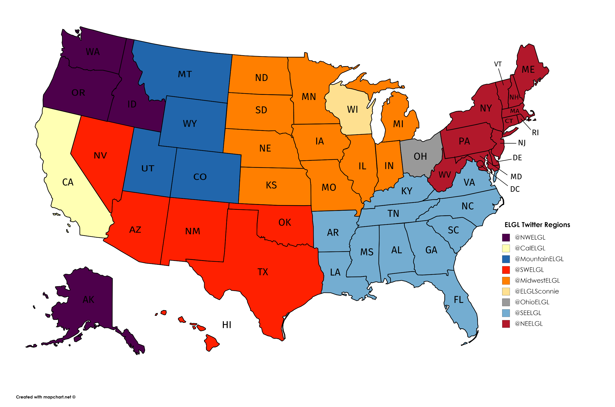**Rinse and Repeat! –** Once you are done, you can always plan another one! We are always here to help you if you need assistance!

