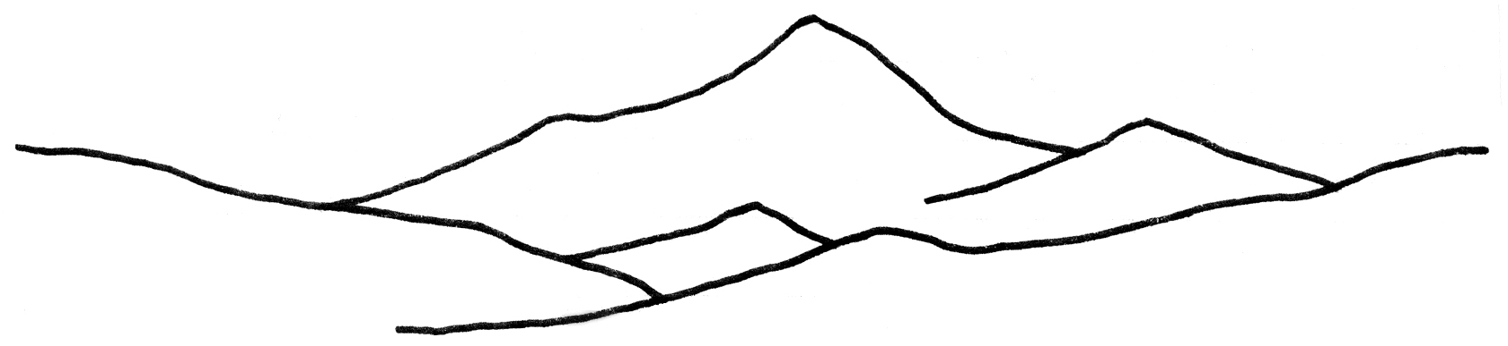

MINUTES
REGULAR FAIRFAX OPEN SPACE COMMITTEE MEETING
16 Park Road / Youth Center, Fairfax, CA 94930
Tuesday, November 27, 2018 at 7:00 p.m.

Fairfax Open Space Members:

Michael Ardito, Co-Secretary
Chris Borjian
Shelley Clark
Charles Cornwell, Treasurer
Chance Cutrano
Lauren Hinxmann, Chair
Ruth Horn, Co-Secretary
Jack Judkins, Vice Chair
Susan Pascal Beran
Georgia Little, Youth Member (ex officio)

- Call to Order and Roll Call: Jack Judkins, Acting Chair
Present: Michael Ardito, Chris Borjian, Shelley Clark, Charles Cornwell, Chance Cutrano, Ruth Horn, Jack Judkins, Susan Pascal Beran
Absent: Lauren Hinxmann (chair); Georgia Little (youth member)
- Approval of Agenda for November 27, 2018. The agenda was approved.
- Drake High School class film project for FOSC (discussion and possible action). This item was postponed to the next meeting in January.
- Open Time for Public Expressions (The public is welcome to address the Committee at this time on matters not on the agenda. Please be advised that pursuant to Government Code 54954.2, the Committee is not permitted to take action on any matter not on the agenda, unless it determines that an emergency exists, or that the need to take action arose following posting of the agenda. Each speaker is limited to three minutes and a spokesperson for an organization is limited to five minutes.) None.
- Update about Spring Lane properties near Sky Ranch (discussion and possible action). We had two guests, Nick Fain and Suzanne Kay, who live on Spring Lane and provided some current information about trail access to Sky Ranch/Bald Hill. It was a mystery as to what person placed a saw horse restricting access. There were also questions about the Spring Lane extension as a paper road. Jack Judkins volunteered to research this issue, find out about the easement and write letters if necessary. Michael Ardito volunteered to contact realtor Russ Knudsen regarding an update about several Spring Lane properties. This agenda item is being continued until the next meeting.
- Treasurer’s Report: Charles Cornwell reported that our account balance is $30,528.86. This included two transactions: cash donations of $205 received from the movie night on November 8; and the $89 expense to pay the screen fee for that night’s movie.
- Approval of FOSC Meeting Minutes for August 15, August 28, September 25, October 23, 2018. All of the minutes were approved with a minor correction to the August 28 meeting minutes.
- Review of FOSC Movie Night on November 8 (discussion and possible action): Shelley Clark reported we had about 50 people in attendance for the movie night featuring the documentary “Wilder Than Wild: Fire, Forests and the Future.” There was an excellent panel discussion. There was good publicity and outreach in advance. Shelley volunteered to research with the Redford Center about a future film for the next movie night. Susan volunteered to research possible purchase of audio-visual equipment so we do not have the same technical issues we had for the movie night this month. Ruth reported that she has the DVD copy of former FOSC member Ray Burgarella’s copy of the “Emma’s Time Machine.”
- Update about FOSC and Town Website (discussion and possible action): Chance Cutrano will work on the blurb about our current work on Marinda Heights. We will follow-up with former FOSC member Ryan O’Neil about his photos on our original FOSC website.
- FOSC Outreach, Merchandise and Web Activities (discussion and possible action). Chance will bring some long-sleeve T-shirts to our next meeting. He did some modeling of the T-shirts in the outdoors for our website.
- Reimbursements for costs of FOSC long-sleeve T-shirts; and small, laminated maps of Fairfax open space (discussion and possible action). Two Fairfax Open Space maps needed to be updated prior to reprinting and laminating. The invoices for the long-sleeve T-shirts were forwarded to the Town’s Finance Department for payment to the vendor.
- FOSC Outreach to Fairfax Volunteers: Chance Cutrano reported about upcoming holiday events sponsored by the Fairfax Volunteers.
- FOSC Consideration of Comments to Town Planning Department for March 22, 2018 FOSC Special Meeting on Marinda Heights (discussion and possible action). The FOSC comments document was approved (with some editing changes to be incorporated) for submission to the Town Planning Department.
- Reports from FOSC Committees and Subcommittees (including Tree Committee). Michael Ardito reported that the Town is now advertising vacancies on the Tree Committee.
- Reports of activities from partner agencies such as San Anselmo Open Space Committee; Bay Area Open Space Council; Marin Open Space Commission: FOSC representatives. No reports.
- Quorum Check and Agenda for next, regular FOSC meeting on Tuesday, January 22, 2019. It appears there will be a quorum.
- FOSC Members Expressions. It was announced that FOSC Chair Lauren Hinxmann will be resigning from FOSC and moving soon to Novato. Acting Chair / Vice Chair Jack Judkins agreed to serve as Acting Chair for the January meeting. We will put invasive broom pulls and cleanups of Fairfax open space on the agenda for our next meeting.
- Adjournment at 9 p.m.

