**NOTICE OF SPRING ELECTION**

**State of Wisconsin**

**April 1, 2025**

**Election Details**

An election is to be held in the towns, villages, cities, wards, and election districts of the State of Wisconsin, on Tuesday, April 1, 2025. The following officers are to be elected:

**Department of Public Instruction**

One (1) State Superintendent, for the term of four (4) years to succeed the present incumbent listed, whose term of office will expire on July 31, 2025:

STATE SUPERINTENDENT OF PUBLIC INSTRUCTION Jill Underly

**Judicial Officers**

One (1) Justice of the Supreme Court,for the term of ten (10) years, to succeed the presentincumbent listed, whose term of office will expire on July 31, 2025:

JUSTICE OF THE SUPREME COURT Ann Walsh Bradley

Three (3) Court of Appeals Judges, for the term of six (6) years, to succeed the present incumbents listed, whose terms of office will expire on July 31, 2025:

COURT OF APPEALS JUDGE-DISTRICT THREE Lisa K. Stark

**For Candidates**

The first day to circulate nomination papers is December 1, 2024, and the final day for filing nomination papers is 5:00 p.m. on Tuesday, January 7,2025. Candidates for (list statewide and judicial titles) file nomination papers and declarations of candidacy with the Wisconsin Elections Commission. Candidates for (list county titles) file (insert your own office filing information).

**Primary Election**

If a primary is necessary, the primary will be held on Tuesday, February 18, 2025.

**Additional Information**

Acceptable Photo ID will be required to vote at this election. If you do not have a photo ID, you may obtain a free ID for voting from the Division of Motor Vehicles.

DONE in the City of Madison on November 12, 2024

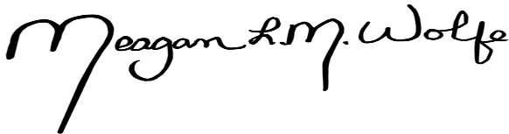

_______________________________

Meagan Wolfe, Administrator

Wisconsin Elections Commission

201 West Washington Avenue, 2nd Floor

P.O. Box 7984

Madison, Wisconsin 53707-7984

608-261-2028