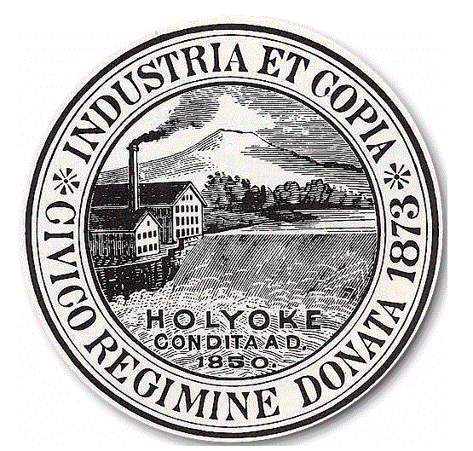
City of Holyoke
Timothy M. Rivers Board of Health
Director City Hall Annex, Room 306
Holyoke, MA 01040
Tel 413-322-5595
Fax 413-322-5596

APPLICATION FOR A PERMIT TO OPERATE A
BODY ARTS ESTABLISHMENT

LICENSE FEE: $ 300.00 LICENSE EXPIRES DECEMBER 31 OF EACH YEAR
Type of Practice: BODY PIERCING □ TATTOOING □ Date_________________________________

Name of Establishment: ___________________________________________________________________________
Address of Establishment: ______________________________________________ Tel. #_______________________
Mailing Address__________________________________________________________________________________
Owner of Establishment: ___________________________________________________________________________
Owner’s Address______________________________________________________Tel. #_______________________
Cell #_____________________________________________________ Email: ________________________________

NOTE: (EACH BODY ART ESTABLISHMENT APPLYING FOR A PERMIT MUST SUBMIT A LIST OF ALL PRACTITIONERS OF BODY ART OPERATING IN THAT ESTABLISHMENT. This list shall be upgraded yearly at the time of license renewal. All Individual Practitioners of Body Art must be licensed separately by the Holyoke Board of Health.

NAME OF PRACTITIONER | HOME ADDRESS OF PRACTITIONER | PHONE #

Please return the following to the Holyoke Board of Health, City Hall Annex, Room 306, 20 Korean Veterans Plaza, Holyoke, MA 01040:

- Completed application and application fee of $300.00. Please make checks payable to the city of Holyoke.
- A Note from a physician stating that the applicant has been examined and found to be free of any contagious or communicable
disease and showing that the examination was conducted within 30 days prior to submission of the application.
- CORI Request Form completed by applicant and returned to this office for processing.

Your permit will be mailed to your residence unless otherwise specified.  Please mail to this address: ______________________

_______________________________________________

______________________________________________________ ______________________________________________
Signature of Establishment Owner Date Signed

____________________OR XXX-_____-________

TAX ID OR SOCIAL SECURITY NUMBER

For Office Use Only-Make all checks payable to the City of Holyoke
Date Received | Amount Received | Check No. | Received by: | Customer No. | Invoice No.

