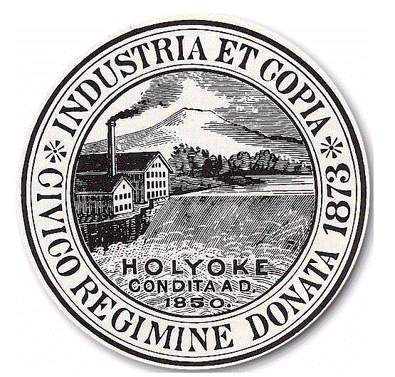
City of Holyoke
Timothy M. Rivers Board of Health
Director City Hall Annex, Room 306
Holyoke, MA 01040
Tel 413-322-5595
Fax 413-322-5596

APPLICATION FOR A PERMIT TO PRACTICE
BODY ARTS, BODY PIERCING AND/OR TATTOOING

LICENSE FEE: $ 150.00 LICENSE EXPIRES DECEMBER 31 OF EACH YEAR
Type of Practice: BODY PIERCING □ TATTOOING □ Date_________________________________
Name of Practitioner: ____________________________________________________Gender  Male  Female
Address of Practitioner: ______________________________________________ Tel. #_______________________
Mailing Address (If different) ________________________________________________________________________
Name of Licensed Body Art Establishment Where Employed: ______________________________________________
Name of Body Art Establishment Owner Address (If different): _____________________________Tel. #_______________________
Cell #_____________________________________________________ Email: ________________________________

NOTE: (A) INDIVIDUAL MUST PRACTICE IN A LICENSED BODY ARTS ESTABLISHMENT.
(B) IF THE INDIVIDUAL PERMIT HOLDER WILL BE PRACTICING BODY ARTS OUT OF HIS/HER
ESTABLISHMENT. A SEPARATE ESTABLISHMENT APPLICATION MUST BE FILED AND A BODY
ARTS ESTABLISHMENT LICENSE OBTAINED

NOTE: FIRST-TIME APPLICANTS MUST PROVIDE THE FOLLOWING INFORMATION.
• Copy of the Driver's License, passport or other photographic proof of identity and age.
• Evidence of course completion in Preventing Disease Transmission (American Red Cross Association of Professional Body
Piercers, or OSHA).
• Evidence of current certification in First Aid and CPR.
• Proof of completion of a course in Anatomy and Physiology.
• Proof of two (2) year of licensing in another municipality or state, or one (1) year apprenticeship training as a piercer, three
(3) years apprenticeship as a tattooist.
• Must submit detailed floor plan of establishment showing restroom and sink locations.

NOTE: (EACH BODY ART ESTABLISHMENT APPLYING FOR A PERMIT MUST SUBMIT A LIST OF ALL PRACTITIONERS OF BODY ART OPERATING IN THAT ESTABLISHMENT. This list shall be upgraded yearly at the time of license renewal. All Individual Practitioners of Body Art must be licensed separately by the Holyoke Board of Health.

Please return the following to the Holyoke Board of Health

- Completed application and application fee of $150.00. Please make checks payable to the City of Holyoke.
- A Note from a physician stating that the applicant has been examined and found to be free of any contagious or communicable
disease and showing that the examination was conducted within 30 days prior to submission of the application.
- CORI Request Form completed by applicant and returned to this office for processing.

Your permit will be mailed to your residence unless otherwise specified.  Please mail to this address: ______________________

______________________________________________________ ______________________________________________
Signature of Applicant Date Signed

____________________OR XXX-_____-________
TAX ID OR SOCIAL SECURITY NUMBER
For Office Use Only-Make all checks payable to the City of Holyoke
Date Received | Amount Received | Check No. | Received by: | Customer No. | Invoice No.

