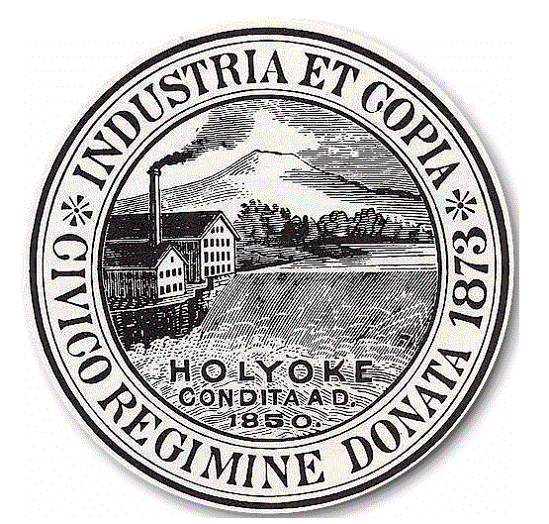
City of Holyoke
Timothy M. Rivers Board of Health
Director City Hall Annex, Room 306
Holyoke, MA 01040
Tel 413-322-5595
Fax 413-322-5596

APPLICATION FOR A PERMIT TO OPERATE A
BODY ARTS ESTABLISHMENT

LICENSE FEE: $ 300.00 LICENSE EXPIRES DECEMBER 31 OF EACH YEAR
Type of Practice: BODY PIERCING □ TATTOOING □ Date_________________________________

Name of Establishment: ___________________________________________________________________________
Address of Establishment: ______________________________________________ Tel. #_______________________
Mailing Address__________________________________________________________________________________
Owner of Establishment: ___________________________________________________________________________
Owner’s Address______________________________________________________Tel. #_______________________
Cell #_____________________________________________________ Email: ________________________________

NOTE: (EACH BODY ART ESTABLISHMENT APPLYING FOR A PERMIT MUST SUBMIT A LIST OF ALL PRACTITIONERS OF BODY ART OPERATING IN THAT ESTABLISHMENT. This list shall be upgraded yearly at the time of license renewal. All Individual Practitioners of Body Art must be licensed separately by the Holyoke Board of Health.

NAME OF PRACTITIONER | HOME ADDRESS OF PRACTITIONER | PHONE #

Please return the following to the Holyoke Board of Health, City Hall Annex, Room 306, 20 Korean Veterans Plaza, Holyoke, MA 01040:

- Completed application and application fee of $300.00. Please make checks payable to the city of Holyoke.
- A Note from a physician stating that the applicant has been examined and found to be free of any contagious or communicable
disease and showing that the examination was conducted within 30 days prior to submission of the application.
- CORI Request Form completed by applicant and returned to this office for processing.

Your permit will be mailed to your residence unless otherwise specified.  Please mail to this address: ______________________

_______________________________________________

______________________________________________________ ______________________________________________
Signature of Establishment Owner Date Signed

____________________OR XXX-_____-________

TAX ID OR SOCIAL SECURITY NUMBER

For Office Use Only-Make all checks payable to the City of Holyoke
Date Received | Amount Received | Check No. | Received by: | Customer No. | Invoice No.
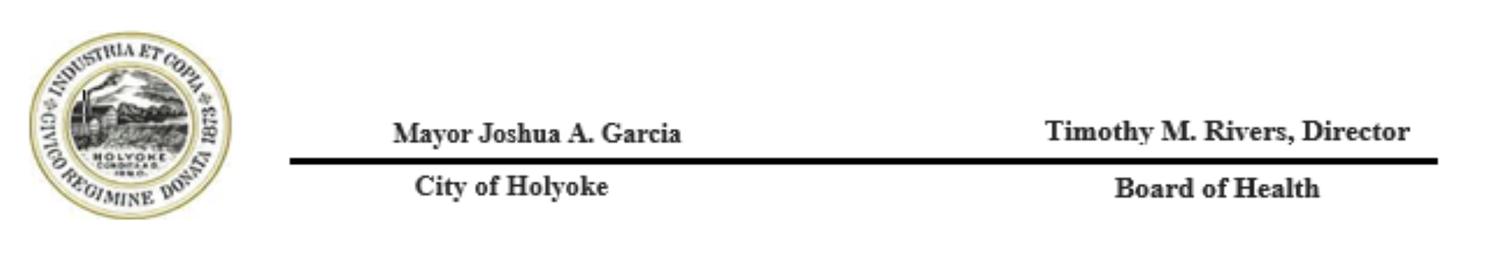

ANNUAL EQUIPMENT EXEMPTION APPLICATION

I, _______________________ __________________________,
First Name Last Name

am the owner of the Body Art Establish located at

________________________________________ in Holyoke, Massachusetts.
Establishment Address

I attest that myself, and all practitioners who are licensed to perform Body Art at this facility, will be using disposal and pre-sterilized instruments to perform all Body Art Procedures. At no time will there be any utensils or instruments used on more than one client or in more than one session.

I recognize by signing this document that I am exempt from the ultrasonic cleaning unit and autoclave that is required in the Holyoke Board of Health Body Art regulations. Any changes in the use of non-disposable instruments will require the owner of this establishment to notify the Director of the Holyoke Board of Health before any changes are made.

By signing below, I attest that I fully understand the statements above. I acknowledge that all instruments used on clients at this Body Art Establishment will be pre-sterilized, disposable, used as intended, and be documented by a reputable distributor. I recognize that this is a condition of my Body Art Establishment license and failure to comply with ALL disposable presterilized instruments may result in fines, suspension, and/or revocation of the Body Art Establishment license.

____________________________ _____________
Establishment Owner’s Signature Date

