FOR BOARD OF HEALTH
DATE RECEIVED:
DATE ISSUED:
PERMIT NO.
DWI-
YEAR
.

APPLICATION FOR PERMIT TO OPERATE AS A DISPOSAL WORKS INSTALLER

CASH
FOR BOARD OF HEALT :
DATE RECEIVED:
DATE ISSUED:
PERMIT NO.
Date:
Name of Business
Mailing Address (If different)
Name & Title of Applicant
Address of Applicant
Name of Owner (If different)
If corporation or partnership, give name, title & home address of officers or partners.
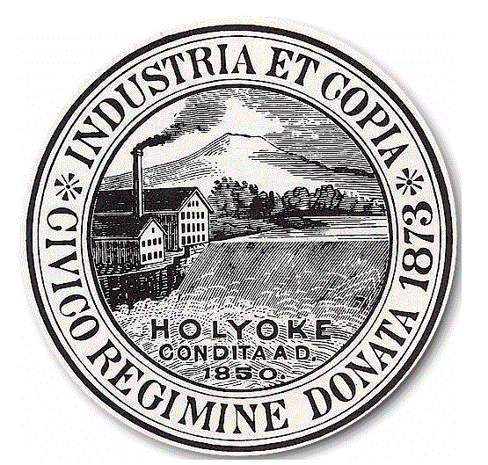
Name
Title
Home Address Tel. #
Holyoke Board of Health
City Hall Annex, Room 306
20 Korean Veterans Plaza
Holyoke, MA 01040
Phone: 413-322-5595 Fax: 413-322-5596
CHECK CASH
LICENSE FEE: $100.00

In accordance with the provisions of the Statutes relating thereto, application for a Disposal
Works Installer’s Permit is hereby made to operate as a DISPOSAL WORKS INSTALLER in
Holyoke, Massachusetts.

OTHER TOWNS CURRENTLY OR PREVIOUSLY LICENSED IN:
Signature of Owner or Corporate Officer
Federal ID #

PLEASE MAKE ALL CHECKS PAYABLE TO THE CITY OF HOLYOKE

______________________________________________

System Installer Supervisor Cell Telephone # Email Address

