CITY OF HOLYOKE CITY HALL ANNEX, ROOM 306
BOARD OF HEALTH 20 KOREAN VETERANS PLAZA
HOLYOKE, MA 01040
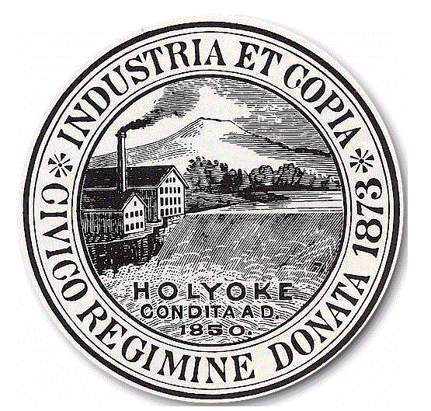
TEL. (413) 322-5595 FAX (413) 322-5596

BULK REFUSE PERMIT APPLICATION
FEE: $20.00

COMMERCIAL SINGLE / MULTI FAMILY PROPERTY
Name of  Business: | Name of  Owner(s):
Address: | Address:
Tel.: | Tel.: Cell/Pager:
Name of Dumpster Col.: | Name of Dumpster Co.:
Property Location of Dumpster: | Property Location of Dumpster:
Dumpster Capacity: | Dumpster Capacity:
Frequency of Empty: (daily, weekly, monthly)  (circle one) | # of Units:  # of Times Emptied Per Week:
Management Contact: | Contact Person:
Address: | Address:
Tel.: Cell/Pager: | Tel.: Cell/Pager:

Person Directly Responsible For Daily Operations (Owner, Person In Charge, Supervisor, Manager, etc.)

Name: _______________________________________________________________

Address: _______________________________________________________________

Tel. No. ______________ Cell/Pager: ________________ Fax#_________________

Emergency No. __________________E-Mail Address: ___________________________

PLEASE NOTE: THIS APPLICATION IS FOR THE SOLE PURPOSE OF PROVIDING AN EASY MEANS OF CONTACT TO PROPERTY OWNERS/MANAGERS IN ORDER TO AVOID TICKET CITATIONS AND/OR COURT ACTION, AND TO PREVENT ANY UNNECESSARY DUMPSTER SITUATIONS.

Please contact Dumpster Company for information regarding pick-up and disposal of large items
(i.e. couch, refrigerator, etc.).
All Payments Due With Application - *No Cash Please*
For Office Use Only-Make all checks payable to the City of Holyoke
Date Received | Amount Received | Check No. | Received by:

