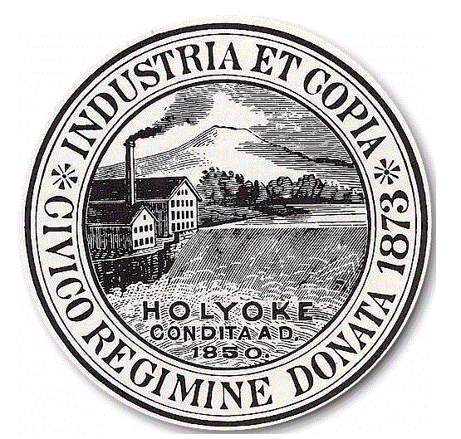
City of Holyoke
Sean Gonsalves Board of Health
Director City Hall Annex, Room 306
Holyoke, MA 01040
Tel 413-322-5595
Fax 413-322-5596

Food Establishment Permit Application

APPLICATIONS MUST BE SUBMITTED TO OUR OFFICE NO LESS THAN 30 DAYS BEFORE OPENING DATE
PLEASE SUBMIT ALL REQUESTED PAPERWORK. INCOMPLETE APPLICATIONS WILL BE RETURNED.
NO PERMITS WILL BE ISSUED IF TAXES ARE OWED.

Name of Establishment_____________________________________________Date________________

Establishment Address_________________________________________________________________

Telephone________________________ Fax___________________ email________________________

Owner/Company Name__________________________________________ FID/SSN# XXX-XX-_______

Mailing Address _______________________________________________________________________

Telephone________________________ Fax___________________ email________________________

Person Responsible for Daily Operations (Manager/Supervisor, etc.)

Name _______________________________________________Title______________________________

Address________________________________________________________________________________

Telephone__________________ Emergency Tel__________________ Email_______ _________________

Please enclose current copies of:

 Food Safety Manager Certification  Food Allergen Awareness Certification  Anti-Choking Procedures Training

ESTABLISHMENT TYPE & FEE SCHEDULE (Check all that Apply)

 Retail (_______sq. ft)  Bakery (please specify)  Full $150.00  Limited $ 50.00
- under 2,500 sq ft $150.00  Caterer-Fee $100.00
- 2,500-15,000 sq ft $200.00  Frozen Dessert Manufacturer-Fee $100.00
- Over 15,000 sq ft $300.00  Tobacco Permit-Fee $100.00
 Food Service- (________ seats) Please provide DOR # ____________________
- under 25 seats $150.00  Enclose copy of Mass State Cigarette License please go to
- 25-100 seats $200.00 (www.mass.gov/dor/forms/cigarette-and-tobacco) OR call 1-800-392-6089
- 101-200 seats $250.00  Other (describe)_________________
- Over 200 seats $300.00
 Food Service-Take Out
 Food Delivery TOTAL FEE AMOUNT $______________________________

I, the undersigned, attest to the accuracy of the information provided in this application and I affirm that the food establishment
operation will comply with 105 CMR 590.000 and all other applicable law. I have been instructed by the Board of Health on how
to obtain copies of 105 CMR 590.000 and the Federal Food Code.

Signature of Permit Holder: ____________________________________________________Date_______________________

Pursuant to MGL Chapter 62C, Section 49A, I certify under the penalties of perjury that I, to my best knowledge and belief,
have filed all state tax returns and paid state taxes required under law.

Signature of Corporate Representative (i.e. President, CFO, COO): _____________________________Date________________________

For Office Use Only-Make all checks payable to the City of Holyoke
Date Received | Amount Received | Check No. | Received by: | Customer No. | Invoice No.

