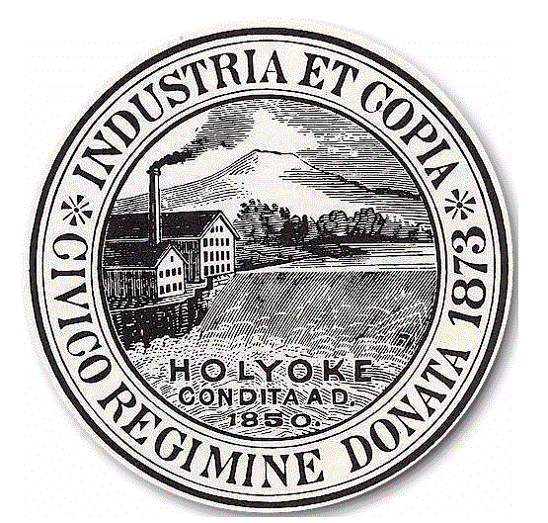
City of Holyoke
Sean Gonsalves Board of Health
Director City Hall Annex, Room 306
Holyoke, MA 01040
Tel 413-322-5595
Fax 413-322-5596

YEAR 2020

APPLICATION TO: REMOVE AND TRANSPORT GARBAGE, SEPTAGE, OFFAL OR OFFENSIVE SUBSTANCES PERMIT

PLEASE SUBMIT ALL REQUESTED PAPERWORK. INCOMPLETE APPLICATIONS WILL BE RETURNED.

In accordance with M.G.L. c.111, Section 31A-31B and 310 CMR 15.402 (Title 5) the undersigned makes application to the Board of Health for permission to remove and transport GARBAGE, SEPTAGE, OFFAL OR OFFENSIVE SUBSTANCES as set forth below:

FEE: (check one)  1-10 Vehicles: $50.00 per vehicle
 11-20 Vehicles: $20.00 per vehicle
 Over 21 Vehicles: $10.00 per vehicle

Business Name: _______________________________________________________________________________________
Name of Applicant: _____________________________________________________________________________________
Address: _____________________________________________________________________________________________
Telephone Number:______________________________________________Email Address: __________________________

List all registration numbers and type of each vehicle used in the City of Holyoke: (Note: complete and attach additional pages if necessary)

Type of Vehicle: __________________________________________Reg. Plate #_________________________________
Type of Vehicle: __________________________________________Reg. Plate #_________________________________
Type of Vehicle: __________________________________________Reg. Plate #_________________________________
Type of Vehicle: __________________________________________Reg. Plate #_________________________________
Type of Vehicle: __________________________________________Reg. Plate #_________________________________
Type of Vehicle: __________________________________________Reg. Plate #_________________________________

If Septic Hauler, list areas where septage will be accepted from (and append customer list):
___________________________________________________________________________________________________
___________________________________________________________________________________________________
If Septic Hauler, list all locations (Cities and Towns) where septage will be disposed of (include a copy of the Contract or approval for use of the disposal location).
______________________________ ______________________________ ______________________________
______________________________ ______________________________ ______________________________
I certify that the information I have provided above is true and accurate. I recognize that it is a violation of this permit to dispose of septage anywhere other than the identified disposal locations or others approved of the by the Board in writing as an amendment to this permit.

Applicant Signature: _______________________________________ Date: ________________________________

All Payments Due With Application

For Office Use Only-Make all checks payable to the City of Holyoke-HLT 12
Date Received | Amount Received | Check No. | Received by: | Invoice: | Customer

