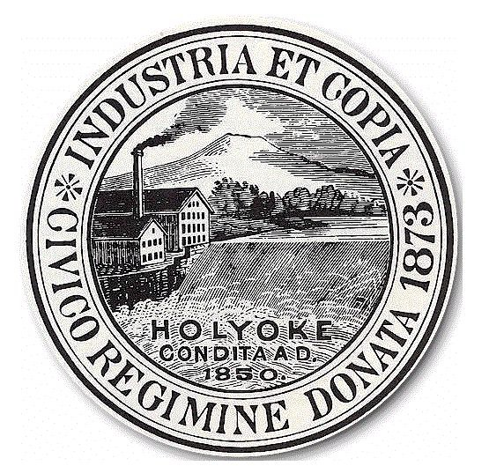

***Mayor Alex B. Morse Sean Gonsalves, Director  
 City of Holyoke Board of Health***

**HOLYOKE BOARD OF HEALTH APPLICATION FOR “PERMIT FOR LOCATION AND SALE OF TOBACCO PRODUCTS”**

This form must be initialed and signed by the owner of the establishment applying for a Board of Health “Permit for   
location and Sale of Tobacco Products”. **No permit will be issued until this form has been initialed and signed.**

## Initial below: _____1. I understand that it is against the law to sell any tobacco product to anyone less than 21 years of age; regardless of how old the person looks. _____2. I understand that the Holyoke Board of Health Regulation requires anyone selling tobacco, to conclusively establish the customer’s age is over 21 years old, by means of government­ issued photographic ID. _____3. I must check and verify photo ID for anyone who wishes to purchase tobacco. _____4. I understand and agree that the Holyoke Board of Health/Tobacco Control Program may conduct frequent compliance checks of my business to ensure that tobacco products are not sold to minors. This means that:

a. The Board of Health/Tobacco Control Program may send persons under 21 into my establishment who will   
 attempt to purchase tobacco products.  
 b.These persons may or may not look 21 years of age.  
 c.These persons may or may not have identification.  
 _____**5. I understand** that self­service tobacco displays from which the customer may select tobacco products are   
 prohibited: all sales must be face­to­face.  
 _____**6. I understand** that tobacco vending machines are prohibited.  
 _____**7. I understand** that the sale of single or loose cigarettes, or cigarettes in packages smaller than 20 cigarettes  
 is prohibited.  
 _____**8. I understand** that I must display Department of Public Health signs stating, “**Sale Of Tobacco To Persons  
 Under 21 Prohibited”.**  
 _____**9.** I will provide the Board of Health with proof of a current “**Cigarette Retail License”** from the Massachusetts   
 Department of Revenue. **(Attach copy of DOR license).**  
 _____**10.I understand** that I am responsible for informing any and all persons who sell tobacco about both state and   
 local regulations pertaining to tobacco sales and I am responsible for any violations of these regulations.  
 _____**11.I understand** that I may not sell tobacco products below state minimum prices.  
 _____**12.I understand** that penalties for violation of the regulation include monetary fines and/or suspension of this   
 permit for **three days, seven days, thirty days, or one year.**  
 _____**13.I understand** that if I am found in violation, I cannot confront the minor who purchased the tobacco  
 _____**14.The Board of Health will notify me about mandatory Tobacco Control Program Training** to take place   
 annually.

# 

**I have read and understand the Holyoke Board of Health “Regulations Affecting Smoking in Certain Places and Youth Access to Tobacco” and agree to abide by them. Smoking is not permitted in any workplace.**

# Establishment Name Address

# Signature DOR #_______________________________

**Please Print Name** **Date**

## CITY HALL ANNEX • 20 KOREANS VETERANS PLAZA • Room 306 • HOLYOKE, MASSACHUSETTS 01040

PHONE: (413) 322­5595 • FAX: (413) 322­5596

***Birthplace of Volleyball***