City of Holyoke
Alex B. Morse, Mayor

Licenses & Permits for
Bars/Night Club Owners

Bar/Night Club Permitting Overview

This checklist describes the permitting process for night club owners in the City of Holyoke. Additional business resources, such as customized permitting guidelines, applications, regulations, and property listings are available at holyoke.org. Below is a timeline showing the steps involved in starting your own small business. For more information contact the Office of Planning and Development at (413) 322-5575.

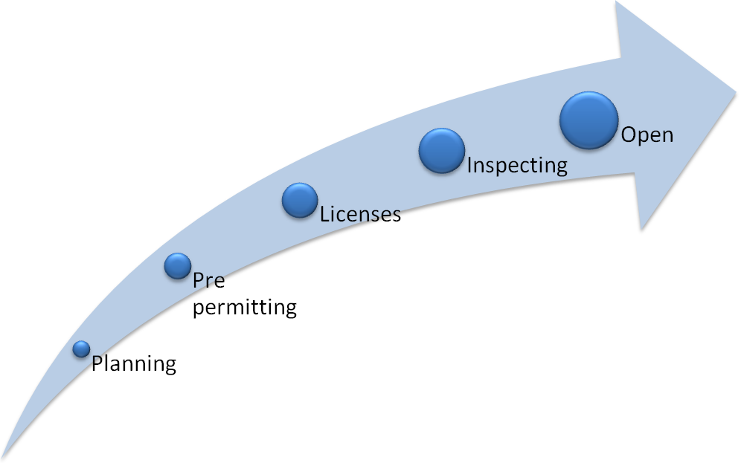

Choosing a Location – Zoning & Occupancy

- Check zoning online by searching for the property on the Online Property Viewer, available on the city’s website, and referring to the zoning map. Then check whether your desired use is permitted, prohibited or authorized under special permit in the Zoning Code (Part II, Appendix A, Section 4 of the Code of Ordinances).
- If you plan on building a new structure for your business that is at least 5,000 square feet, visit the Planning Department for a Special Permit for Site Review.
- If the proposed use of your business is in a Zoning District that requires a Special Permit, contact the City Clerk's Office for a petition.
- If you think you qualify for an exemption from specific zoning standards, submit an Application for a Variance with the Board of Appeals.
- Check the building’s existing legal use by contacting the Department of Codes and Inspections (Building Dept.)

Designing the Space –
Construction & Building Approval

- All construction, renovation, demolition, repairs, and remodeling requires a Building Permit from the Department of Codes and Inspections. Make sure all plumbing, electrical, and gas fitting work is also accompanied by the proper permits.
- File for a Certificate of Occupancy if you don’t already have one, you’re completing substantial construction, or if you’re seeking to change the use of the space.

Bar/Night Club Licenses & Permits

- In order to serve alcohol in your establishment, you will need to obtain either an All Alcohol Restaurant License or a Wine and Malt Restaurant License from the Licensing Board.You also need to file for a license with the Alcoholic Beverages Control Commission and submit the paperwork to the Licensing Board.
- If you plan on selling food, you will need a Common Victualer License from the Licensing Board.
- Contact the Licensing Board if you plan on having the following: arcade games, television, radio, or juke box
- Contact the Licensing Board for an Entertainment License.
- Contact the City Clerk's Office if you plan on having a pool/billiard table.

Other Considerations – Additional Permits

- Contact the Board of Health to obtain permits for dumpsters and transportation of refuse
- Storefront signage requires a permit from the Department of Codes and Inspections.
- After obtaining all necessary licenses and permits, and prior to opening your business, you must file with the City Clerk’s Office for a Business Certificate.

Local, State, and Federal Taxes

- Visit the City Assessor’s Office to file a Form of List, which is used to document the property owned by your business, so that it may be assessed and taxed by the city.
- For tax purposes, you will need to define your business structure and obtain a Federal Tax or Employee Identification Number from the Internal Revenue Service (IRS).
- In order to file taxes in Massachusetts, you must first register your business with the Massachusetts Department of Revenue (DOR).

Common Fees
Certificate of Occupancy  $60 | All Alcohol Restaurant License  $1,100 annually
Wine & Malt Restaurant License  $675 annually | Application for a Variance  $200
Common Victualer License  $25 annually  $675 (All Alcohol) | Entertainment License  $110 annually

* Fees subject to change

Inspection Criteria
Building Permit Inspections - Certificate of Inspection (Annual)
- Emergency lights installed and functional
- Fire escapes in satisfactory condition
- Fire extinguisher tag dates current
- Suppression system maintained
- Kitchen hood cleaning on schedule
- Stairs properly railed
- Exits/directional signs visible and lit
- Sprinklers functioning properly
- Fire alarm system/smoke detectors/carbon monoxide detectors working properly
- Exitways unobstructed
- General conditions satisfactory
* Pre-existing structures with the same use are not subject to change
Place of Assembly
- Certificate of Inspection/Place of Assembly Permit/Occupant Load posted
- If occupant load is 100+, there shall be one crowd manager for every 250 occupants. He/she must be at least 21 years of age, shall be the owner/operator of the business or under the direct control of said owner/operator.
- Flammability permits for all decorations, furnishings, and interior finishes
- Egress plan on site, consistent with layout of furniture
- Fire escapes clear and operable
- Exits unobstructed, lead to a public way
- Good general housekeeping
- Stairwells clear with proper signage
- Alarm system inspections up to date
- Sprinkler inspections up to date
Contact Information

AGENCY | ADDRESS | PHONE
Board of Health | City Hall Annex, Room 306 | (413) 322-5595
Codes and Inspections  (Building Dept.) | City Hall Annex, Room 300 | (413) 322-5600
City Clerk’s Office | City Hall, Room 2 | (413) 322-5525
City Assessor | City Hall, Room 4 | (413) 322-5550
Fire Department | 600 High Street | (413) 534-2254
Licensing Board | City Hall Annex, Room 306 | (413) 322-5599
Planning Department | One Court Plaza | (413) 322-5575
Department of Public Works | City Hall Annex, Room 300/ 63 Canal St | (413) 322-5645

