NEW: ________ DATE: _________________________________________________________
RENEWAL: _____
$50 FEE: _____
TAX COLLECTOR LETTER: _____
TREASURE’S LETTER: ______
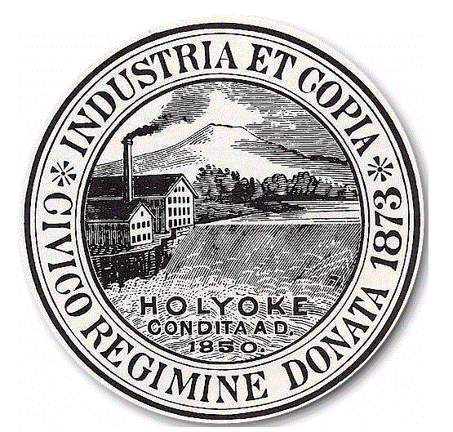

HOLYOKE CITY COUNCIL
JUNK DEALER, JUNK COLLECTOR,
SECOND HAND LICENSE APPLICATION

Please Check One:
- Junk Dealer’s License
- Second Hand License
- Junk Collector’s License

ADDRESS:_____________________________________________________________________________________________________________________________________

APPLICANT’S NAME:_________________________________________________________________________________________________________________________

APPLICANT’S ADDRESS:_____________________________________________________________________________________________________________________

APPLICANT’S TELEPHONE:____________________________ EMAIL:_____________________________________________________________________________

SS#_____________________________________________________________________________________________________________________________________________

=============================================================
Said license runs from May 1st to April 30th of each year; regardless of application date
Sec. 66-32. - Record of purchases.
Every person dealing in junk, old metals, rags, papers, bottles or secondhand articles or keeping a shop for the purchase, sale or barter of the same shall keep a book in which he shall record in plain English language, at the time of every purchase by him of any of the aforesaid articles, a description of the article purchased, the name, age and residence of the person from whom, and the day and hour when he so purchased it. No entry made in such book shall be erased, obliterated or defaced and the form of such book shall be prepared by the chief of police. Such book shall at all times be open to the inspection of the mayor and city council or any person by them authorized to make such examination.

Sec. 66-35. - Purchases from minors or apprentices; dealers to purchase only from licensed collectors.
No dealer in or keeper of a shop for the purchase or barter of junk, old metal or secondhand articles, and no collector of the aforesaid articles, shall, directly or indirectly, purchase or receive by way of barter or exchange any of the articles aforesaid from a minor or apprentice, knowing or having reason to believe him to be such. No such dealer or keeper of a shop shall, directly or indirectly, purchase or receive as aforesaid any of such articles from a person not a duly licensed collector of junk, except, however, that he may make such purchase directly from mills or manufacturers.

Sec. 66-61. - Dealers or shopkeepers.
No person shall be a dealer in or keeper of a shop for the purchase, sale or barter of junk, old metals or secondhand articles in the city, unless he is duly licensed therefor by the city council and shall exhibit his license when requested to do so.

Sec. 66-36. - Articles purchased not to be sold for 30 days.
No article purchased or received by a dealer or keeper of a shop for the purchase, sale or barter of junk, old metal or secondhand articles shall be sold until at least 30 days from the date of its purchase or receipt has elapsed

________________________________________________________
APPLICANT’S SIGNATURE

