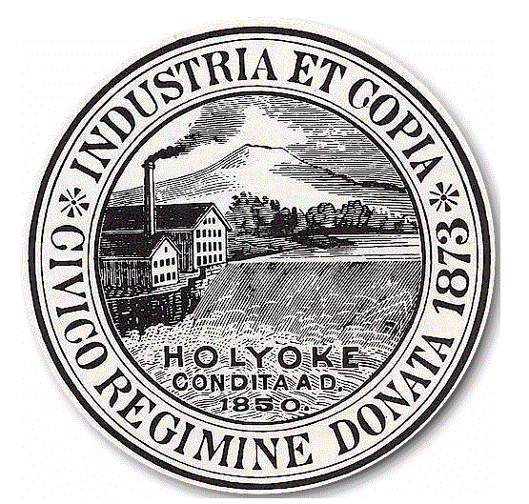
Mayor Terence Murphy License Board City of Holyoke Anthony Luciano, Chair
Jose Correa, Commissioner
Michael Moriarty, Commissioner

APPLICATION FOR A NEW LICENSE OR RENEWAL OF A CLASS I, AND II LICENSE TO BUY, SELL OR EXCHANGE MOTOR VEHICLES

We, the undersigned, Duly Authorized by the businesses herein mentioned apply to for a Class______ (indicate I or II) license to buy, sell or exchange motor vehicles, in Accordance with the Provision of Section 11-9 of the Ordinance of the City of Holyoke

- Name of the Licensee________________________________________

Business Name__________________________________________________

Address of where the license holder conducts or wishes to conduct business:
______________________________________________________________

Business phone number___________________________________________

All of the following questions must be answered by the Applicant seeking the license or renewal and must be answered completely and accurately. Any false or misleading information provided by the Applicant may result in the denial of the request and may result in the revocation of the existing license holder’s Class I or II, license.

1a. Full Name and home address of the applicant seeking the license or renewal.

Individual:_______________________________________________________

Address:________________________________________________________

Home Phone: ____________________________________________________

If a Corporation: Corporate Name:____________________________________

Corporate Address:__________________________________

Date and State of Corporation:_______________________________________

President:_______________________________________________________

Treasurer:_______________________________________________________
Clerk::__________________________________________________________

Registered Agent:_________________________________________________

CITY HALL ANNEX • 20 KOREAN VETERANS PLAZA • HOLYOKE, MASSACHUSETTS 01040
PHONE: (413) 322-5595 E-MAIL: Licenseboard@holyoke.org

Any Changes in Corporate Officers since Last Renewal list Below

If a LLC: Business Name: _______________________________________

Name of Manager:_____________________________________

Address:_______________________________________

Home Phone:____________________________________

Registered Agent:________________________________

If a partnership: Name and Residential Address of all Partners and Home Phone

________________________________________________________________

________________________________________________________________

________________________________________________________________

- Emergency Contact Name: __________________________________________

2a Emergency Telephone Contact:_______________________________________

- Proposed address of where the applicant is seeking to conduct business:
________________________________________________________________

3a. Do you own or lease the property ______________________?. If you lease the property a copy of your lease agreement must be provided.

- Will the purchase, sale or exchange of second hand motor vehicles be your principal business at the proposed location? ______. If no, please describe what your principal business will be at the proposed location.

_______________________________________________________________

_______________________________________________________________

_______________________________________________________________

- What, if any, license(s) have been issued to the Applicant by the City of Holyoke, Commonwealth of Massachusetts or the Federal Government, which have as their principal place of business the proposed location as indicated in paragraph three (3) above.

________________________________________________________________

- Has any license as described in paragraph five (5) above ever been suspended or revoked for any reason including, but not limited to, a lawsuit initiated by the Attorney General or Public Prosecutor or due to a violation of a state deceptive practice or fraud ___________.
If yes, describe in detail the circumstances surrounding the suspension and/or
revocation: _____________________________________________________

____________________________________________________________

- Have you ever applied for a Class I, II or III in any town, city or State? ________

If yes, where ______________________________________________________

Did you receive a license___________________________________________?

If so, please attach copies of all current licenses.
When: ___________________________________________________________

- Describe in detail your access to a repair facility sufficient to enable you to
satisfy the warranty repair obligation imposed by MGL c. 90-§ 7N ¼.
________________________________________________________________

________________________________________________________________

- Number of cars that you are currently licensed to have for sale at your current location ________________________

______________________________ ______________
Applicant Signature Date

______________________________ ______________
Applicants Signature Date

*CHECKS OR MONEY ORDERS SHOULB BE MADE PAYABLE TO THE CITY OF HOLYOKE*

