Department of Public Services
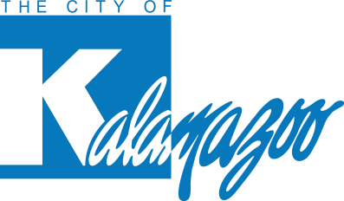
415 E Stockbridge Ave

Kalamazoo, MI 49001
Phone: (269) 337-8660
311 (269) 337-8000 www.kalamazoocity.org

Media Contact:
James J. Baker, PE
Public Services Director and City Engineer
City of Kalamazoo
(269) 337-8660

MEDIA RELEASE
ON WEST MAIN STREET
FROM WEALTHY STREET TO JENNISON STREET

KALAMAZOO, Mich. – May. 9, 2024 – W. Main Street between Wealthy Street and Jennison Street will be closed until May 14, 2024, for infrastructure repairs needed as a result of a water main break.

There will be impacts to traffic, please follow the posted detour. Access to homes will be maintained. Pedestrians may pass through the work zone via the south sidewalk.

