1720 Riverview Drive
Kalamazoo, Michigan 49004
Tele: (269) 381-8080
Fax: (269) 381-3550
www.ktwp.org

Notice
CHARTER TOWNSHIP OF KALAMAZOO
BOARD OF TRUSTEES SPECIAL MEETING
March 3, 2023
3:30 P.M.

Please take notice that the Township Board of the Charter Township of Kalamazoo will conduct a special meeting on Friday, March 3, 2023, commencing at 3:30 p.m. for purposes of receiving attorney-client privileged communications in a closed session pursuant to MCL 15.268(h) regarding public safety issues including but not limited use of public funds; disciplinary options including authorization to undertake discipline; and options regarding the potential restructuring of public safety administration.

Lisa Moaiery, Clerk
Charter Township of Kalamazoo
1720 Riverview Drive
Kalamazoo, Michigan 49004
269-381-8080
www.ktwp.com
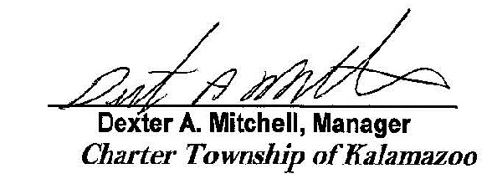
Posted March 2, 2023

