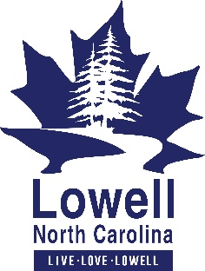
Phone: 704-824-3518
www.lowellnc.com
City of Lowell
101 W. 1st Street
Lowell, North Carolina 28098

FOR IMMEDIATE RELEASE

City of Lowell & Two Rivers Utilities Encourage Water Conservation
Stage 2 (Mandatory) Drought Declaration Has Been Issued
Lowell, NC (May 5, 2026) The City of Lowell and Two Rivers Utilities (TRU) are asking residents and businesses to conserve water. This comes after the Catawba–Wateree Drought Management Advisory Group declared a Stage 2 (Mandatory) drought for the Catawba–Wateree River Basin due to rapidly developing dry conditions.
At this stage, residents and businesses are required to limit water use and they are strongly encouraged to conserve water where possible. The goal is for all users to reduce water consumption by 5 to 10 percent or more.
Residents and businesses shall take simple steps to help reduce overall demand and protect the community’s water supply such as:
- Shortening Showers.
- Washing full loads of laundry; Running the dishwasher when full of dishes.
  - Outdoor watering/Irrigation is limited to two days per week between the hours of 7:00 p.m. and 5:00 a.m.
- Outdoor use of drinking water for washing impervious surfaces is prohibited.
- Residential vehicle washing is prohibited. (Commercial car washes are not affected)
  - Operation or introduction of water into any non-circulating fountains, pools, ponds or similar structures is prohibited.

City officials will continue to monitor conditions and provide updates if further measures become necessary. City of Lowell & TRU water customers who would like more information or have questions, may contact Two Rivers Utilities Customer Care Center, 704-866-6714 or email Two Rivers Utilities at droughtinfo@tworiversutilities.com
You can also visit Duke Energy’s website for general information about drought conditions in the Catawba Wateree River Basin.
###

