Building Relationships. One Cup At A Time!
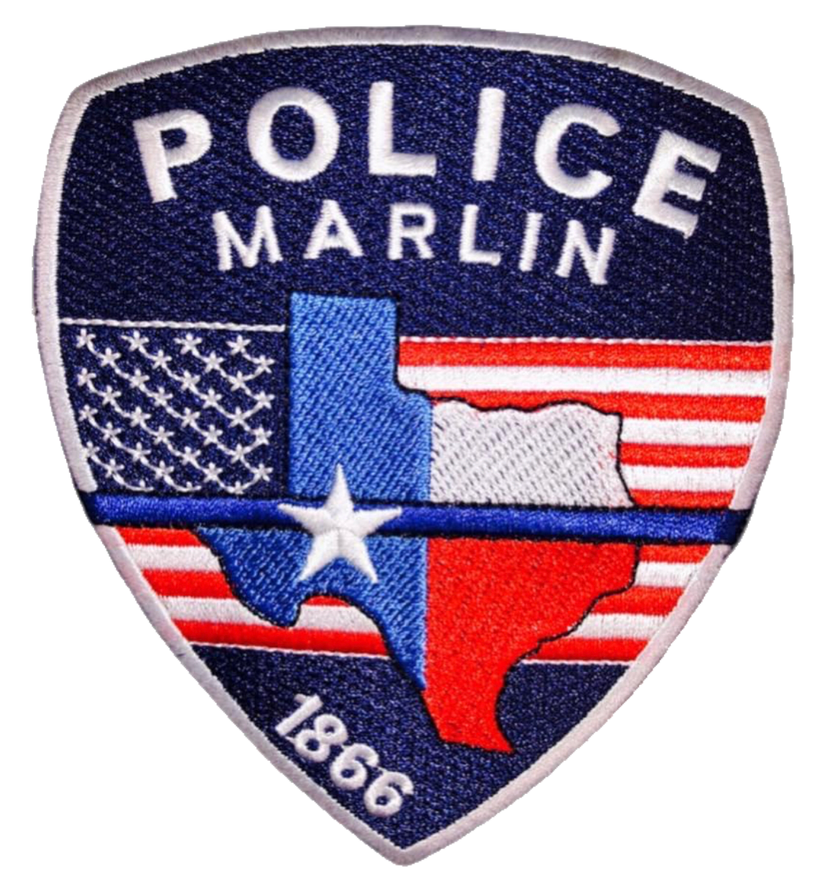
Join your neighbors for coffee
and conversation with the Marlin Police Department.

Every First Tuesday of the Month

________________________________________________________
McDonalds
1430 Live Oak St.
Marlin, Texas 76661
__________

8:30 am-9:30 am


No agendas or speeches! Just a chance to ask questions, voice concerns, and get to know your officers.

