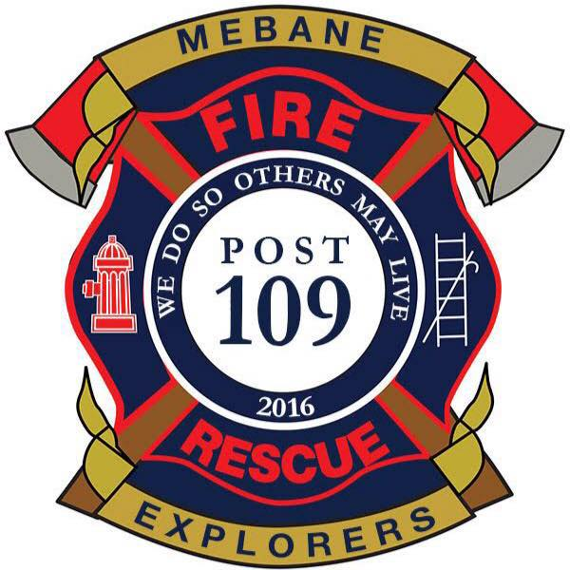**Mebane Fire Department**

**Explorer Program**

**Our Mission:**

The mission of the Mebane Fire Department’s Explorer Program is to provide participants opportunity for career development, leadership experience, life skills, and character education.   
Our vision is to provide hands on training and experience in fire and emergency operations, while serving the local community.

**Our Program:**

The Mebane Fire Department Explorer program is for teens, male and female, between the ages of 14 (must have completed the 8th grade) or 15 years of age and 20 years of age. It is operated under the guidelines established by the Boy Scouts of America and the Learning for Life career education program. When these participants reach the age of 18, they may become eligible for full membership with the Mebane Fire Department as a volunteer firefighter.  
  
As an Explorer, members serve in a support role for the senior firefighters at actual emergencies. Explorers will attend monthly training drills with post advisors and other members of the Department.