To complete this survey, you will need a smart phone (camera), a coin, a key or another tool, and a magnet.
Step 1: Customer Contact information (write in)
- Account number:
- Name:
- Address:
- Email address:
Step 2: Locate the water service line coming into your home/building.
The service line comes into your home/building from the street. It is typically located in a utility room on the lowest level of the building or in a crawl space or basement. The service line will be connected to the water meter which is located in your yard. Identify a test area on the pipe between the point where it enters the building and the inlet valve. If the pipe is covered or wrapped, expose a small area of metal.
- Were you able to find your drinking water service line?
☐ Yes
☐ No
Step 3: Perform a scratch test.
Scratch test instructions: Use the coin, key, or another tool to carefully scratch the pipe (like you would a lottery ticket). If your line is painted, you may need sandpaper to clear a small area.
- Were you able to perform a scratch test?
☐ Yes
☐ No
Step 4: What was the color result after the scratch test?
☐ Shiny and silver – Lead
☐ Copper colored (like a penny) – Copper
☐ Dull and gray – Galvanized
☐ Visibly plastic (White and rigid) – Plastic
Step 5: Perform a magnet test.
Magnet test instructions: Place the magnet on the pipe.
- Were you able to perform a magnet test?
☐ Yes
☐ No

Step 6: What was the result of the magnet test?
☐ The magnet does not stick to the pipe
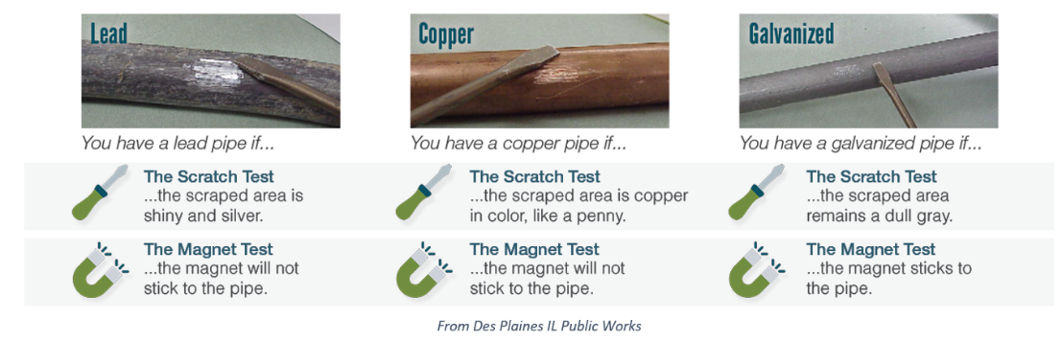
☐ The magnet sticks to the pipe

Step 7: Add a photo or two of the pipe tested here:

Step 8: Provide any additional information you would like to provide here:

