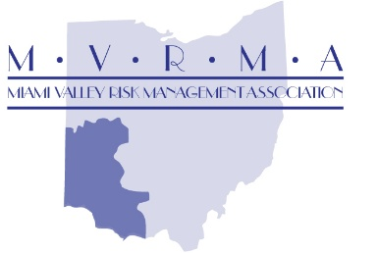
Entry Level Driver Training Program
The Entry Level Driver Training (ELDT) will be held August 14th -15th & 21st -22nd of 2025. It is mandatory that participants attend each day of the 4-day class schedule. Classes start at 8 AM daily and last until approximately 3:30 PM. Lunch is included each day as part of the $1,200 registration fee. There will be a maximum of 8 students for this session.
Training Schedule
Day 1 -Thursday, August 14th will be held at the West Carrolton Fire station training room located at 125 W. Central Avenue, West Carrollton, Ohio. You will not need a truck for this classroom day.
Day 2, 3 and 4 - Friday, August 15th, Thursday, August 21st and Friday, August 22nd will be held at the Mound parking lot, 900 Mound Road, Miamisburg. It is located across the street from the Mound golf course.
*** Please note: All required documentation for each driver must be received at least one-week prior to the first day of the training session for your employee to be eligible to participate. This enables MVRMA to keep and maintain accurate and detailed records per the FMCSA requirements. Each employee is required to complete 30-40 hours of driving under the supervision of city staff prior to class attendance. Attached you will find the CDL-ELDT Application, and the Ohio LTAP online course account setup.
The following is REQUIRED to finalize your employee’s spot in the class:
- Copy of the employee’s Temporary CDL License
- The Completed Application
- Copy of the certificate of completion of the online LTAP class section – there are 31 parts
- Written statement emailed to TJWhite@mvrma.com verifying that the employee has completed 30-40 hours of driving under the supervision of city staff.
- I need to know if the student is going for a Class A CDL or a Class B CDL so that our instructor can give them the proper pre-trip inspection form.

Each municipality will need to provide a dump truck, dump truck with trailer (for pre-trip) and other employees to assist with the class for at least one of the 3 driving days. We understand that equipment is a challenge since your employee cannot drive those vehicles yet without their CDL. It has worked well in the past when the city that is volunteering the truck just has that employee stay for day and assist. Please respond by REPLY ALL to my e-mail which day you would like to provide the equipment so that we can coordinate this.

