Quarter 1
Community Update:

In June of 2022, the Petaluma City Council adopted a Three-Year Strategic Action Plan (“the Plan”) for addressing homelessness in our community. The Plan includes eight strategic focus areas, with each area including three to seven workstreams to be completed over the next three years (view the plan). To ensure accountability and transparency, the City will be providing quarterly updates regarding our progress.

At its core, the Plan is about building a “Pathway to Housing” that rapidly and effectively ends people’s homelessness. This will be achieved by:

- Ensuring the City has the right programmatic building blocks to support people experiencing homelessness
- Aligning those programmatic building blocks around the goal of getting people rehoused as quickly as possible
- Constantly evaluating what is working and what is not and reinvesting resources accordingly

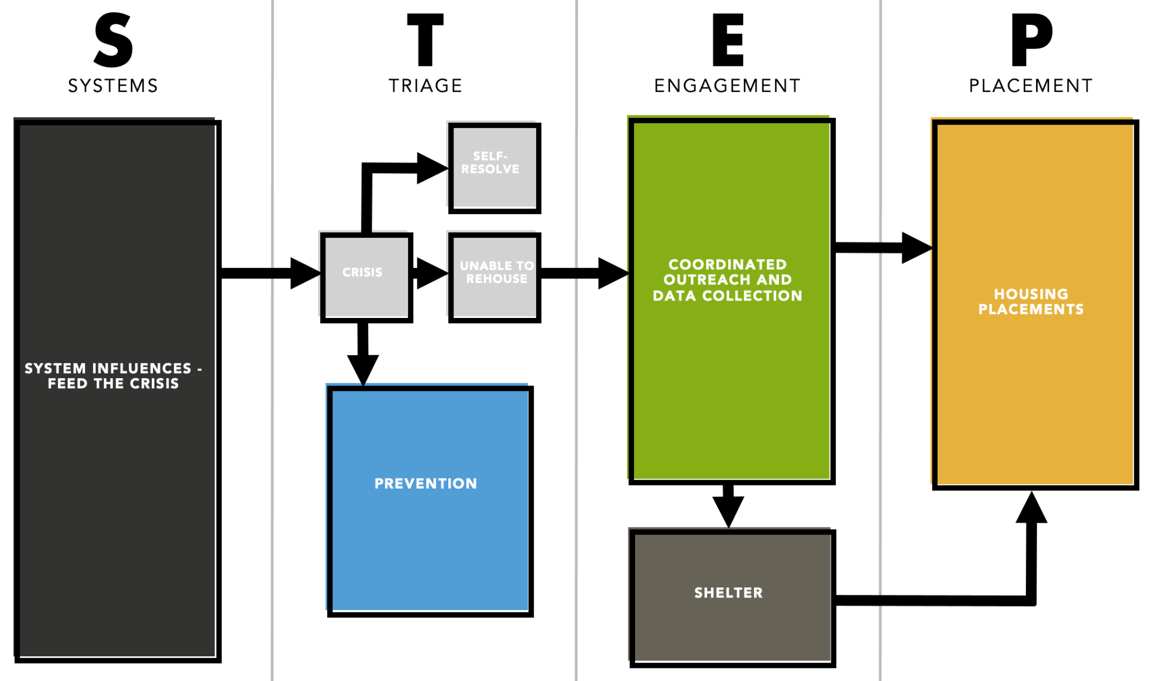

To begin to put the Plan in motion, Year 1 will be focused on:

- Establishing the baseline level of need in our community, so we can effectively evaluate the impact of our investments at the end of Year 3.
- Developing a clear accounting of the financial resources available for addressing homelessness in Petaluma.
- Beginning to redirect financial investments to build the programs and systems envisioned in our Pathway to Housing

Baseline Level of Need

Across the country, there are two primary strategies communities use to determine the level of need among people experiencing homelessness.

The first strategy is called the “Homeless Point-in-Time Count” (PIT).

In order to receive federal funding, every two years the United States Department of Housing and Urban Development (HUD) requires communities to conduct a census of every person experiencing homelessness at a given moment in time. This count includes people sleeping on the street, in vehicles, in encampments, as well as in emergency shelters and transitional housing programs.

The count is usually done in January because it is thought that emergency shelter utilization rates are the highest during the winter, thus making it easier to find people. HUD also requires follow up surveying to gather demographic information.
Sonoma County’s PIT is coordinated by the County, and recent results can be found here (Sonoma County has opted to do the PIT annually). As of January 2022, there were 2,893 people experiencing homelessness on a given day in Sonoma County, 293 of whom were in Petaluma.
The second strategy for determining the level of need in a given community is to create what is referred to as a “By-Name-List” (BNL).
At the risk of oversimplification, the modern homelessness crisis is really two different problems. For most people, homelessness is a relatively rare and brief occurrence that is often precipitated by an economic or relational crisis (e.g., a job loss, a rent increase, a healthcare crisis, divorce, domestic violence). By comparison, for a small but often visible minority (generally 10-30% of the homeless community at any given time), homelessness is a long-term challenge lasting many years, and it is often accompanied by disabling conditions, such as mental illness, addiction, chronic health issues, a traumatic brain injury, or often many of these issues at the same time. The technical term for this type of homelessness is “chronic homelessness.” The BNL is a particularly helpful strategy for coordinating care for this group.
Since June of 2021, a team of local partners, including the City, Downtown Streets Team, COTS, and Petaluma People Services has been meeting on a weekly basis to identify, by-name, the most visible and vulnerable people experiencing long-term homelessness in Petaluma. Importantly, these are often the folks who reside in encampments or are otherwise very evident to the community.
Our Plan aims to end chronic homelessness by the end of Year 3, and as of October 1, 2022, there were 123 individuals on Petaluma's BNL.

New Strategic Investments
Beyond these numbers, the analysis that went into creating our Plan revealed a number of qualitative issues within the existing system of care, including:
- An historic inability to house the most vulnerable people experiencing chronic homelessness
- A lack of housing and landlord leads overall
- A lack of accessible shelter for people experiencing chronic homelessness
- A relatively low exit rate from emergency shelter to permanent housing
- At times overlapping and conflicting street outreach efforts
Fortunately, efforts are already underway to rectify these issues.
For example, in the spring of this year, COTS opened the “Petaluma People’s Village.” This 25-unit, non-congregate shelter (i.e., residents will have their units compared to a communal space with bunk beds) is specifically designed and tailored to the unique needs of people experiencing chronic homelessness. The program was funded in partnership between the City and the County, and since launching, it has remained 100% fully utilized, and 4 people have graduated on to permanent housing.
Additionally, and again thanks to financial collaboration with the County, at the beginning of this year, the City and Burbank Housing received $15.3M in State Project Homekey funding to acquire and redevelop 5135 Montero Way, which will be renamed “The Studios at Montero.” When this program opens in the spring of 2023, we will have 60 more permanent supportive housing units in our community, which are the data-driven solution to chronic homelessness.

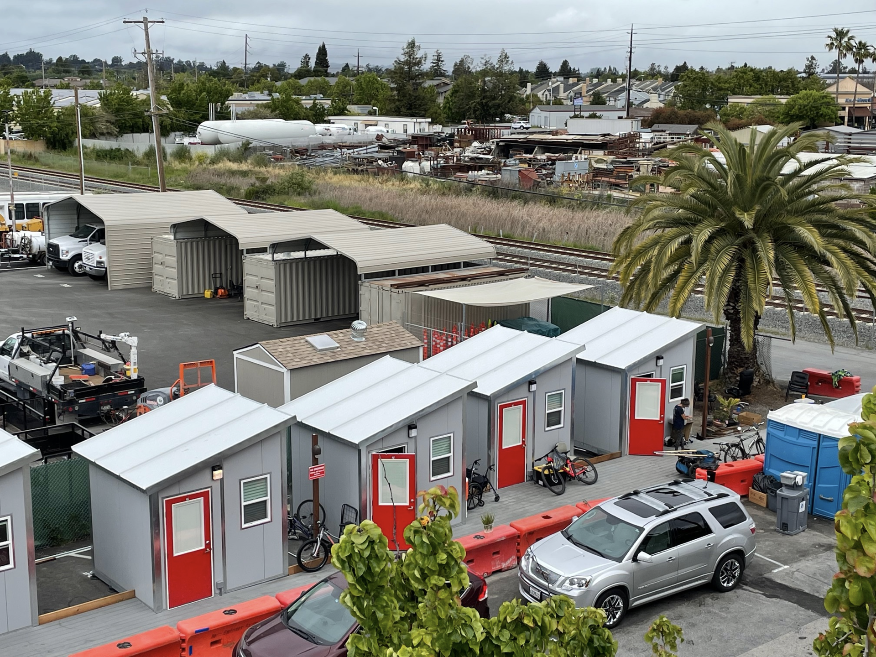
Photo Courtesy of COTS
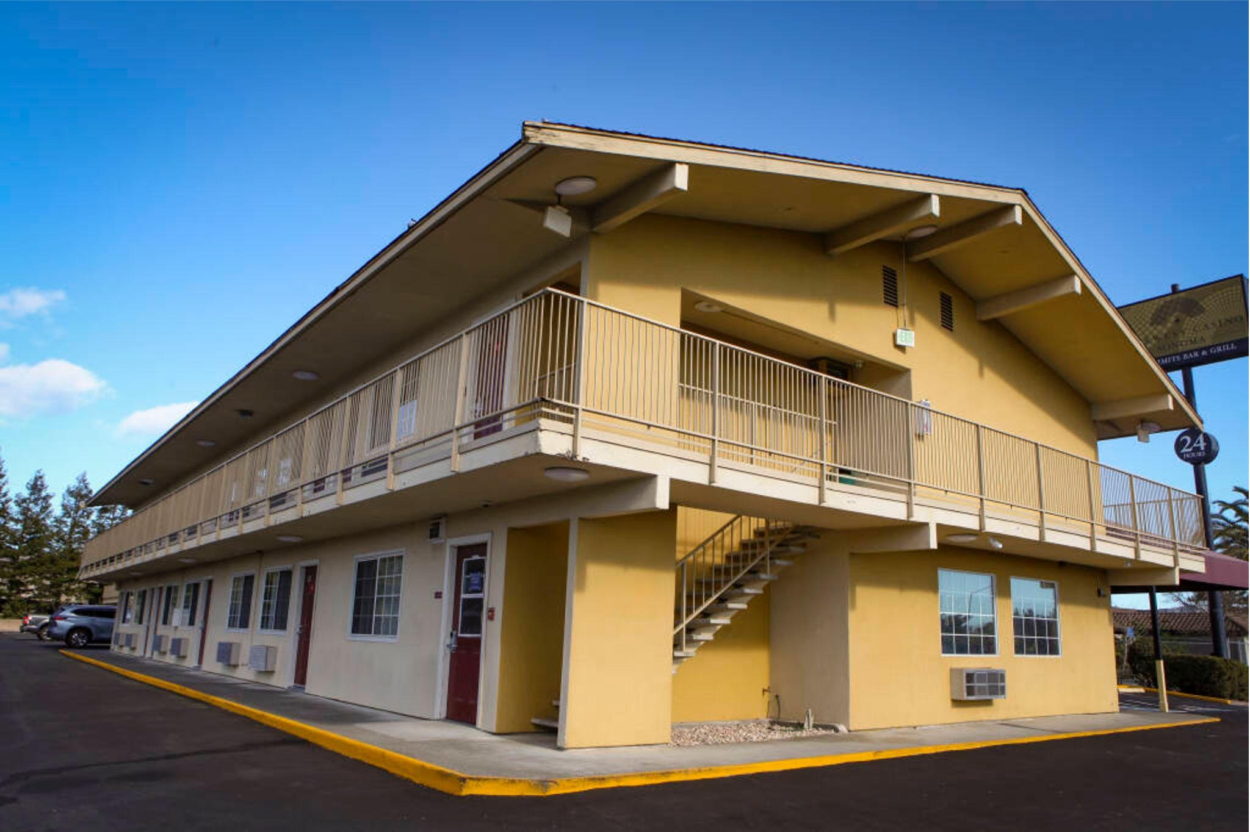
Photo Courtesy of the Petaluma Argus Courier
Building on this momentum, on Monday October 17th, the City released a Request for Proposals (RFP) for two new service initiatives in our community.
First, while the City will continue to invest in new housing and redevelopment efforts, one of the most expedient strategies for getting people rehoused is simply finding and securing rental opportunities with local landlords. These opportunities can then be paired with one-time financial assistance, housing vouchers, or even service provider-managed master leases.
With the upcoming RFP, the City of Petaluma is seeking to create a dedicated landlord recruitment provider to accelerate the rate of community-based housing placements.

Second, the City is planning to overhaul current street outreach efforts.

Street-based outreach is one of the most important “front doors” to a homeless system of care. It is a combination of client engagement outside the traditional office setting, networking to identify clients, and meeting clients where they are, on their own terms, to connect them with services. The goal is to build supportive, genuine, and action-based relationships that are ultimately oriented around getting a person rehoused.

To increase both the capacity and effectiveness of local outreach, the City is seeking to fund two outreach teams of two staff members per team. Each staff member will be required to maintain a caseload of up to 25 clients (up to 50 clients per team), and one team will be fully dedicated to encampments.

Having a caseload is critical. This means there will be individual providers accountable for building relationships, getting clients ready for services, and ultimately helping the most vulnerable, chronically homeless people in our community finally get the help they need to come back inside.

Coming Up
Many communities check the box on creating strategic plans, and then those plans simply sit on the shelf. That will not be the case in Petaluma. We spent twelve months gathering feedback from local providers, the public, and people with lived experience of homelessness. We know where we need to go, and the City will not delay in building the system of care our most vulnerable residents so desperately need.
Importantly, as the City is making these investments, we want to ensure they are having the intended impact. Over the next quarter we will be developing a community dashboard to track our progress. A few of the data points will include placements in long-term housing and rates of shelter. More information and details coming next time.

Helpful Resources
Get Help If You’re Currently or At-Risk of Homelessness
People’s Village Overview
Studios at Montero Overview
City’s Homelessness Webpage

