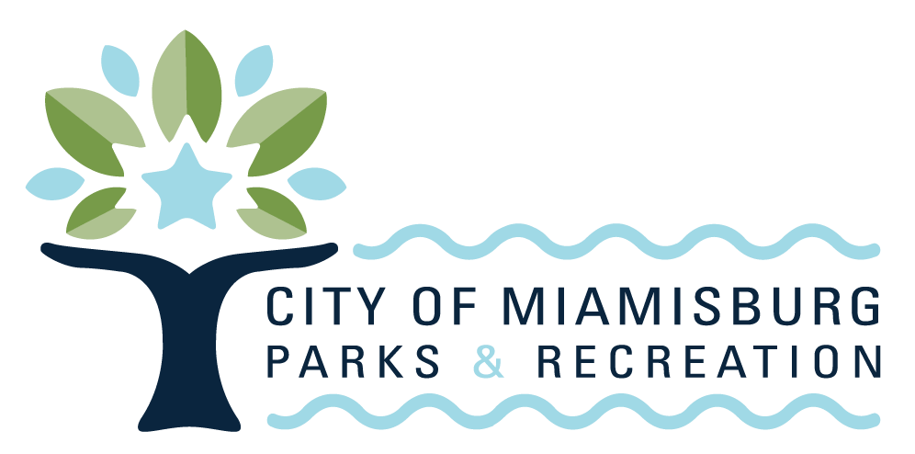
----------------------------------------------------
REFUND POLICY

General Refund Information
If the original payment method was credit or debit card, a refund will be issued to the card used for payment. If the original payment method was cash or check, a refund will be issued via a City check. Be aware, these checks may take up to three (3) weeks to process. No cash refunds will be granted for any circumstance.

Program Refund Policy
For a full refund, requests for refunds must be made 7 days prior to the start of the program or session. No refunds will be given after this date. Special consideration may be given for life-altering situations*.

Admissions and Greens Fees Refund Policy
No refunds for daily admissions or green fees will be granted for any circumstance including inclement weather, inappropriate attire, or rule infractions/disorderly conduct.

Pass Refund Policy
All passes are non-transferable and non-refundable from the time of purchase*.
Rental Refund Policy
Buildings/Rooms/Aquatic Facility
For a full refund, requests for cancelation must be made 7 days prior to the rental. Cancelation after this date, but prior to the rental date will result in refund of rental fees but a loss of deposits paid. Refund of deposit and rental fees requested after the reservation date will not be given*.
*Exceptions to policy may be made in cases of hardship with Manager’s discretion. Please contact the Miamisburg Parks & Recreation office to discuss these circumstances.

