

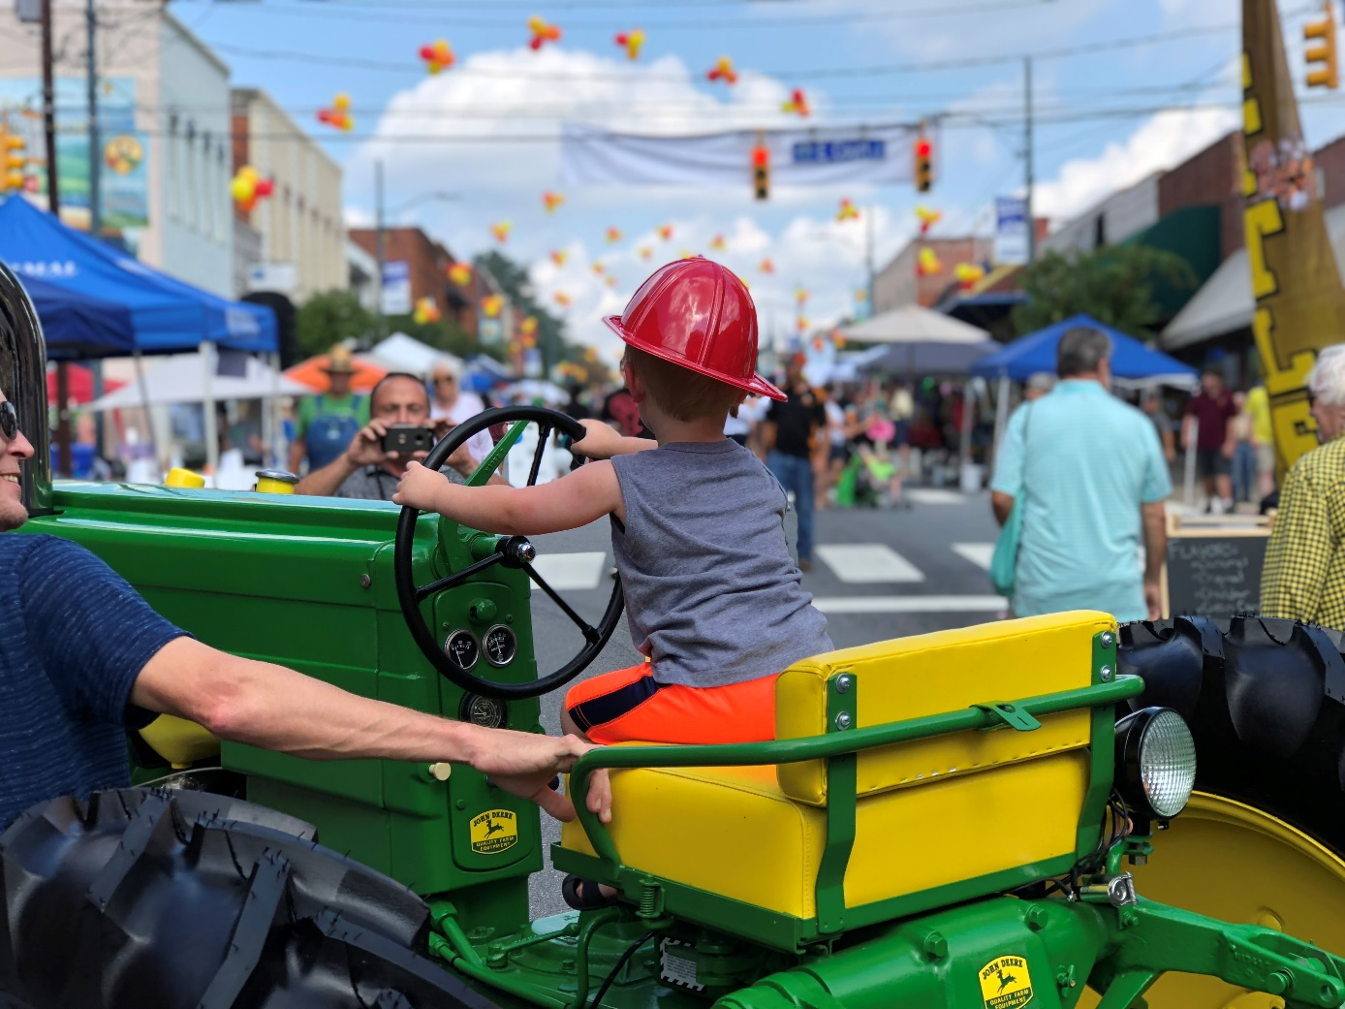

**Action Plan**

**2019**

The Town Council of the Town of Rutherfordton pledge to create an environment in which the Town will flourish around the concept of its mission statement and core values. The Town Council acknowledges its role in Vision and Action Planning for the future of the Town and pledges that this document will be a living, changing, and evolving document to help guide the Town’s path to the future.

**Mayor**

Jimmy Dancy

**Councilmembers**

Christy Bare

Henry Giles

Stan Clements

Terry Cobb

**Town Manager**

Doug Barrick

**Approved by the Rutherfordton Town Council on February 6, 2019**



**Executive Summary**

In January of 2019 the Town of Rutherfordton Town Council met to formulate a set of goals to guide the Town towards the future. The Town Council evaluated past major accomplishments, issues, organizational effectiveness, priorities, and opportunities for success as we strive for the future. These items were then used to set specific action points, goals, and programs to guide the Town over the next several years. The specific responses of each category discussed are included in this Action Plan.

This Plan will be used to establish the Town’s priorities as it undertakes new ideas or amends existing programs. It is a proactive statement of where the Town wants to be in the future. The Action Plan identifies key initiatives with corresponding goals to direct the Town’s actions to help achieve its overarching mission while remaining in line with its values. The Town Council has committed to an annual review of this plan to measure progress and to update the plan to best suit the ever evolving needs of the community.

**Components of the Plan**

**Mission Statement**

The Town of Rutherfordton Mission Statement describes how the community will reach its full potential and drives the action planning process. The Mission articulates and reflects the high ideals of the Town as it looks to the future.

**Mission Statement**

**“We are a Safe, Caring, Beautiful & Vibrant Town. Businesses Thrive & Involved Citizens Take Pride in our Community”**

**Core Values**

The Core Values of the Town describe the key attributes that are the most important to the Town Council and the Community.

* Excellent and Cost-effective services including police, fire, and public works.
* Long term financial stability
* Planned growth and economic development
* Leisure and culture activities
* Environmentally sensible practices
* Citizen Involvement

**Action Plan Outline**

The Action Plan identifies and defines key initiatives and includes corresponding goals and sub goals to direct future actions by the Town to achieve the vision of the plan and the overarching Town mission and values. The plan is broken down into five key areas:

* **Housing & Residential Development**
* **Excellent Customer Service**
* **Development of Commercial Corridors**
* **Business Development**
* **Outdoor Recreation**

Each of these key areas includes goals to help give shape to each topic. The goals are the specific desires of the Town Council over the next several years. The goals are seen as comprehensive and give shape and substance to each key area of the plan.

**Housing & Residential Development**

Quality housing is a foundational aspect of a healthy community and the Town seeks to ensure access to housing for all citizens. This key area reinforces the Towns desires to provide a welcoming environment for citizens, builders, and industry.

**Develop Ways to Encourage Infill Development**

* Look for properties that can be repurposed or used for housing and create an inventory of properties
* Ensure that Tax foreclosures sales are occurring and work with new owners to improve housing conditions
* Remove abandoned structures and sell condemned properties with the goal of creating new housing options.

**Sidewalk Development**

* Ensure that existing Sidewalk inventory is useable and well maintained
* Look for ways to improve connectivity to provide access to residential areas
* Seek ways to increase the inventory of sidewalks, while focusing on the walkability & connectivity of the Town

**Healthy Living Community**

* Seek ways to encourage safe & useable pedestrian alternatives
* Promote access to healthy food options
* Focus on community policing & remaining a safe place to raise a family
* Support access to Healthcare and programs to increase awareness of healthy living
* Add recreational opportunities to promote healthy lifestyles

**Excellent Customer Service**

This key area describes the Town’s desire to be the Gold Standard in service. It also seeks to maintain effective operational standards that will equate to effective delivery of services. This area also seeks to assure that the appropriate services are provided in a manner that reflect both the needs of the community and the ability of the Town to provide them.

**Gold Standards**

* Increase civic engagement in Town planning & operations
* Ensure the Town is setting the standard for local government services in the region
* Provide superior Public Safety services that aim to exceed national standards.
* Keep open lines of communication and teamwork between departments

**Provide Excellent Core Services**

* Ensure that core service of Recycling, Community Policing, Fire, Library, Public Works, Administration & Sewer Operations are cost effective and operate efficiently
* Provide for Financial stability through strong fiscal management.
* Ensure that Town priorities are aligned in annual budgets

**Development of Commercial Corridors**

In order to ensure that the Town growth is not bypassed along with the Construction of the new 221, this goal looks to ensure ways to have planned growth and development around the new road and to link the Town with new corridors to the roadway.

**Guide Development along new Entrances**

* Look at existing conditions of the corridors leading to the bypass and seek ways to ensure the highest & best use of those corridors in the future
* Look for ways to restructure and redevelop high traffic intersections and evaluate road diets in areas that the bypass alleviates traffic.
* Seek overlay districts to encourage smart growth, housing options and mixed use spaces.

**Ensure Availability of Infrastructure and Development Potential**

* Ensure the needed infrastructure is available to areas the bypass will open access to
* Seek to ensure the proper land us controls are in place to steer develop that benefits the overall health of the Town.
* Ensure sidewalks, street trees, signage and other aesthetic features are included in the improvements made by the Town and NCDOT.

**Business Development**

This key area includes the retention of existing businesses, attracting new businesses, and encouraging the creation of quality jobs for the community. In doing so the Town must also strive to foster, support and retain a diverse economic base, to continue long term financial stability and planned growth.

**Foster a Thriving Downtown**

* Create and implement business recruitment and entrepreneurship training program, that includes mentorship and fosters business relationships
* Launch a support local campaign
* Share information on multiple platforms about businesses, successes and opportunities for growth in the Town.
* Continue to support all business and look to expand ways to sustain the historic district through grants and programs aimed at preservation and restoration.

**Master Planned Growth Areas**

* Look for ways to redevelop and support developments along the Purple Martin corridor
* Work with Land Owners and Duke Energy to find ways to maximize the use of the Laurel Hill Drive Area
* Create an inventory of available spaces for businesses to thrive

**Outdoor Recreation**

Vibrant parks and engaging programs play an important part in the overall health of our community. This key area defines the need to provide recreational and culture activities to meet the needs of all our citizens and to ensure that existing projects are fully implemented. It also indicates an approach to stewardship of the environment and history of the Town to ensure the proper protection and development of these assets for the future.

**Develop Parks**

* Ensure the Master Plan for Kiwanis Park is constructed
* Work to phase in the Parks & Recreation Master Plan
* Ensure that all parks facilities are top notch venues that promote a draw to the Town and improve the quality of life for our residents.

**Improve the walkability of the Town**

* Implement the pedestrian master plan for the Town
* Ensure proper sidewalk, trail and greenway connectivity
* Look for ways to improve the sidewalk inventory and ensure the proper maintenance of the existing inventory.

**Expand greenways**

* Implement the master plan for greenways within the Town
* Promote and facilitate corridor redevelopment to support businesses along the trail system.
* Ensure the connectivity of Crestview Park to Kiwanis Park with the Greenway Trail
* Seek partnerships and grants to implement the construction of the trails plan

**Explore ways to use the Golf Course property**

* Seek a PGA or Golf Course professional to fully evaluate and outline recommendations for the cost of reopening the course. To include the needed capital items and ongoing operational expenses.
* Should the course not be reopened as a functioning golf course, the Town will seek citizen and stakeholder input to master plan the property.

**Other Recreational Opportunities**

* Look for new venues for the Town to increase recreational opportunities including options for future staff positions.

**Implementation**

Plan implementation will be dependent both on the Town Staff and the Town Council to take action on the recommendations contained in this report. Staff has the responsibility to take on these goals as a part of the operations of the Town and the Town Council must reinforce the desire and need for these actions to occur. The Staff and Town Council must also be willing to update and review progress on these action points throughout the year along with a holistic annual review prior to the beginning of the budgeting process to ensure alignment of priorities and funding.