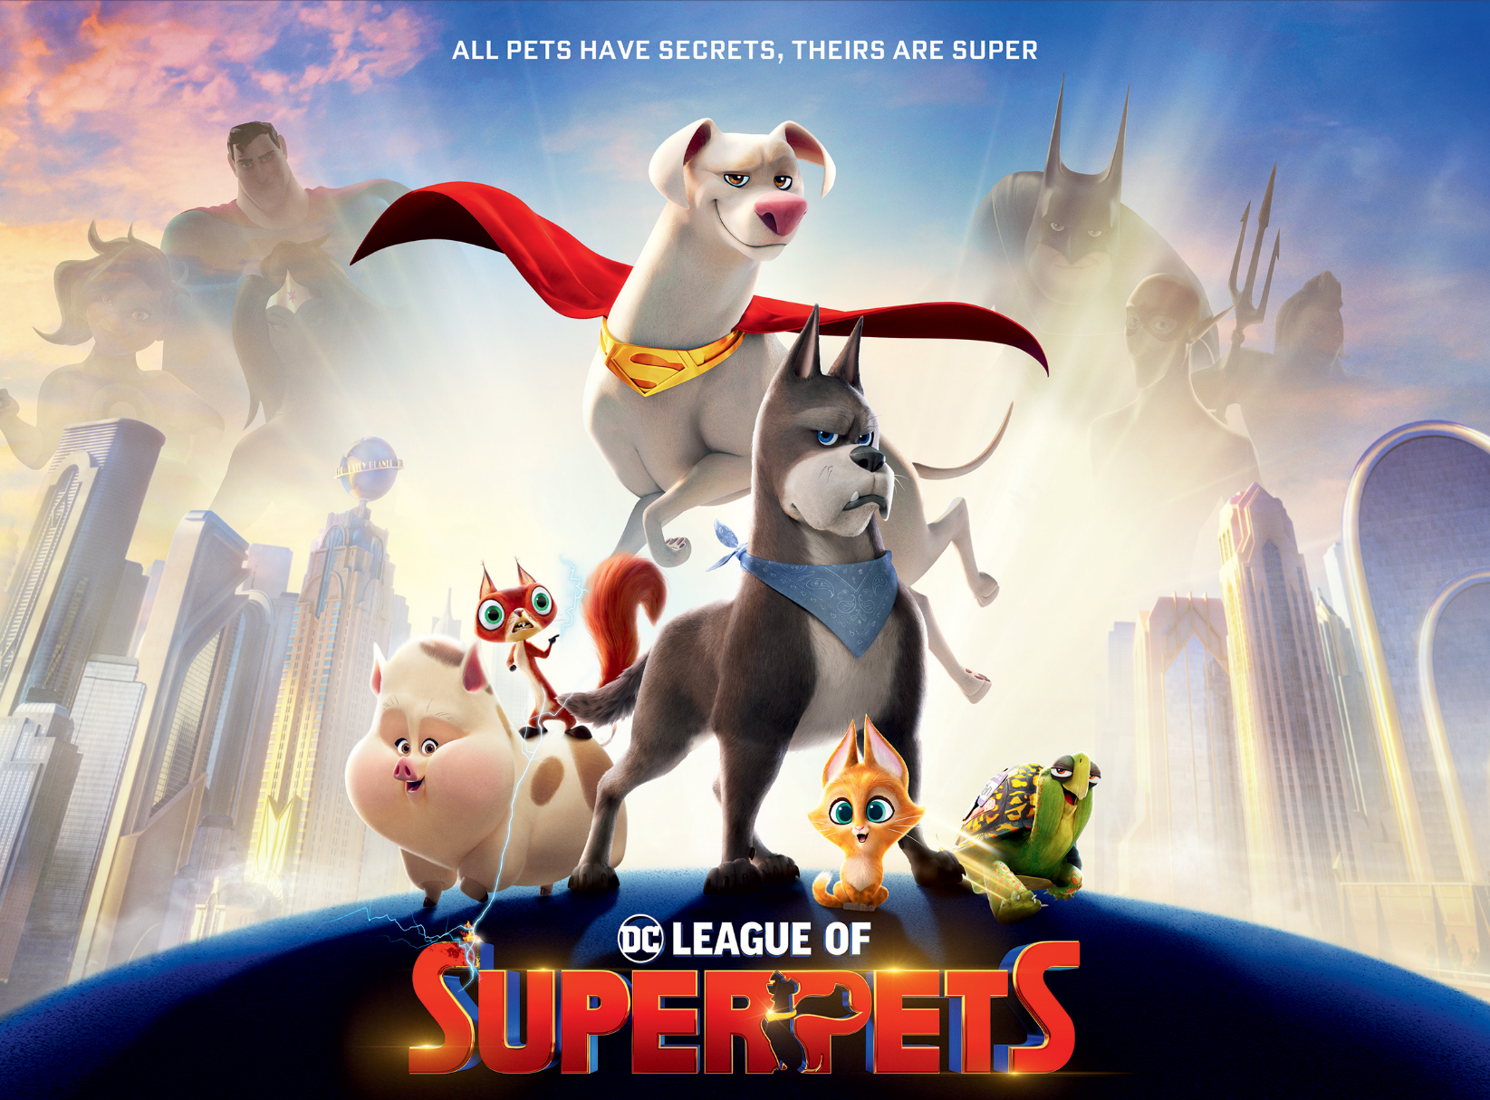
RYE BROOK’S
AUGUST MOVIE NIGHT
FEATURING: DC LEAGUE OF SUPERPETS
DATE: FRIDAY, AUGUST 11TH @ 8:15PM
WHERE: PINERIDGE PARK
***FREE ICE CREAM WILL BE SERVED 7:00-8:00 PM BEFORE THE MOVIE
ICE CREAM FRIDAY SPONSORED BY THE RYE BROOK PBA***
BRING YOUR BLANKET & CHAIRS TO WATCH THE MOVIE UNDER THE STARS
REFRESHMENTS WILL BE SOLD AT CONCESSION

