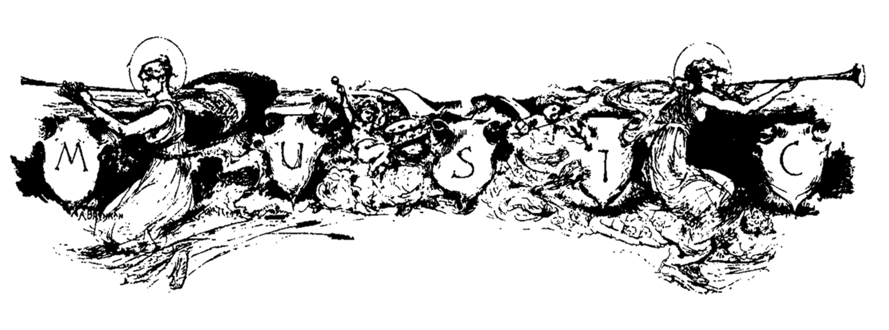***Sackets Harbor Historical Society***

***2022 CONCERTS on the WATERFRONT***

**Our 38th Season - “Let’s Celebrate”**

**Sundays 3:00 – 5:00 at the Sackets Harbor Battlefield**

**June 26        Sacci Band  (Big Band)**

**July 3           Tink Bennett & Taylor Made*  (Country)**

**July 10         Alex Torres & His Latin Orchestra (Latin)**

**July 17         Atlas   (80’s party)**

**July 24         Dakotas*  (Alternative Bluegrass)**

**July 31          Son BoriKua  (Caribbean)**

**August 7      Oceans Below (Favorites)**

**August 14    Ruby Shooz*  (50 – 60’s)**

**August 21    *10th Mountain Division Army Band***

**August 28    Hot Jazz Jumpers*  (Jazz)**

**Sept. 4          Maria DeSantis Orchestra  (Big Band)**

**Our concerts are free and open to the public.  Bring a chair or blanket.**

**Rain site: St. Andrew Parish Center (corner of East Main & Woolsey Streets)**

**Sponsored by**



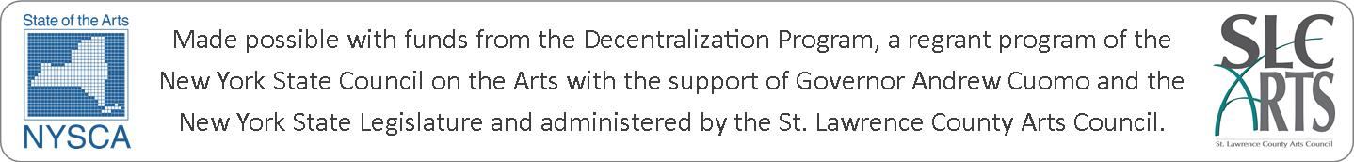

Additional funding is received from the Village of Sackets Harbor, the Town of Hounsfield's Committee for the Advancement of Tourism, contributions from area businesses, residents, and organizations, and a "Pass the Hat" at the concerts.

**Website:** [**www.sacketsharborhistoricalsociety.org**](http://www.sacketsharborhistoricalsociety.org)**,** [**shhistoricalsociety@gmail.com**](mailto:shhistoricalsociety@gmail.com)**, Call: (315) 778-0156**