This Standard has been developed pursuant to the 2016 California Fire Code, the 2015 International Fire Code and Appendix B of the 2015 Edition of the International Wildland Urban Interface Code, all as adopted by local ordinance by the City of San Rafael and Section 4290 and 4291 of the Public Resources Code. Fuel modification distances, type of vegetation and topographic features are factors in determining adequate green belts and fire fuel modification around structures. This methodology is implemented for the primary purpose of providing time for fire suppression personnel and equipment to respond and establish effective operational tactics and strategies during an ensuing wildland fire.

This standard applies to all new homes and structures, and subdivisions that are within the Wildland-Urban Interface as defined by the San Rafael Fire Department.

Included here are requirements for submitting a vegetation management plan (VMP), and a fire-hazard-assessment matrix that defines the recommended extent of defensible space based on site features including aspect, slope, and vegetation type. Guidelines for treating vegetation within the recommended defensible space are also provided.

This standard will determine the minimum required defensible space without reference to property lines. If the minimum required defensible space crosses property lines, the property owner will be required to obtain a “defensible space easement” from the adjoining property owner. If this cannot be obtained, the proposed structure may be required to be re-sited. For existing structures, additional fire protection measures may be required to mitigate a reduction in the required defensible space.

I. General

- The Vegetation Management Plan referred to hereinafter as the VMP shall be submitted to the Fire Marshal for review prior to implementation. The VMP shall be submitted in two forms, line drawings and text format describing specific and applicable contributing factors in the selection and design of the plan.

II. VMP Content

A. The VMP shall include at the minimum:

- The entire “plan content” elements described in narrative form. A text narrative describing specific and applicable contributing factors in the selection and design of the plan and scope of work.

- Vegetation management and defensible space agreement to perform annual maintenance. An Annual Maintenance Plan to include a statement agreeing to “maintain annually”, the required defensible space and vegetation annually.

- Not less than three (3) complete graphic plan sets should be submitted to the San Rafael Building Department for review. The plan sets are required to show the structure(s) and its defensible space zone, the location and configuration of existing plants/shrubs/trees, delineate those planned to be removed and/or modified, and the location, name and configuration of vegetation to be planted.

- The Hazard Assessment Matrix

- The list of plants to be used and/or retained.

- Irrigation Graphic Plan. The irrigation system and its related components shall be planned and designed to allow for proper installation, management, and maintenance.

- San Rafael Fire Department permit application with permit fee deposit.

**Landscape plans will be rejected unless they include a specific outline of the information required by this standard**

III. Determining Risk

- Using the Hazard Assessment Matrix in the back of this standard, determine the hazard points of the specific property.

- Aspect. This is the direction in which the face of the slope is situated.

- Slope. This is the degree of angle on the site that the structure is to be placed.

- Fuel. Zone A - Identify from the fuel type list on the hazard assessment matrix what vegetation is mostly represented in the 0 to 30 ft. zone from the proposed structure.

- Fuel. Zone B - Identify the fuel type list on the hazard assessment matrix what vegetation type is most represented in the 31 to 100 ft. zone from the proposed structure.

- Fuel. Zone C - Identify the fuel type list on the hazard assessment matrix what vegetation type is most represented from the outermost edge of Zone B up to 200 feet from structure or to property line.

- Total the hazard assessment points for each category. This will provide a set of distances that clearance is required around the proposed structure.

IV. Plant List and Selection within the Zone

- The entire defensible space zone (see Figure II) shall be planted (if applicable) and irrigated if necessary.

- By using the FireScape Plant selection list on the University of California Cooperative Extension Pyrophytic vs. Fire Resistant Plants brochure or attached list (Table 2) of Fire Resistant Plant List as determined by the Fire Marshal, select use of native, domestic or combination thereof that best suits the architectural and planning design of the proposed project. Slope, soil type, drought resistance should be considered when selecting plant types. Also, see the attached list (Table 1) of Fire Prone prohibited plants. Note that these lists are not all-inclusive and some proposed plants may be deleted from your project.

- Zone A - Landscaping and vegetation in this zone shall consist primarily of green lawns, ground covers not exceeding 6 inches in height, and adequately spaced shrubs. Irrigation by automatic or manual systems shall be provided to landscaping to maintain healthy vegetation and fire resistance. The overall characteristics of the landscape shall provide adequate defensible space in a fire environment. Plants in Zone A shall be inherently highly fire resistant and spaced appropriately.

- Fuel. Zone B - Irrigation by automatic or manual systems shall be provided to landscaping to maintain healthy vegetation and fire resistance. Landscaping and vegetation in this zone shall typically consist primarily of green lawns, ground covers, and adequately spaced shrubs and trees. Unless otherwise approved, Ground covers shall be maintained at a height not to exceed 6 inches in Zone A and B. If on a slope 12 inches is acceptable in Zone B within 50 feet of a structure and 18 inches beyond 50 feet. The overall characteristics of the landscape shall provide adequate defensible space in a fire environment. Specimen native plants may be approved to remain if properly maintained for adequate defensible space. Plants in Zone B shall typically be fire resistant and spaced appropriately.

- Fuel. Zone C - Required thinning and clearance will be determined upon inspection. Required clearance may increase to the maximum allowed by the Fire Code as needed because of vegetation growth. Irrigation systems are not required for this zone if it consists entirely of native plants. (Native plants are generally not compatible with regular, un-seasonal supplemental water.) Vegetation in this zone may consist of modified existing native plants, adequately spaced ornamental shrubs and trees, or both. In all cases the overall characteristics of the landscape shall provide adequate defensible space in a fire environment. Plants in Zone C shall be spaced appropriately. Existing native vegetation shall be modified by thinning and removal of those species constituting a fire risk.

Please Note: Chipped wood and mulch can provide an excellent thermal barrier, which will help prevent, lost moisture in ground fuels. However, shredded bark, sometimes referred to as “monkey hair” is prohibited from use because its ease of ignition and fire spread characteristics.

V. Plant Spacing and Crown Separation

- Regardless of plant selection, shrubs should be spaced so that no continuity exists between the ground fuels and tree crowns, such that a ground fire will not extend into the tree canopy.

- Trees should be planted such that when mature, their crowns will be separated by at least 10 feet. Add an additional five feet for every ten (10%) percent increases in slope. Existing trees may be required to be thinned and/or removed depending on their configuration and distance from the structure(s).

- Separate individual shrub crowns by at least two times the height or clump shrubs into islands of no greater than 18-ft. diameter. Separate the islands by a distance of no less than two times the canopy height.

VI. Adjacent to Roadways and Driveways:

A. Trim and maintain vegetation within 10 feet of roadways as for defensible space.

B. Trim trees so they do not hang lower than 15-ft. above the roadway.

Figure I

HAZARD ASSESSMENT MATRIX
Hazard  Points | 1 | 2 | 3 | 4 | 5 | 6 | 7 | 8 | Points
Aspect | NE, E | NW, N | SE, W | S | SW
Slope |  | 0-10 |  | 11-20 |  | 21-30 |  | 31+
Fuel  0-30 | Specimen  Garden | Hardwood | Grass | Mostly  Grass | Mostly  Brush | Pyrophoric  Hardwoods  Chaparral | Conifer | Conifer  w/brush  under story
Fuel  31-100 | Grass, Mostly  Grass | Mostly Brush |  | Pyrophoric  Hardwoods  Chaparral | Conifer  with brush  under story
Total Hazard Points _________

Minimum Horizontal Modification Requirement in feet ______________

Hazard Points:

1 2 3 4 5 6 7 8 9 10 11 12 13 14 15 16 17 18 19 20 21 22 23 24 25 >
30x30x30 ft. 30x30x50 ft 50x50x100 ft.

V. Fuel Types:

- Specimen Garden: a well-maintained ornamental garden, usually irrigated. Trees and shrubs are well spaced or clustered, thinned and free of deadwood. The lawn is mowed and clean. No pyrophytic plants within 15 ft. of house.
- Hardwood (Model 9): Broadleaf (non-pyrophytic) trees such as oaks, maples, ash, etc.
- Grass (Model 1): Wild field grass dominates; trees and shrubs occupy less than 1/3 of the area.
- Mostly Grass (Model 2): Brush and tree reproduction occupy more than 1/3 and less than 2/3 of the area.
- Mostly Brush (Model 5): Brush and tree reproduction occupies 2/3 of the area. Includes young chaparral, coastal scrub and broom stands.
- Pyrophytic Hardwoods (Model 12): Broadleaf trees that is high in volatile oils, which produce heavy debris and burn intensely. May have some conifers mixed in but the flammable hardwoods dominate the fire behavior.
- Chaparral (Model 4): Six foot and taller old, pyrophytic brush with excessive deadwood. Includes mixed chaparral of Manzanita, scrub oak, chaparral pea, tall ceanothus, chamise, etc. Often has some young Douglas fir or pines.
- Conifer (Model 8): Needleleaf trees typically with heavy litter, low branches and plentiful deadwood. Often mixed with some hardwoods or even pyrophytic hardwoods, but conifers dominated and carry the fire.
- Conifer with Brush Understory (Model 10): Pine and Douglas Fir with heavy brush and down & dead branches and suppressed trees in the understory.

VI. Slope Influence on Minimum Defensible Space Clearances

Increasing slopes require increased defensible space clearances to be equally effective. For example, to be equally effective upslope, cross slope, and down slope clearances, around each structure must be increased as percentage of slope increases when compared to level terrain.

Rate of spread, flame length, convective and radiant heat increase in relation to fuel type, aspect, and percentage of slope factors. Increased defensible space zone radiuses in relation to slope are required around structures through fuel modification and reduction.

Note increased upslope and cross slope defensible space clearance requirements related to increase in slope. Minimum recommended cross slope and upslope increases are shown. Specific terrain may require adjustment:

Figure II

Defensible Space Zones

Minimum Minimum
30’X30’X30’X30’ 30’X30’X30’X50’ 50’X50’X50’X100’
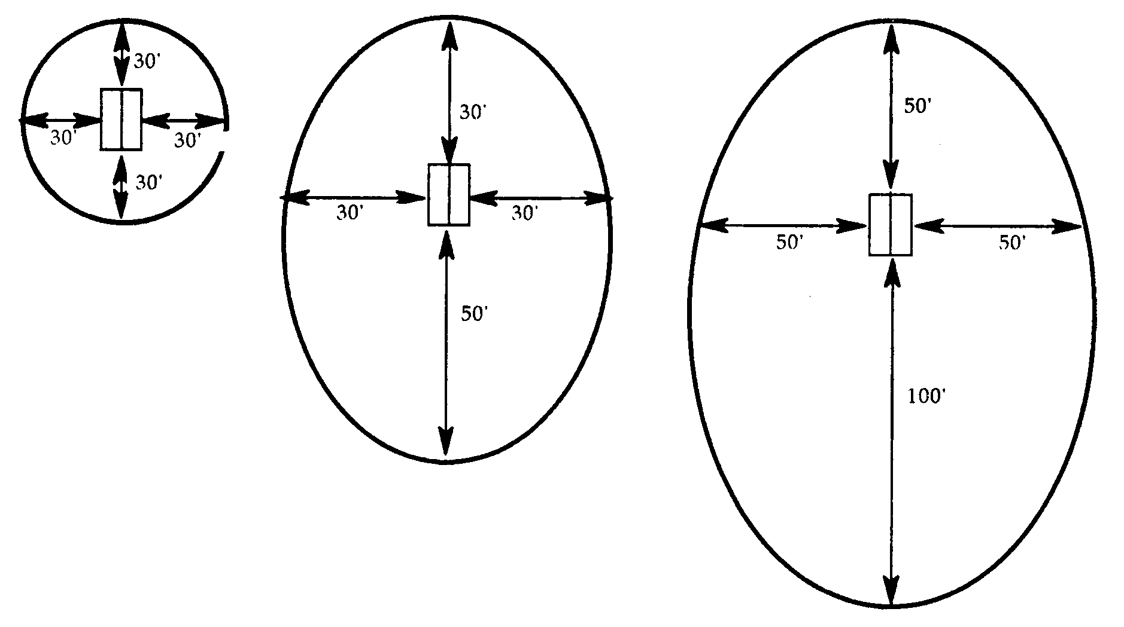 Level Moderate Slope Steep Slope Greater than
0-10% 11-30% 30%

Figure II

Vertical Clearance, Horizontal and Slope Spacing
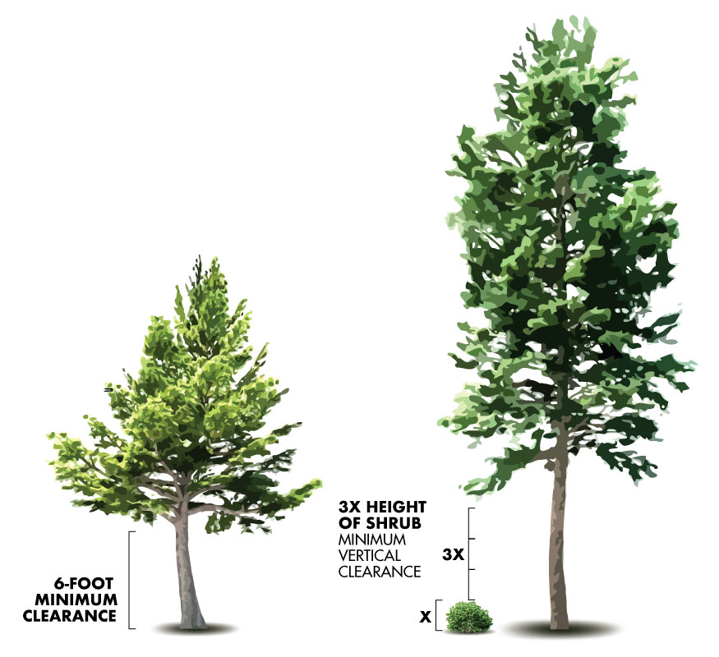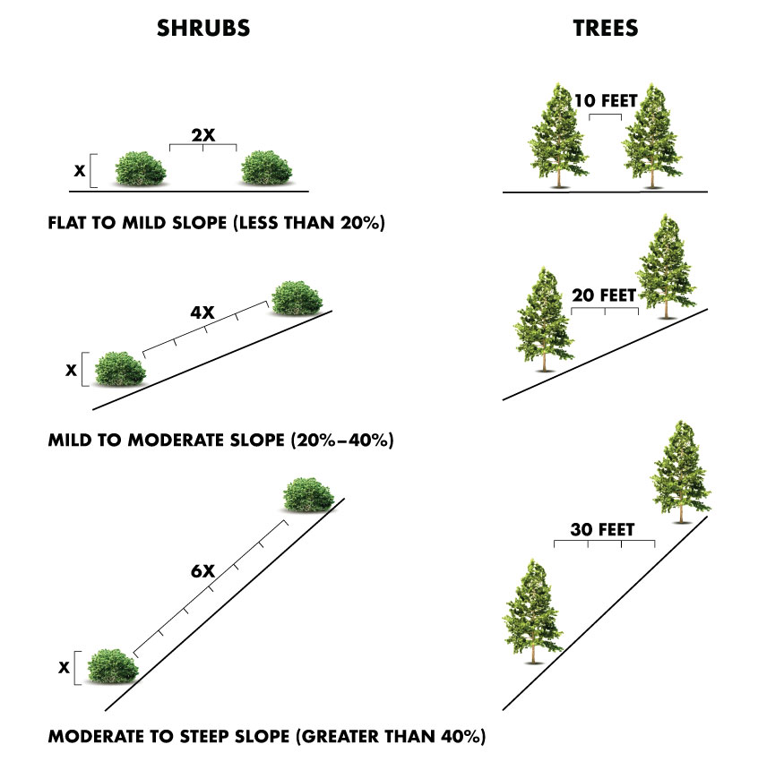
Table 1

Fire Prone Plants

This is a list of common native and non-native fire prone plant species in Marin County. Plants marked "Avoid" should not be planted, be removed if possible, and require greater maintenance and care if allowed to remain in the Defensible Space Zone.

 | Scientific Name | Common Name | Lifeform | Recommendation | Native
1 | Abies spp. | Firs | Tree | Remove
2 | Acacia spp. | Acacia species | Tree | Remove
3 | Adenostoma fasciculatum | Chamise, Greasewood | Shrub | Remove | X
4 | Arctostaphylos spp. | Manzanita (some twiggy) | Shrub | Remove
5 | Baccharis spp. | Coyote Brush | Shrub | Remove | X
6 | Bambusa spp. | Bamboo | Shrub, Grass | Remove
7 | Cortaderia jubata | Jubata Grass | Grass | Remove
8 | Cortaderia selloana | Pampas Grass | Grass | Remove
9 | Cupressus spp. | Cypress | Tree | Remove
10 | Cytisus scoparius | Scotch Broom | Shrub | Remove
11 | Eucalyptus spp. | Eucalyptus | Tree | Remove
12 | Genista monspessulana | French Broom | Shrub | Remove
13 | Juniperus spp. | Junipers | Tree, Shrub | Remove
14 | Notholithocarpus densiflorus | Tan Oak, Tanbark Oak | Tree | Remove | X
15 | Pennisetum spp. | Fountain Grass | Grass | Remove
16 | Picea spp. | Spruces | Tree | Remove
17 | Pinus attenuata | Knobcone Pine | Tree | Remove
18 | Pinus coulteri | Coulter Pine | Tree | Remove
19 | Pinus muricata | Bishop Pine | Tree | Remove | X
20 | Pinus radiata | Monterey Pine | Tree | Remove
21 | Pinus sabiniana | Gray Pine | Tree | Remove
22 | Pinus serotina | Pond Pine | Tree | Remove | X
 | Scientific Name | Common Name | Lifeform | Recommendation | Native
23 | Pinus sylvestris | Scots Pine | Tree | Remove
24 | Pinus torreyana | Torrey Pine | Tree | Remove
25 | Rosmarinus officinalis | Rosemary | Shrub | Remove
26 | Spartium junceum | Spanish Broom | Shrub | Remove
27 | Thuja spp. | Arborvitae | Tree | Remove
28 | Tsuga spp. | Hemlock | Tree | Remove
29 | Ulex europea | Gorse | Shrub | Remove
30 | Umbellularia californica | California Bay | Tree | Remove | X
31 | Artemisia californica | Coastal Sagebrush | Shrub | Avoid | X
32 | Cedrus spp. | Cedars | Tree | Avoid
33 | Chamaecyparis spp. | False Cypress | Tree | Avoid
34 | Chrysolepis chrysophylla | Chinquapin, Giant | Shrub, Tree | Avoid | X
35 | Erigonum fasciculatum | California Buckwheat | Shrub | Avoid
36 | Larix spp. | Larch | Tree | Avoid
37 | Palms | Palm (if dry fronds) | Tree | Avoid
38 | Pickeringia montana | Chaparral Pea | Shrub | Avoid | X
39 | Pseudotsuga menziesii | Douglas-Fir | Tree | Avoid | X
40 | Quercus spp. | Scrub Oak (brushy oaks) | Shrub | Avoid | X
41 | Salvia mellifera | Black Sage | Shrub | Avoid
42 | Taxus spp. | Yew | Tree, Shrub | Avoid
43 | Vaccinium ovatum | Evergreen Huckleberry | Shrub | Avoid | X

Table 2

Fire Resistant Plant List

This is a curated list of common native and non-native fire safe plant species suitable to the climate in Marin County. This list is not comprehensive - other suitable plants may be fire resistant. These are preferred species for landscaping around homes in the Wildland Urban Interface. These plants exhibit relatively more resistance to burning when exposed to fire. To ensure fire-resistance, all plants on this list must be maintained in a living state, irrigated properly, and must be kept free of dead or dry twigs and material at all times.

 | Scientific Name | Common Name | Lifeform | Recommendation | Native
1 | Acer spp. | Maple | Tree | Preferred
2 | Achillea millefolium | Yarrow | Perennial | Preferred | X
3 | Achillea tomentosa | Woolly Yarrow | Perennial, Cover | Preferred
4 | Aeonium spp. | Aeonium | Perennial | Preferred
5 | Agapanthus spp. | Lily-of-the-Nile | Perennial | Preferred
6 | Agave spp. | Agave | Perennial | Preferred
7 | Ajuga reptans | Carpet Bugle | Cover | Preferred
8 | Aloe spp. | Aloe | Perennial | Preferred
9 | Aquilegia formosa | Western Columbine | Perennial | Preferred | X
10 | Arbutus unedo | Strawberry Tree | Tree | Preferred
11 | Armeria maritima | Common Thrift | Cover | Preferred | X
12 | Asarum caudatum | Wild Ginger | Perennial | Preferred | X
13 | Berberis [Mahonia] aquifolium var. repens | Creeping Mahonia | Shrub | Preferred | X
14 | Bergenia spp. | Bergenia | Perennial | Preferred
15 | Brugmansia spp. | Angel's Trumpet | Shrub | Preferred
16 | Carpenteria californica | Bush Anemone | Shrub | Preferred
17 | Centaurea cineraria | Dusty Miller | Perennial | Preferred
18 | Cerastium tomentosum | Snow-in-Summer | Cover | Preferred
19 | Ceratonia siliqua | Carob | Tree | Preferred
20 | Cercis occidentalis | Western Redbud | Tree | Preferred | X
21 | Cercocarpus betuloides | Mountain Ironwood | Tree | Preferred | X
22 | Citrus species | Citrus | Tree | Preferred
23 | Clinopodium [Satureja] douglasii | Yerba Buena | Perennial | Preferred | X
 | Scientific Name | Common Name | Lifeform | Recommendation | Native
24 | Coleonema aka "Diosma" | Breath of Heaven | Shrub | Preferred
25 | Convulvus cneorum | Bush Morning Glory | Shrub | Preferred
26 | Coprosma kirkii | Creeping Coprosma | Cover | Preferred
27 | Coreopsis spp. | Coreopsis | Shrub | Preferred
28 | Cotyledon spp. | Cotyledon | Perennial | Preferred
29 | Crassula spp. | Crassula | Perennial | Preferred
30 | Delosperma "Alba" | White Trailing Iceplant | Cover | Preferred
31 | Dicentra formosa | Western Bleeding Heart | Perennial | Preferred | X
32 | Dietes bicolor | African Iris | Perennial | Preferred
33 | Dietes vegeta | Fortnight Lily | Perennial | Preferred
34 | Drosanthemum sp. | Rosea Ice Plant | Cover | Preferred
35 | Dudleya | Dudleya or Cliff Lettuce | Perennial | Preferred
36 | Echeveria spp. | Hen and Chicks | Perennial | Preferred
37 | Eounymus Fortunei coloratus | Winter Creeper | Cover | Preferred
38 | Erigeron glaucus | Beach Aster | Cover | Preferred | X
39 | Eriogonum spp. | Wild Buckwheat | Perennial | Preferred | X (some)
40 | Eriophyllum confertiforum | Golden Yarrow | Perennial | Preferred | X
41 | Eriophyllum stachaedifolium | Lizardtail | Perennial | Preferred | X
42 | Erysimum capitatum | Foothill Wallflower | Perennial | Preferred | X
43 | Erysimum linifolium | Wallflower | Perennial | Preferred
44 | Escallonia spp. | Escallonia | Shrub | Preferred
45 | Eschscholzia spp. | California Poppy | Perennial | Preferred | X
46 | Fagus spp. | Beech | Tree | Preferred
47 | Feijoa sellowiana | Pineapple Guava | Tree | Preferred
48 | Festuca rubra | Creeping Red Fescue | Grass, Cover | Preferred | X (some)
49 | Fragaria chiloensis | Beach Strawberry | Cover | Preferred | X
50 | Fragaria vesca | Wood Strawberry | Cover | Preferred | X
51 | Fraxinus spp. | Ash | Tree | Preferred | X (latifolia)
52 | Grindelia stricta, camporum | Coastal Wild Gum | Perennial | Preferred | X
53 | Hemerocallis hybrids | Daylily | Perennial | Preferred
54 | Hesperaloe parviflora | Red Yucca | Perennial | Preferred
55 | Heuchera maxima | Island Alum Root | Perennial | Preferred
 | Scientific Name | Common Name | Lifeform | Recommendation | Native
56 | Heuchera micrantha | Coral Bells | Perennial | Preferred | X
57 | Iris douglasiana | Douglas Iris | Perennial | Preferred | X
58 | Iris macrosiphon | Ground Iris | Perennial | Preferred | X
59 | Iris spp. | Iris | Perennial | Preferred
60 | Kniphofia uvaria | Red Hot Poker (Torch Lily) | Perennial | Preferred
61 | Lampranthus spp. | Bush Ice Plant | Cover | Preferred
62 | Lantana montevidensis | Lantana | Shrub | Preferred
63 | Lavandula spp. | Lavender | Shrub | Preferred
64 | Lavatera assurgentiflora | Malva Rose (Tree Mallow) | Shrub | Preferred
65 | Iberis sempervirens | Evergreen Candytuft | Cover | Preferred
66 | Liriope gigantea | Giant Turf Lily | Cover | Preferred
67 | Lonicera hispidula | Pink Honeysuckle | Vine | Preferred | X
68 | Lupinus spp. | Lupine | Perennial | Preferred | X (some)
69 | Macadamia hybrids | Macadamia Nut | Tree | Preferred
70 | Metrosideros excelsus | New Zealand Christmas Tree | Tree | Preferred
71 | Mimulus spp. | Monkey Flower | Perennial, Shrub | Preferred | X (some)
72 | Monardella villosa | Coyote Mint | Perennial | Preferred | X
73 | Nolina spp. | Nolina (related to Yucca) | Shrub | Preferred
74 | Oenothera berlandieri | Mexican Evening Primrose | Perennial | Preferred
75 | Pelargonium peltatum | Ivy Geranium | Cover | Preferred
76 | Penstemon spp. | Beard Tongue | Perennial | Preferred | X (some)
77 | Phyla nodiflora | Common Lippia | Cover | Preferred | X
78 | Pistacia chinensis | Chinese Pistache | Tree | Preferred
79 | Polystichum munitum | Sword Fern | Perennial | Preferred | X
80 | Portulacaria afra "Variegata" | Elephant's Foot | Perennial | Preferred
81 | Potentilla neumanniana | Alpine Cinquefoil | Cover | Preferred
82 | Prunus lyonii | Catalina Cherry | Shrub | Preferred
83 | Punica granatum | Pomegranate | Shrub | Preferred
84 | Quercus spp. | Oaks | Tree, Shrub | Preferred | X (some)
85 | Ranunculus californica | Buttercup | Perennial | Preferred | X
86 | Rhapiolepis spp. | India Hawthorn | Shrub | Preferred
 | Scientific Name | Common Name | Lifeform | Recommendation | Native
87 | Rhododendron (Azalea) spp. | Rhododendrons and Azaleas | Shrub | Preferred | X (some)
88 | Rhus integrifolia | Lemonade Berry | Shrub | Preferred
89 | Rhus lancea | African Sumac | Tree | Preferred
90 | Romneya coulteri | Matilija Poppy | Perennial | Preferred
91 | Rosa banksiae | Lady Banks' Rose | Vine | Preferred
92 | Santolina chamaecyparissus | Lavender Cotton | Shrub, Cover | Preferred
93 | Santolina virens | Green Lavender Cotton | Cover | Preferred
94 | Sedum sp. | Stonecrop | Cover | Preferred | X (some)
95 | Senecio serpens, mandralisce, vitalis | Blue chalksticks | Cover | Preferred
96 | Sidalcea malviflora | Checkerbloom | Perennial | Preferred | X
97 | Simmondsia chinensis | Jojoba | Shrub | Preferred
98 | Sisyrinchium bellum | Blue-eyed Grass | Perennial | Preferred | X
99 | Sisyrinchium californicum | Yellow-eyed Grass | Perennial | Preferred | X
100 | Sisyrinchium spp. | Blue-Eyed Grasses | Perennial | Preferred | X (some)
101 | Solanum jasminoides | Potato Vine | Vine | Preferred
102 | Solanum xanti | Purple Nightshade | Shrub | Preferred | X
103 | Stachys byzantina | Lamb's Ears | Perennial | Preferred
104 | Strelitzia reginae | Bird of Paradise | Perennial, Shrub | Preferred
105 | Symphiotrichum [Aster] chilensis | Wild Aster | Perennial | Preferred | X
106 | Symphoricarpos mollis | Creeping Snowberry | Vine | Preferred | X
107 | Tecomaria capensis | Cape Honeysuckle | Vine | Preferred
108 | Thymus praecox arcticus | Creeping Thyme | Cover | Preferred
109 | Toxicoscordion [Zigadenus] fremontii | Star Lily | Perennial | Preferred | X
110 | Trachelospermum jasminoides | Star Jasmine | Shrub | Preferred
111 | Triteleia [Brodiaea] laxa | Grass Nut | Perennial | Preferred | X
112 | Tulbaghia violocea | Society Garlic | Perennial | Preferred
113 | Vaccinium corymbosum | Blueberry | Shrub | Preferred
 | Scientific Name | Common Name | Lifeform | Recommendation | Native
114 | Verbena peruviana | Perennial Verbena | Cover | Preferred
115 | Yucca spp. | Yucca | Shrub | Preferred
116 | Zauschneria californica | California Fuchsia | Perennial | Preferred | X

