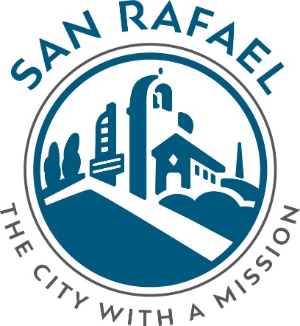

Request for Proposal
Pump Testing Equipment

Issued Date: May 30, 2019

RFP Coordinator:
JASON HATFIELD
BATTALION CHIEF - OPERATIONS
City of San Rafael
FIRE DEPARTMENT
JASON.HATFIELD@cityofsanrafael.org
415-485-3368

Table of Contents
1 Request for Proposal (RFP) 3
2 Introduction to San Rafael Fire Department 3
3 Scope of Work 3
4 Selection Criteria 3
5 Response Contents and Format 4
6 Communications and Response 4
7 RFP Addenda 4
8 Proposal Delivery Instructions 4
9 Key Dates 4
10 No Obligation 5

Request for Proposal (RFP)
The City of San Rafael invites you to respond to this Request for Proposal (RFP). The focus of the RFP is to select pump testing equipment for the San Rafael Fire Department.

Introduction to San Rafael Fire Department
The City of San Rafael is a charter city founded in 1913. The mission of the City is to enhance the quality of life and to provide for a safe, healthy, prosperous and livable environment in partnership with the community. The City has a staff of about 400 full-time employees and an annual budget of approximately $100 million. The San Rafael Fire Department (SRFD) is one of 14 City departments.

SRFD was established in 1874 as a 45-man voluntary fire company. Today, the department is an organization with 79 professionals trained in specialties including life safety emergency and nonemergency services in the areas of fire protection, technical rescue, emergency medical services, and disaster response. There are 6 Fire Stations with 23 personnel 24/7 that provide these services within the City limits and other areas as defined through contracts and mutual aid agreements with bordering areas.

SRFD needs pump testing equipment to allow for annual pump testing and for training new firefighters during their fire academy. The Department also is looking to conserve water and better protect the environment. Currently, firefighters conduct their annual pump testing in parking lots and runoff flows to stormwater drains.

Scope of Work
SRFD is seeking pump testing equipment that meets the following specifications:
- No longer than 27 feet total in length
- Shall be mobile and able to be towed behind a vehicle
- Shall be capable of conducting NFPA 1962 nozzle testing
- Shall be capable of conducting NFPA 1962 appliance/valve testing
- Shall be capable of conducting NFPA 1962 hose testing
- Shall be capable of conducting NFPA 1962 static pump testing
- Shall be capable of re-circulating water
- Shall be capable of conducting drafting/pump training
- Shall be capable of maintaining a safe water temperature while flowing
- Shall have nozzle mounts to direct streams
- Shall be capable of receiving streams from ground level and from elevated locations
- Shall be capable of drafting/flowing up to 1500 GPM

Selection Criteria
SRFD will use multiple criteria to evaluate the proposal. While base price for the product meeting all the listed specifications will be given the most weight, the following list summarizes the major qualitative areas that will also be evaluated to select the winning proposal:
- Industry expertise and experience
- Demonstrated customer service quality and support
- Vendor strength and stability
- Available equipment enhancements
- Other financial considerations

Response Contents and Format
There is no required format for vendors to use in responding to this RFP. Please respond in no more than ten pages, double‐sided. If additional material is required, please label attachments clearly and reference them in your response. Your response to this RFP will serve as the basis for the consideration of your proposal.

Communications and Response
The designated City of San Rafael representative for this initiative is Jason Hatfield. Please direct all RFP-related inquiries to him. See contact information below:

Jason Hatfield
A Shift Battalion Chief
San Rafael Fire Department
Jason.Hatfield@cityofsanrafael.org
415-485-3368

RFP Addenda

All requests for clarification for this RFP must be made in writing. The City will only respond to written questions from proposers. The City will not respond to verbal questions submitted by telephone or in person.
All questions relating to the RFP shall be presented at least 96 hours prior to the due date to Jason Hatfield at the email address set forth in the Communications and Response section above. All addenda will be posted to the City’s website and emailed to known RFP holders.
By submitting a proposal, the proposer affirms that they are aware of any addenda and have prepared their proposal accordingly. No allowances will be made for a proposer’s failure to inform themselves of addenda content.

Proposal Delivery Instructions
Submit an electronic copy of your proposal to the email address indicated in the Communications and Response section above. All responses must be received on or before close of business (5:00 pm PT) on the Proposals Due date indicated in the Key Dates table below.

Key Dates

Event | RFP Issued | Proposals Due | Award Notification
Date | 5/30/2019 | 6/9/2019 | July 2019
Time | 5:00 PM | 5:00 PM | TBD

No Obligation
The submission of a proposal shall not in any manner oblige City of San Rafael to enter into a contract or to be responsible for the costs incurred by your organization in responding to this request.

