Generators and other Mechanical Equipment on Residential sites

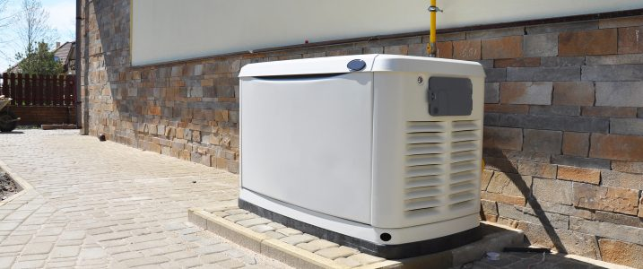
The City of San Rafael has specific setback and noise requirements for mechanical Equipment like A/C units, pool equipment, and stationary generators. The setback information can be found in the municipal code section 14.16.320. The basic information to know is that all mechanical equipment needs a minimum five (5) foot setback from all property lines and fifteen (15) feet from a neighbor’s bedroom window. Mechanical equipment is not allowed in the required front yard. It also needs to be on your property so we will need a letter from your HOA if they are authorizing it in a common area. The General Noise Limits are also detailed in the municipal code and it is the applicants responsibility to show that the unit will not exceed the noise limits. In light of the recent Public Safety Power Shutoffs, Community Development is currently approving permits for stationary generators in a residential area that do not exceed 69 dBa at 7 meters from the unit (typical industry standard measuring distance).

Plans/Documents required for permitting
Three (3) sets of plans will be required. Plans should include:
- Site plan
  - Showing all property lines and structures
  - Distance of unit to property lines and neighboring bedroom windows
- Manufactures Specifications Including:
  - Decibel ratings for unit and distance from unit the rating is measured at.
  - Installation instructions, including details how the unit will be permanently installed
- Electrical information (see attached diagram)
  - including modifications to be made to existing electrical service and connection to the unit.
- Gas Schematic (see attached diagram)
  - Required when connecting to your existing Natural Gas system.
- Additional Items if applicable:
  - Product documentation for any Noise reducing measures or products being added to the unit.
. 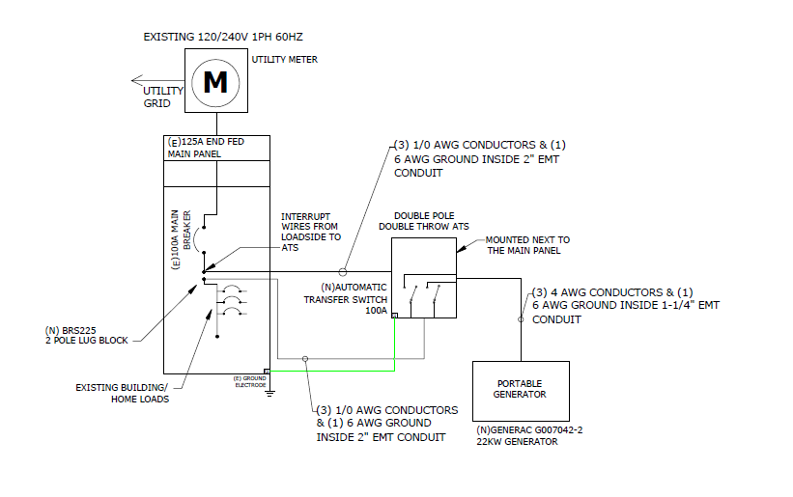
Example:
Electrical Single Line Diagram

