**P1. Other Identifier:** ____

\***P2. Location:** **Not for Publication** X **Unrestricted**

**\*a. County** Marin **and** (P2c, P2e, and P2b or P2d. Attach a Location Map as necessary.)

**\*b. USGS 7.5' Quad** San Rafael-Marin County, CA **Date** 1993 **T** ; **R** ;  **of**   **of Sec** ; **B.M.**

1. **Address** 1539 Fifth Avenue City San Rafael, CA Zip 94901
2. **UTM:** (Give more than one for large and/or linear resources) Zone , mE/  mN

**e.** **Other Locational Data:** APN 011-196-05

**\*P3a. Description:** (Describe resource and its major elements. Include design, materials, condition, alterations, size, setting, and boundaries)

The single story raised basement house is U-shaped in plan with a steeply pitched cross-gabled roof. It is constructed of brick with a slate roof and has two decorative brick chimneys. Windows feature leaded diamond panes. The entrance is fitted with a wide paneled wood door.

**\*P3b. Resource Attributes:** (List attributes and codes) HP2. 1-3 Single Family Property.

**\*P4. Resources Present:** ⌧ Building 🞏 Structure 🞏 Object 🞏 Site 🞏 District 🞏 Element of District 🞏 Other (Isolates, etc.)

P5b. Description of Photo: (View, date,

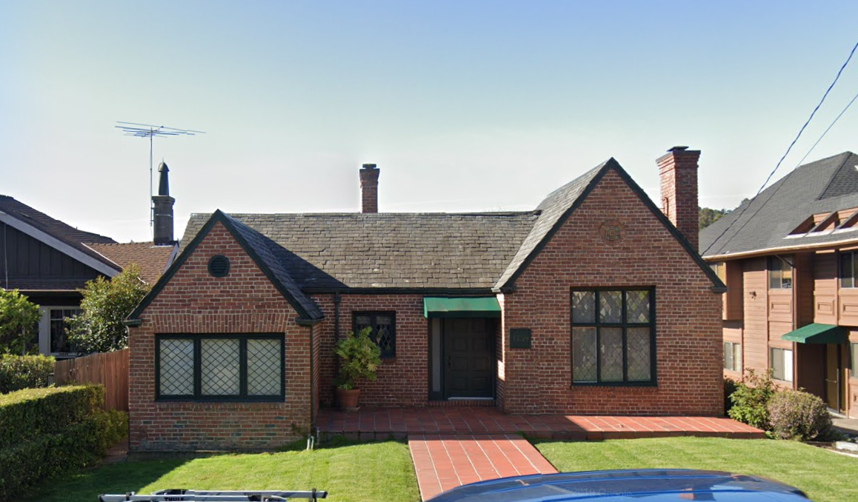

accession #) 1539 Fifth Avenue viewed from North side of Fifth Ave, looking South.

Google, 2019.

*P6. Date Constructed/Age and Sources:

⌧ Historic 🞏 Prehistoric 🞏 Both

1935, (City Data)

**\*P7. Owner and Address:**

**\*P8. Recorded by:** (Name, affiliation, address)

Kai Morgan

Garavaglia Architecture, Inc.

582 Market Street, Suite 1800

San Francisco, CA 94104

**\*P9. Date Recorded:** July 30, 2020

**\*P10. Survey Type:** (Describe) Intensive.

**\*P11. Report Citation:** (Cite survey report and other sources, or enter “none.”) None

**\*Attachments:** NONE ⌧ Location Map 🞏 Sketch Map ⌧ Continuation Sheet ⌧ Building, Structure, and Object Record 🞏 Archaeological Record 🞏 District Record 🞏 Linear Feature Record 🞏 Milling Station Record 🞏 Rock Art Record 🞏 Artifact Record 🞏 Photograph Record 🞏 Other (list) ________________

B1. Historic Name:

B2. Common Name: 1539 Fifth Avenue

B3. Original Use: Single Family Residence B4. Present Use: Single Family Residence

\***B5. Architectural Style:** Tudor

**\*B6. Construction History:** (Construction date, alteration, and date of alterations)

Built 1935 (City Data).

**\*B7. Moved?** ⌧ **No** 🞏 **Yes** 🞏 **Unknown Date:** **Original Location:**

*B8. Related Features:

B9. Architect: Unknown b. Builder: Unknown

**\*B10. Significance: Theme** Residential Development **Area** San Rafael, Marin County

**Period of Significance** 1935 **Property Type** Residential  **Applicable Criteria** C/3

(Discuss importance in terms of historical or architectural context as defined by theme, period, and geographic scope. Also address integrity.)

Continued on page 3

B11. Additional Resource Attributes: (List attributes and codes)

**\*B12. References:**

Ancestry.com. *U.S. City Directories, 1822-1995* [database on-line]. Provo, UT, USA: Ancestry.com Operations, Inc., 2011.

California Missions Foundation. (2017, September 03). San Rafael Arcángel. Accessed July 29, 2020.

California Missions Resource Center, San Rafael Arcángel Key Facts. (2019). Retrieved July 29, 2020, from https://missionscalifornia.com/san-rafael-arcangel-mission/key-facts

City and County of San Francisco Planning Department, *Neighborhood Commercial Buildings: Historic Context Statement 1865-1965*-Draft for Public

Review (February 17, 2016), 20.

City of San Rafael, Historic resources Inventory 1978, 918 Fifth St. Provided by City of San Rafael to Garavaglia Architecture.

County of Marin, Assessor-Recorder-County Clerk, Assessor record detail 011-221-08. Accessed online 7/20/2020

“History of Mission San Rafael Arcángel,” California Missions Foundation, website. Accessed April 24, 2019.

“History of San Rafael,” San Rafael Chamber, website. Accessed April 24, 2019

Jessica Sewell, “Sidewalks and Store Windows as Political Landscapes,” Perspectives in Vernacular Architecture, Volume 9, Constructing Image, Identity, and Place (2003)

Marin County History Museum, *Images of America: Modern San Rafael*: 1940-2000, (Charleston, SC: Arcadia Publishing, 2008)

Marin History Museum, Images of America: Early San Rafael (Charleston, SC: Arcadia Publishing, 2008.

B13. Remarks:

**\*B14. Evaluator:** Kara Brunzell

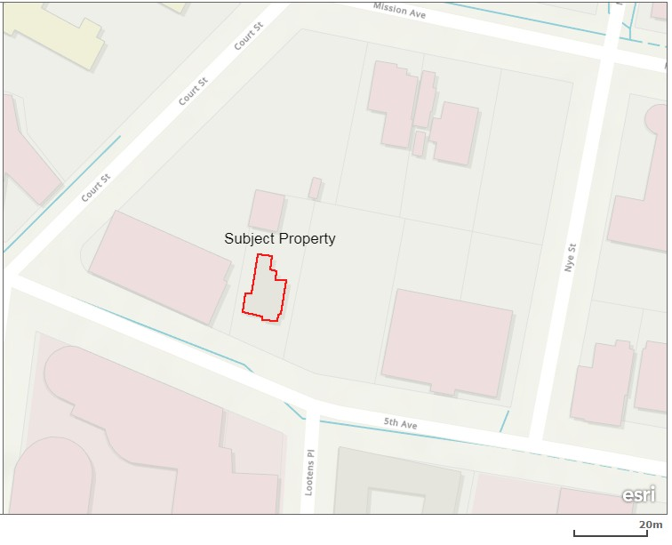**\*Date of Evaluation:** July 30, 2020

(This space reserved for official comment)

**\*P3a. Description: (continued)**

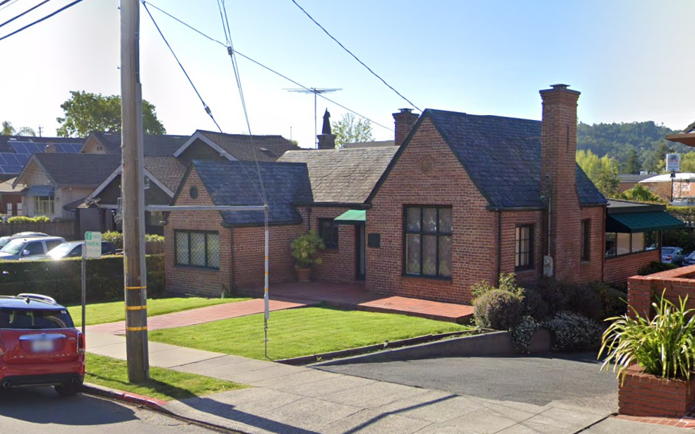

Photograph 2: View from the North side of Fifth Ave, camera facing South-east, Google 2019.

Character Defining Features of 1539 Fifth Avenue:

- Steep, cross gabled roof.

- Slate stone shingled roof

- Raised basement house with U-shaped plan.

- Exposed brick construction.

- Leaded diamond window panes.

- Wide, wood paneled door.

**B10. Significance (continued):**

Historic Context of San Rafael

The area that is now the City of San Rafael was once the site of several Coast Miwok villages, including the village of Nanaguani along San Rafael Creek, inhabited by the Aguasto tribe.[1] In 1817, Mission San Rafael Arcángel was founded as the 20th of 21 Spanish missions in the Spanish colonial province of Alta California. Originally planned as an *asistencia* (hospital) for Native Americans who became ill at Mission Dolores in present day San Francisco, San Rafael Arcángel gained full mission status in 1822.[2] Mission San Rafael was noted for its abundant agricultural products including vineyards, orchards, grain, and thousands of sheep, cattle and horses.[3] Following the secularization of the missions in 1834, the mission was placed under the control of administrators. In 1837, Timothy Murphy was appointed as administrator, and by 1844, was granted three contiguous parcels that were eventually divided into smaller tracts, shaping the boundaries of San Rafael.[4] The Mission itself declined rapidly as an economic or political force in San Rafael and was largely abandoned by 1840. The ruins of the Mission were removed in 1870 and what stands on the site now are 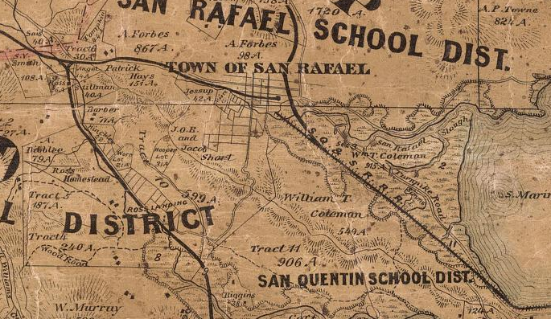reconstructions from 1919 and 1949.[5]

Figure 2: Official county map of Marin County. Produced by H. Austin, 1873.

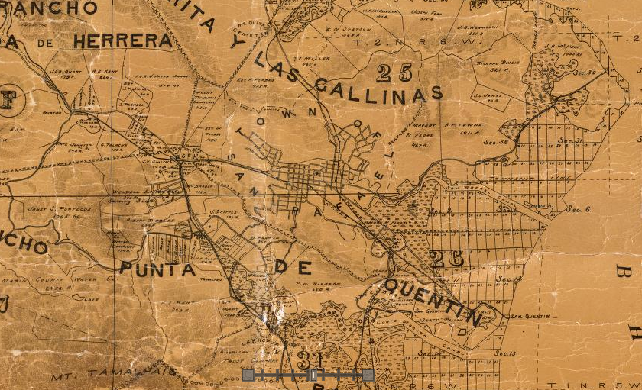

Figure 3: Official county map of Marin County. Produced by George M. Dodge, 1892.

1937-1945: Opening of Golden Gate Bridge and the Second World War

The opening of the Golden Gate Bridge in 1937, and the increasing popularity of the automobile, created a new connectivity between Marin County and San Francisco, effectively ending the rail transit era. The last commuter train departed from San Rafael in 1941, the same year a viaduct for Highway 101 was completed over San Rafael creek.[6] This raised freeway alignment through the heart of San Rafael alongside the railroad tracks created a visual and physical barrier between east and central San Rafael. Though San Rafael was still a satellite of San Francisco it had now entered a period of increasing prosperity with the town’s first Highrise building, the Albert Building, being completed a few years earlier. San Rafael was also now home to several opera houses and theatres including The Orpheus, Gordon’s Opera House, and the Rafael Theatre.

These changes were accelerated by the Japanese bombing of Pearl Harbor in December of 1941 and the entry of the US into World War II. The larger Bay Area became a major hub for wartime industry, mainly shipping and arms production, bringing waves of migration and development to San Rafael. San Rafael’s proximity to Point Richmond, the Mare Island ship yards and Marin Ship in Sausalito caused a severe housing shortage and the construction of many new homes, even including the subdivision of existing housing. These events refocused new development to provide locally oriented goods and services to many working families now residing in San Rafael. Even as the automobile became more ubiquitous, neighborhoods like the West End developed a “village” like character of small shops and residences. This period also saw the beginnings of larger auto-focused developments, like those seen east of the freeway in Montecito.[7]

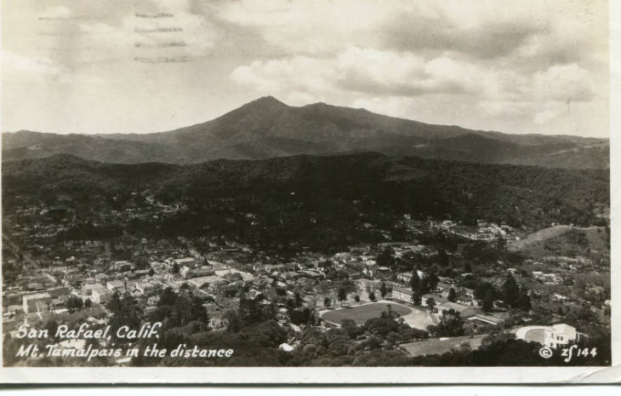

Figure 4: View of San Rafael looking west with Mt. Tamalpais in Background, 1937. Anne T. Kent California Room.

Following the war, housing starts increased, and the Sun Valley, Terra Linda, Glenwood, Peacock Gap and Marinwood neighborhoods were developed on former ranch lands from 1953 through the 1970’s. Industries around San Rafael Canal also continued well into the 1950’s including petroleum sales for other local industries.

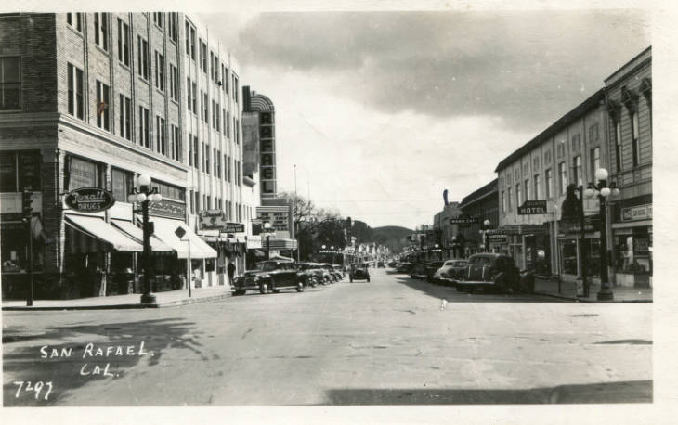

Figure 5: View looking west from Fourth and B Streets, 1947. Anne T. Kent California Room.

Architecture:

1539 Fifth Avenue is an excellent example of Tudor revival architecture, relatively unique in San Rafael.

Evaluation

The NRHP and California Register of Historical Resources (CRHR) require that a significance criterion from A-D or 1-4 (respectively) be met for a resource to be eligible.

Criterion A/1: The property at 1539 Fifth Avenue is not associated with events that have made a significant contribution to the broad patterns of our history. It was developed within the general context of the residential development San Rafael and its growth during the last decades of the nineteenth century. However, research has not revealed any particularly important associations with that or any other historic context. Therefore, the property is recommended not eligible to the NRHP and CRHR under Criterion A/1.

Criterion B/2: The property is not associated with the life of persons important to our history. Therefore, the house is recommended to lack the associative significance required for eligibility to the NRHP or CRHR under Criterion B/2.

Criterion C/3: The property at 1539 Fifth Avenue is significant for its architecture. It is an excellent example of Tudor revival architecture displaying features characteristic of the style. For these reasons, the property is recommended eligible to the NRHP and CRHR under Criterion C/3.

Criterion D/4: In rare instances, buildings themselves can serve as sources of important information about historic construction materials or technologies and be significant under Criterion D/4. The building is an example of a well-understood type of construction and does not appear to be a principal source of important information in this regard. It is therefore recommended not eligible for the NRHP or the CRHR under Criterion D/4.

Historic integrity is defined as the authenticity of a property’s historic identity, evidenced by the survival of physical characteristics that existed during its historic period. There are seven aspects of integrity: location, design, setting, materials, workmanship, feeling, and association. Loss of integrity, if sufficiently great, would be more determinative than significance, rendering a property ineligible for historic listing.

The building has not been moved and therefore retains integrity of location. The composition of elements that constitute the form, plan, space, structure, and style of the building are unaltered; therefore, the building retains integrity of design. The immediate setting has been somewhat altered over decades with the intrusion of large-scale buildings, its integrity of setting has therefore been partially degraded. The building’s integrity of materials and workmanship is evident in the survival of exterior architectural features. The property therefore retains sufficient significant physical characteristics from its original construction to convey its historic qualities and therefore retains integrity of feeling. Its continued use as a residence allows it to retain integrity of association. Therefore, the building retains sufficient integrity convey its historic significance.

The property is recommended eligible for listing on the NRHP and CRHR and qualifies as a historical resource under CEQA.

1. Marin County History Museum, Images of America: Early San Rafael, (Charleston, SC: Arcadia Publishing, 2008), 9.
2. “History of San Rafael,” San Rafael Chamber, website. Accessed April 24, 2019. http://srchamber.com/history-of-san-rafael/.; and, “History of Mission San Rafael Arcangel,” California Missions Foundatin, website. Accessed April 24, 2019. <http://californiamissionsfoundation.org/mission-san-rafael/>.
3. California Missions Resource Center, San Rafael Arcángel Key Facts. (2019). Retrieved July 29, 2020, from https://missionscalifornia.com/san-rafael-arcangel-mission/key-facts
4. Images of America: Early San Rafael, 19.
5. California Missions Foundation. (2017, September 03). San Rafael Arcángel. Retrieved July 29, 2020, from http://californiamissionsfoundation.org/mission-san-rafael/
6. Marin County History Museum, *Images of America: Modern San Rafael*: 1940-2000, (Charleston, SC: Arcadia Publishing, 2008), 14.
7. *Images of America: Early San Rafael*, 37; and, *Images of America: Modern San Rafael*: 1940-2000, 9.