P1. Other Identifier: ____
*P2. Location: Not for Publication X Unrestricted
*a. County Marin and (P2c, P2e, and P2b or P2d. Attach a Location Map as necessary.)
*b. USGS 7.5' Quad San Rafael-Marin County, CA Date 1993 T ; R ; of of Sec ; B.M.
- Address 848 B Street City San Rafael, CA Zip 94901
- UTM: (Give more than one for large and/or linear resources) Zone , mE/ mN
e. Other Locational Data: APN 011-262-01

*P3a. Description: (Describe resource and its major elements. Include design, materials, condition, alterations, size, setting, and boundaries)
The two-story building is rectangular in plan with facades on B and Third Street and a mansard roof with metal tiles. Its focal point is a projecting bay at the corner with peaked hexagonal roof. There are three projecting upper floor bays on the B Street façade and two on Third Street, all are capped with diminutive hipped roofs and feature a cornice with scrolled brackets. Cladding is drop siding with vertical-groove plywood above and below windows. Windows are double-hung wood sash. There are two original storefronts at the south end of the west façade similar to those on 834-840, with multi-light stained glass transoms. The northernmost storefront has been boarded up except for a hexagonal window. An entrance facing the corner is fitted with double partially glazed doors. Storefront bays on Third Street have been modernized with large panes of glass.

*P3b. Resource Attributes: (List attributes and codes) HP6. 1-3 Story Commercial building.

*P4. Resources Present: Building Structure Object Site District Element of District Other (Isolates, etc.)
P5b. Description of Photo: (View, date,
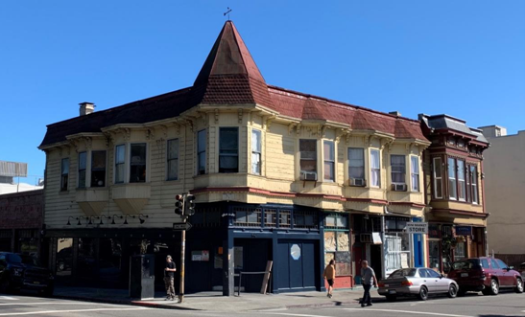

accession #) 848 B Street viewed from the South side of Fourth Street, looking North. Google 2019.

*P6. Date Constructed/Age and Sources:
Historic Prehistoric Both
1887-1894 (Sanborn maps)
*P7. Owner and Address:
848 B Street, San Rafael, CA

*P8. Recorded by: (Name, affiliation, address)
Kai Morgan
Garavaglia Architecture, Inc.
582 Market Street, Suite 1800
San Francisco, CA 94104

*P9. Date Recorded: July 30, 2020
*P10. Survey Type: (Describe) Intensive.
*P11. Report Citation: (Cite survey report and other sources, or enter “none.”) None
*Attachments: NONE Location Map Sketch Map Continuation Sheet Building, Structure, and Object Record Archaeological Record District Record Linear Feature Record Milling Station Record Rock Art Record Artifact Record Photograph Record Other (list) ________________

B1. Historic Name:
B2. Common Name: 848 B Street
B3. Original Use: Commercial Storefront/ Residential B4. Present Use: Commercial
*B5. Architectural Style: Queen Anne Commercial
*B6. Construction History: (Construction date, alteration, and date of alterations)
Built 1887-1894 (Sanborn).
*B7. Moved? No Yes Unknown Date: Original Location:
*B8. Related Features:
B9. Architect: b. Builder:
*B10. Significance: Theme Commercial Development Area San Rafael, Marin County
Period of Significance 1887-1894 Property Type Commercial/Residential Applicable Criteria C/3
(Discuss importance in terms of historical or architectural context as defined by theme, period, and geographic scope. Also address integrity.)
Continued on page 3
B11. Additional Resource Attributes: (List attributes and codes)
*B12. References:
Ancestry.com. U.S. City Directories, 1822-1995 [database on-line]. Provo, UT, USA: Ancestry.com Operations, Inc., 2011.
California Missions Foundation. (2017, September 03). San Rafael Arcángel. Accessed July 29, 2020.
California Missions Resource Center, San Rafael Arcángel Key Facts. (2019). Retrieved July 29, 2020, from https://missionscalifornia.com/san-rafael-arcangel-mission/key-facts
City and County of San Francisco Planning Department, Neighborhood Commercial Buildings: Historic Context Statement 1865-1965-Draft for Public
Review (February 17, 2016), 20.
City of San Rafael, Historic resources Inventory 1978, 918 Fifth St. Provided by City of San Rafael to Garavaglia Architecture.
County of Marin, Assessor-Recorder-County Clerk, Assessor record detail 011-221-08. Accessed online 7/20/2020
“History of Mission San Rafael Arcángel,” California Missions Foundation, website. Accessed April 24, 2019.
“History of San Rafael,” San Rafael Chamber, website. Accessed April 24, 2019
Jessica Sewell, “Sidewalks and Store Windows as Political Landscapes,” Perspectives in Vernacular Architecture, Volume 9, Constructing Image, Identity, and Place (2003)
Marin County History Museum, Images of America: Modern San Rafael: 1940-2000, (Charleston, SC: Arcadia Publishing, 2008)
Marin History Museum, Images of America: Early San Rafael (Charleston, SC: Arcadia Publishing, 2008.
B13. Remarks:

*B14. Evaluator: Kara Brunzell

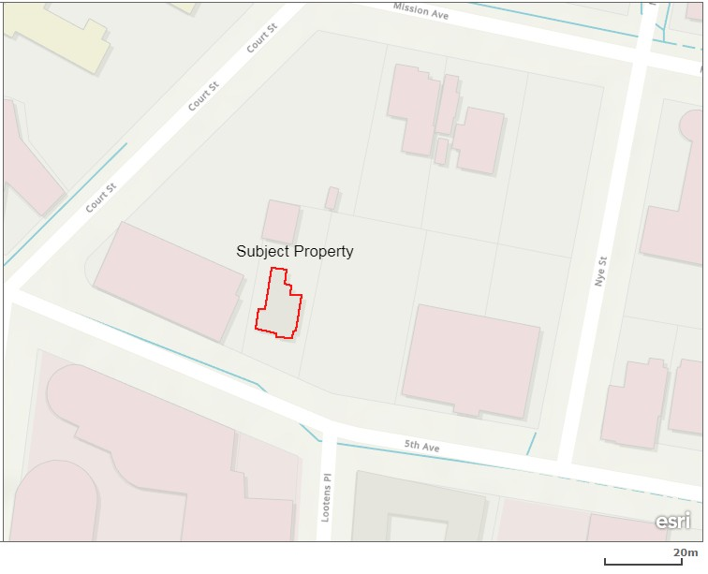
*Date of Evaluation: July 30, 2020

(This space reserved for official comment)
*P3a. Description: (continued)
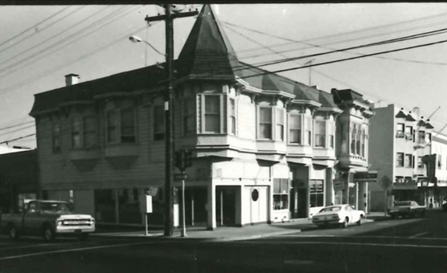
Photograph 2: Historic Photograph, view from the North-east corner of 3rd and B Streets, camera facing South-West.

Character Defining Features of 848 B Street:
- Mansard roof with metal tiles.
- Projecting bay on corner with peaked hexagonal roof.
- Three projecting upper floor bays on B St, two on Third Street, all capped with diminutive hipped roofs and cornice’ with scrolled brackets.
- Cladding is drop siding with vertical-groove plywood.
- Double-hung wood sash widows.
- Multi-light stained glass transoms.

B10. Significance (continued):
Historic Context of San Rafael
The area that is now the City of San Rafael was once the site of several Coast Miwok villages, including the village of Nanaguani along San Rafael Creek, inhabited by the Aguasto tribe. In 1817, Mission San Rafael Arcángel was founded as the 20th of 21 Spanish missions in the Spanish colonial province of Alta California. Originally planned as an asistencia (hospital) for Native Americans who became ill at Mission Dolores in present day San Francisco, San Rafael Arcángel gained full mission status in 1822. Mission San Rafael was noted for its abundant agricultural products including vineyards, orchards, grain, and thousands of sheep, cattle and horses. Following the secularization of the missions in 1834, the mission was placed under the control of administrators. In 1837, Timothy Murphy was appointed as administrator, and by 1844, was granted three contiguous parcels that were eventually divided into smaller tracts, shaping the boundaries of San Rafael. The Mission itself declined rapidly as an economic or political force in San Rafael and was largely abandoned by 1840. The ruins of the Mission were removed in 1870 and what stands on the site now are reconstructions from 1919 and 1949.
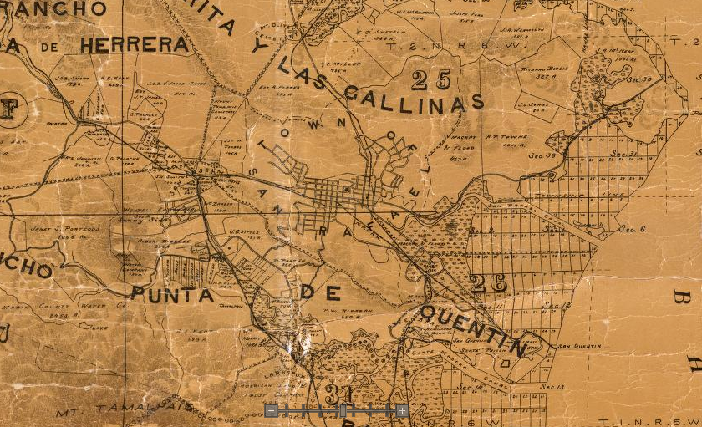
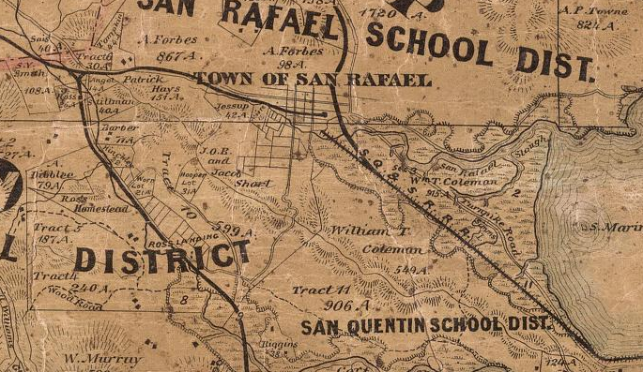
Figure 2: Official county map of Marin County. Produced by H. Austin, 1873.

Figure 3: Official county map of Marin County. Produced by George M. Dodge, 1892.

1850-1906: Early Growth of San Rafael
San Rafael grew gradually after California statehood in 1850, and was named seat of Marin County in 1851. Following the completion of the Transcontinental Railroad in 1869, the construction of Marin County Courthouse in 1872, and incorporation in 1874, San Rafael entered a period of accelerated growth. The discovery of gold in California led to a massive influx of new residents to California and eventually San Rafael. Several individuals who immigrated to California during the Gold Rush played foundational roles in the civic development of the city. William Tell Coleman, who had moved to San Rafael in 1871, was influential in the construction of the Marin County Courthouse, in the development of the water system, promotion of the railroad, and construction of the Hotel Rafael. During this period nearly all of San Rafael’s first generation of buildings were lost including the original Mission buildings. Over the ensuing decades leading into the twentieth century, the town built out as freight, passenger, and interurban railway to Sausalito ferry extensions were completed. The streetscape of San Rafael’s commercial downtown continued to develop along a typical pattern of regional growth from the late 1860s to the 1890s, when the advances in transportation technologies and expansion in services determined the location for housing and businesses.

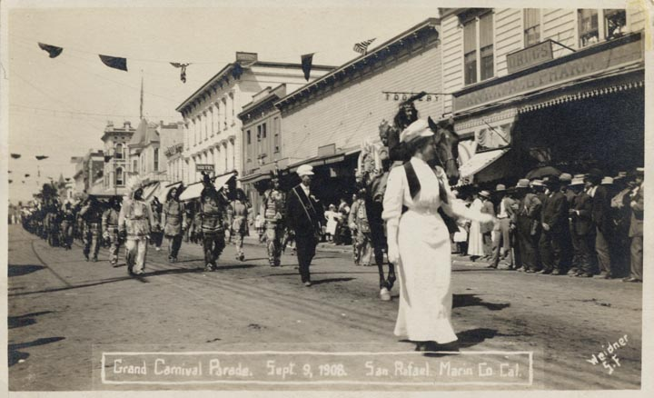
Figure 4: Grand Carnival Parade, Fourth Street San Rafael. September 9th, 1908.

Transportation infrastructure also included the inauguration of ferry service from Point San Quentin including a short rail line connecting San Rafael to the ferry and the completion a railroad from Petaluma through San Rafael to Tiburon. Faster and more reliable electric train service was introduced in 1903. The railroad’s arrival started a modest hospitality industry for summer and weekend visitors that contributed to the growth of the town, with the opening of several hotels, saloons, and specialty shops. Development of the San Rafael Canal (San Rafael Creek) led to the emergence of commercial activity around the tidal estuary linking San Francisco to the communities, ranches, and farms along the bay and sloughs. The most notable remaining example of this industry is the McNear Brick Yard adjacent to the Dutra Quarry.

Commercial development in the downtown began in the mid-1860s. John A. Davis and Daniel T. Taylor were credited with opening the first general store, which was immediately followed by a meat market. By 1866, the town had three stores, two hotels, two boarding houses, one restaurant, two Point San Quentin. The North Pacific Coast Railroad (NPC) followed in 1871, which provided San Rafael with a spur track that connected San Anselmo to the station at B Street. A new depot was constructed on Tamalpais Avenue between Third and Fourth Streets in 1884.stables, three boot makers, two blacksmith shops, a butcher shop, a clock maker, a barber, three lawyers, and a physician. This period saw Fourth Street become San Rafael’s “Main Street” with retail and commerce centered on the east-west thoroughfare. The rail station at B and Second streets also became a hub of activity with a smaller commercial district beginning to grow on the north-south axis connecting the rail junction to Fourth Street. Commercial activity also sprang up along Fourth and B Streets, in the pocket connecting both rail lines. By the 1890’s San Rafael was a commercial and cultural center and was taking on a shape we can recognize today. Fourth Street was a premier shopping area, with the largest department store in Marin County (owned by Jacob Albert and located at 1216 Fourth Street). A Chinese community had begun to grow around the east side of C Street. This period saw the construction of many large residential buildings, some of which still stand today. Commercial streets developed during this period feature a mixture of one-story single-business establishments and multi-story mixed-use buildings (typically residential, hotel rooms, or offices above ground-floor storefronts). Commercial buildings aligned with turn-of-the century regional trends, and increasingly featured multiple, narrow storefronts. Stylistically, the design of commercial buildings from this period was closely aligned with Victorian-period residential architectural styles.

Architecture:
720 B Street is an example of Queen Anne Commercial architecture.

Evaluation
The NRHP and California Register of Historical Resources (CRHR) require that a significance criterion from A-D or 1-4 (respectively) be met for a resource to be eligible.
Criterion A/1: The property at 848 B Street is not associated with events that have made a significant contribution to the broad patterns of our history. It was developed within the general context of the residential development San Rafael and its growth during the last decades of the nineteenth century. However, research has not revealed any particularly important associations with that or any other historic context. Therefore, the property is recommended not eligible to the NRHP and CRHR under Criterion A/1.
Criterion B/2: The property is not associated with the life of persons important to our history. Therefore, the house is recommended to lack the associative significance required for eligibility to the NRHP or CRHR under Criterion B/2.
Criterion C/3: The property at 848 B Street is significant for its architecture. It is an excellent example of the Queen Anne Commercial style of architecture displaying features characteristic of this style. For these reasons, the property is recommended eligible to the NRHP and CRHR under Criterion C/3.
Criterion D/4: In rare instances, buildings themselves can serve as sources of important information about historic construction materials or technologies and be significant under Criterion D/4. The building is an example of a well-understood type of construction and does not appear to be a principal source of important information in this regard. It is therefore recommended not eligible for the NRHP or the CRHR under Criterion D/4.
Historic integrity is defined as the authenticity of a property’s historic identity, evidenced by the survival of physical characteristics that existed during its historic period. There are seven aspects of integrity: location, design, setting, materials, workmanship, feeling, and association. Loss of integrity, if sufficiently great, would be more determinative than significance, rendering a property ineligible for historic listing.
The house has not been moved and therefore retains integrity of location. The composition of elements that constitute the form, plan, space, structure, and style of the building are unaltered; therefore, the building retains integrity of design. The immediate setting has been somewhat altered over decades with the intrusion of large-scale buildings, its integrity of setting has therefore been partially degraded. The building’s integrity of materials and workmanship is evident in the survival of exterior architectural features. The property therefore retains sufficient significant physical characteristics from its original construction to convey its historic qualities and therefore retains integrity of feeling. Its continued use as a residence allows it to retain integrity of association. Therefore, the building retains sufficient integrity convey its historic significance.
The property is recommended eligible for listing on the NRHP and CRHR and qualifies as a historical resource under CEQA.

Marin County History Museum, Images of America: Early San Rafael, (Charleston, SC: Arcadia Publishing, 2008), 9.
“History of San Rafael,” San Rafael Chamber, website. Accessed April 24, 2019. http://srchamber.com/history-of-san-rafael/.; and, “History of Mission San Rafael Arcangel,” California Missions Foundatin, website. Accessed April 24, 2019. http://californiamissionsfoundation.org/mission-san-rafael/.
California Missions Resource Center, San Rafael Arcángel Key Facts. (2019). Retrieved July 29, 2020, from https://missionscalifornia.com/san-rafael-arcangel-mission/key-facts
Images of America: Early San Rafael, 19.
California Missions Foundation. (2017, September 03). San Rafael Arcángel. Retrieved July 29, 2020, from http://californiamissionsfoundation.org/mission-san-rafael/
Images of America: Early San Rafael, 28.
Ibid, 37.
Ibid, 37.
Ibid, 37.
Ibid, 59.
Ibid, 37.
Ibid, 59.
Ibid., 59-70.
Ibid, 67-68.
City and County of San Francisco Planning Department, Neighborhood Commercial Buildings: Historic Context Statement 1865-1965-Draft for Public Review, February 17, 2016.

