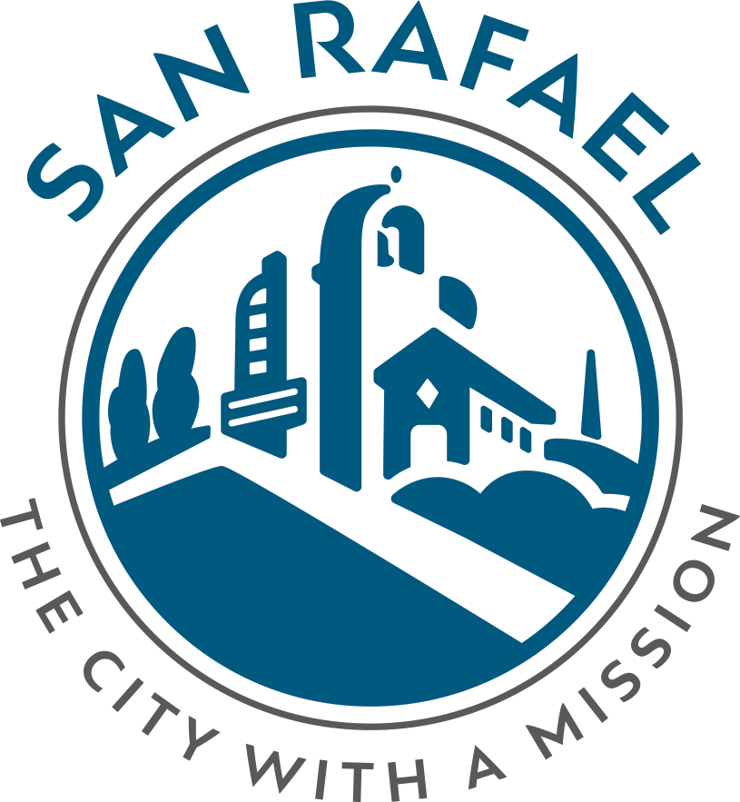
Policing in our Community: Agenda
November 3rd, 2022 6-8pm
Albert J. Boro Community Center
Zoom: https://tinyurl.com/4etm9rxs

6:05 p.m. - Opening Remarks – City’s Commitment & Introduce City Team (Councilmember Maika Llorens Gulati - 5 minutes)

6:10 p.m. - Overview of Police Accountability & Tonight’s Agenda (Francine Tournour) 10-15 minutes)

6:25 p.m. - Opening Statement – Chief’s Commitment (Chief David Spiller) (5 -10 minutes)

6:35 p.m. - Instructions for Breakout Groups (Councilmember Maika Llorens Gulati) (5 minutes)

6:40 p.m. - Breakout Groups (30-40 minutes, depending on number of participants)

7:20 p.m. - Report out to Larger Group (20-30 minutes, depending on number of participants)

7:50 p.m. - Wrap Up & Next Steps (Chief David Spiller) (5 minutes)

7:55 p.m. – Thank You (Councilmember Maika Llorens Gulati - 5 minutes)

8:00 p.m. - Closing

Breakout Group Instructions:
- Split into groups of 5-8 people (depending on how many people attend the meeting)/ Zoom participants will join breakout rooms
- Each group will be assigned 1 facilitator who will ask questions and engage the group in conversation. The facilitator will identify someone to 1) take notes, 2) report out to the larger group. The facilitator could offer to take notes and report out to the larger group if the group prefers that.
- For the report out to the larger group – each group to share top/main themes of the group for each question.
- We need 2 facilitators to volunteer to write the main themes of each group on large post-its in front of the room, during the report outs from the small groups.
*Clipboards, note paper, pens, large post-its, tri-pods, and markers provided.
Questions for Break-Out Groups:
You will have 30-40 minutes to discuss the following questions.
- What does feeling safe in your neighborhood mean to you?
  - Do you feel safe in your neighborhood?
  - How can the police improve and maintain your feeling of safety in your neighborhood?

- Do you have concerns about your police department?
  - If so, what are they and what could the police department do better to address these concerns?

- Do you feel your voice is heard? If yes, how?
  - What’s the best way for you to feel like your voice is being heard by your City and Police Department?
4. What do you think the police department is doing well?

