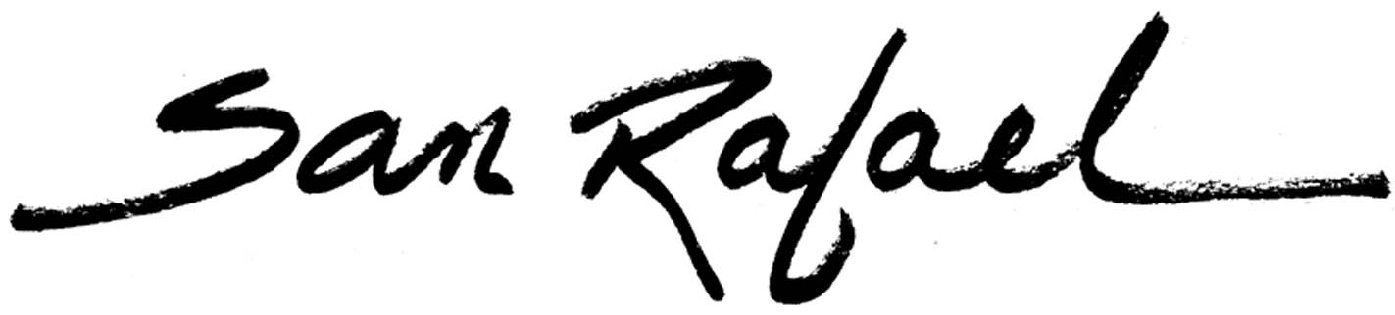

“SIGNIFICANT JOB ACTION” COMPLETION CHECKLIST AND ROUTING SLIP

This form is used to propose any “significant job action.” Its intent is to ensure cross-departmental review of potential impacts. Please complete the information below and contact Human Resources at 485-3391 if you have any questions.

Responsible Department:___________________________________________

Contact:___________________________________________

Significant Job Actions
Note: All items with an asterisk (*) will require Council approval. Some items may require the meet and confer process (see below). Do not use this form for basic step or merit increases, vacation cash out, or any other routine job action. Please check the appropriate box:

□ New Position/Classification(s)*
□ Reclassification without Budget Impact
□ Reclassifications with Budget Impact*
□ Deleted Position/Classification(s)
□ Department or Division Reorganization*
□ Temporary Assignment without Budget Impact
□ Salary or Salary-related Benefit Change other than Step or Merit Increase
□ Accelerated Step Increase
□ Bargaining Unit Side Letter Agreement on Personnel Matters
□ Other Job Actions of this Type

 | Responsible Department | Description | Completion  Date | Initials
1 | Originating Department | Manager/supervisor writes description of requested job action and provides ample supporting documentation (e.g. budget analysis, funding source to encumber, examples) and provides it, with this checklist/routing slip, to the City Manager’s Office.
2 | City Manager’s Office (CMO) | If job action request appears appropriate, CMO forwards to HR for review
3 | Human Resources | Provides preliminary review. If job action request appears appropriate, forwards to Finance Department for review
4 | Finance Department | Provides preliminary review. If job action request appears appropriate, forwards to City Attorney’s Office for review
5 | City Attorney | Reviews request for any legal issues. Identifies if proposed job action requires bargaining unit review/approval and/or City Council review/approval.
6 | Originating Department | Works with HR to obtain City Council approval and/or bargaining unit approval, as necessary. Prepares Personnel Action Report (PAR) and obtains Department Director approval/signature. Delivers to Human Resources with this checklist attached.
7 | Human Resources | Signs PAR and forwards to City Manager’s Office.
8 | City Manager’s Office (CMO) | Final authorization of job action. Returns completed job action checklist and PAR to Human Resources.
9 | Human Resources | Provides copy of PAR and checklist to Finance Department and City Attorney’s Office.
Below is the process (in chronological order) for obtaining significant job action authorization. The Responsible Department should write in their respective completion date and initials (and/or attach to this form any comments or required follow up) prior to forwarding it to the next step.

