# Beginners Romulus Guide

Table of Contents

Beginners Romulus Guide 1

Icon Key 3

Service Request Guide 4

Answering an Inquiry From Inbox: 5

Answering an Inquiry From Service Request: 7

Adding Note to Conversation: 9

Exporting Conversation: 9

Transferring Conversations: 10

Creating service Requests: 11

Externally (from a resident writing in): 11

Internally (from an email or phone call) 13

Changing Service request Status: 16

Using romulus (CP COnnect) for police vehicles: 17

Creating a template: 24

Updated 4/15/2019

W:\01 Administration\01.32 Communications\CRM System

## Icon Key

|  |  |
| --- | --- |
| Symbol | Meaning |
| Box | Inbox |
| Wrench | Service requests |
| Scales | Community Issues |
| Person | Constituents |
| Pillars | Organizations |
| Check box | Pending Tasks |
| Clock wheels | Settings, contact info, preferences, response templates |

## Service Request Guide

|  |  |  |
| --- | --- | --- |
| ASSIGNED STAFF | DIVISION TAG | RESPONSIBILITIES |
| Aaron Tubs | PARKS DIVISION | * Ball fields * Islands/medians * General park questions * General questions * Safety (Mark, Aaron, Brendan) |
| Brendan Mitchell | PARKS DIVISION | * Pools * Trees * Parkettes |
| Gabe Dias | STREETS DIVISION | * Street and Curb Paint and signs * Street sweeping * Graffiti * Illegal Dumping |
| John Shindelus | STREETS DIVISION | * Paving * Pump maintenance * Vegetation removal in certain locations * Storm drainage & emergency response (CC Mark) |
| Lauren Davini | TRAFFIC DIVISION | * Traffic lights * Stop sign request * Crosswalk/midblock request * Tamalpais bike lane |
| Ryan Montes | GARAGE DIVISION | * PD vehicle repair * Non-PD vehicle repair |
| Omar Garcia | FACILITIES | * Usually automated through employee website * Pest control * Facility Issues |
| Appropriate staff member according to inquiry request | DPW GENERAL INQUIRY | * General inquiries that do not fall into any of the other categories |
| Diane Dillon | ENCROACHMENT PERMIT | * Encroachment Permits * Construction Inspection * Construction complaints |
| Willie Lagleva | TRAFFIC DIVISION | * Anything PODS/Debris Box * Traffic control devices (traffic lights, pedestrian signals) |
| Josh Minshall | LAND DEVELOPMENT | * Land development * Grading * Water Course |

## Answering an Inquiry From Inbox:

Inquiry Checklist:

* Send service request if needed
* Tag service request with appropriate division tag (shown on table in page 3)
* Respond to resident, if service request made provide resident with an update (inform of service request sent to specific division)

1. Go to inbox
2. 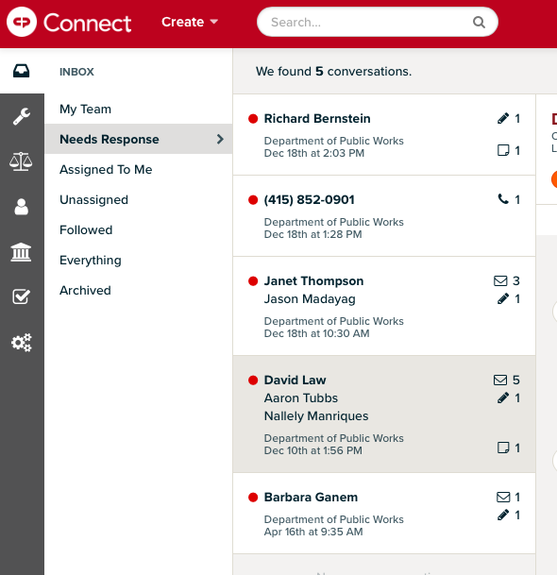Click “Needs Response” to view ***unanswered*** Romulus inquiries. Number of unanswered conversations will appear on top of new inquiries. Unanswered inquiries will have a red dot appear next to the name of the resident.
3. Click on name or red dot next to message to view recent inquiry.
4. An inquiry requires action from DPW, create a service request (for instructions on how to create a service request see “Service Request”). If you are still able to answer their inquiry, please answer service request by using the **“Respond”** section. Once the inquiry has been answered the red dot will disappear. Once you have answered the inquiry follow the instructions in the “Changing Status” section.

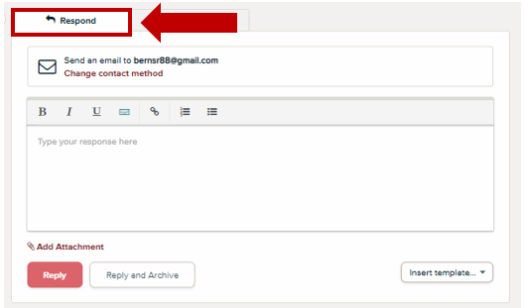

1. To insert an automated response, hit the “Insert template” drop-down menu at the lower right corner of the respond message.

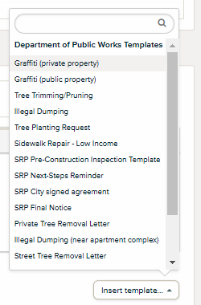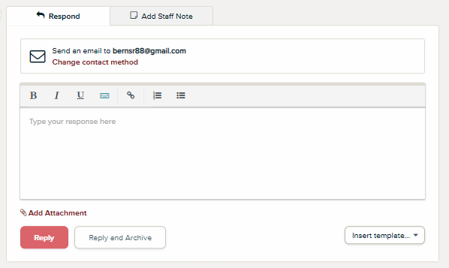Select the desired template from the list to insert in the response box. Hit reply to send message.

1. 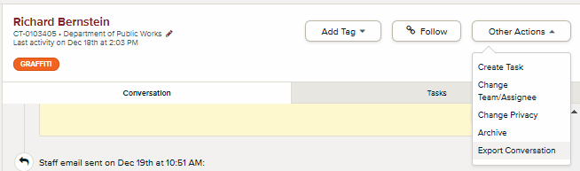Archive inquiry if no further action is needed. This removes inquiry from the inbox. Click the “Other Actions” drop down menu on the upper right side of the inquiry. Click “Archive” to archive conversation.
2. 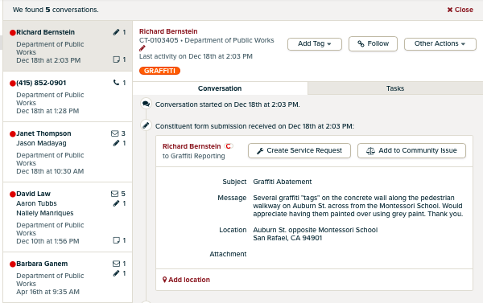Some inquiries will come pre-tagged with a topic, those are inquiries from specific contact forms on our website. The example below has been pre-tagged as “GRAFFITI”.

## Answering an Inquiry From Service Request:

1. 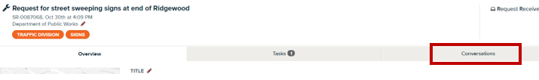While on the service request go to the conversation tab.
2. Click on the arrow on the far right of the message you want to reply to.



1. An inquiry requires action from DPW, create a service request (for instructions on how to create a service request see “Service Request”).



1. To insert an automated response, hit the “Insert template” drop-down menu at the lower right corner of the respond message.

Select the desired template from the list to insert in the response box. Hit reply to send message.

## Adding Note to Conversation:

* 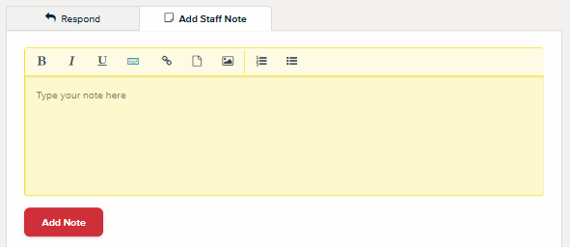Notes are added to service request or inquiry messages to update others on Romulus about the inquiry.

If you are in the process of researching an answer, add it in the notes to update others on the DPW Team. It’s also helpful to add if you have emailed another staff member requesting a response for the resident.

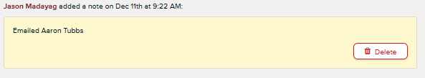

## Exporting Conversation:

1. Exporting a conversation: not all DPW staff is on Romulus (i.e. Project Manager). Inquiries are exported into a pdf and emailed to staff when their expertise is needed. To export click on “Other Actions” drop down menu, select “Export Conversation,” a pdf of the conversation will pop up.

## Transferring Conversations:

There will be times when a constituent’s request belongs to another department. When this occurs you will need to transfer the conversation to another department. There will be no need to create a service request unless this case also involves DPW.

1. While on the conversation. Click the pencil icon and a new menu will appear. 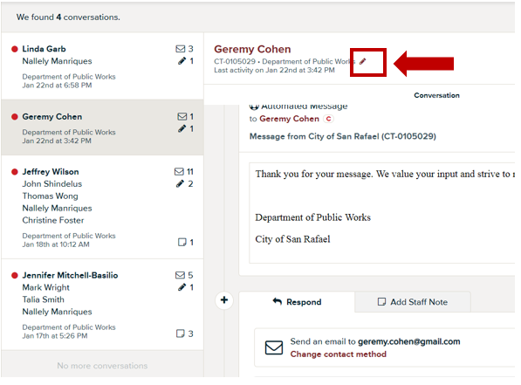
2. Choose the appropriate team that should own the conversation and, if known, you may also choose the appropriate staff member, or you may leave it blank. Then click save.

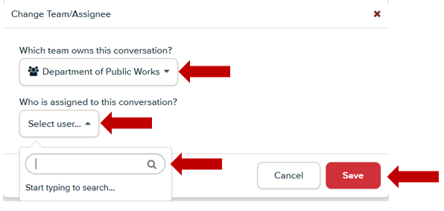

## Creating service Requests:

### Externally (from a resident writing in):

Below is a service request table to guide you in knowing who to assign service requests to. There are 6 division tags: Streets, Parks, Traffic, Garage, Facilities, and DPW non-division.

1. To create a new service request click the "add to service request" button.

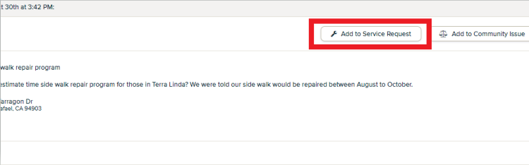

1. Title the service request in the following format: **address/location of service request – followed by service needed** (i.e. 111 Morphew St – graffiti on building door).
2. If you do not wish to tie the current communication to an existing service request and you simply wish to create a new request, start typing the new title, you'll see an option for "add 'blah blah blah' as a new service request", select this option. Note: If you do not see this option it may be because there are many service requests with the same title. Simply scroll down to the end of the list and you will see “Add ‘…..’ as a new service request.”

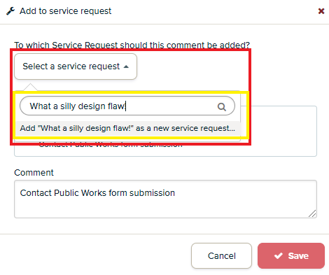

1. Assign to staff member – use *Service Request Guide* for guidance

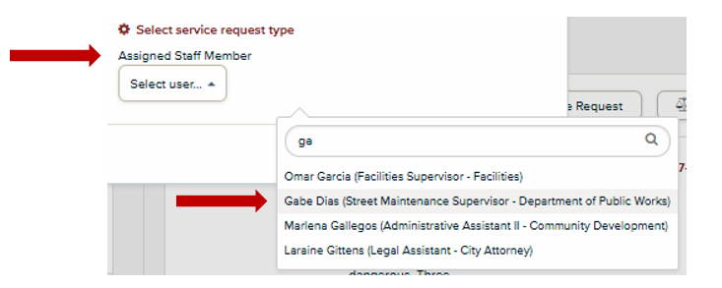

1. Click “save” to submit service request

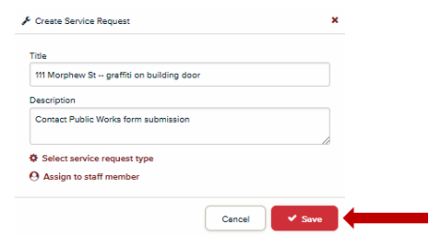

1. After service request has been submitted add appropriate division tag to service request. Division tags are used to generate monthly reports for DPW.

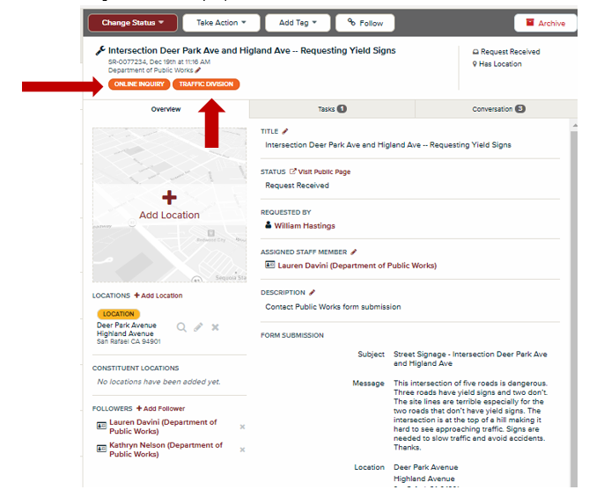

1. Once the service request has been created you and the assigned staff member will automatically be named followers. To add additional followers, click the “+Add Follower” icon located on the lower left side of the service request.

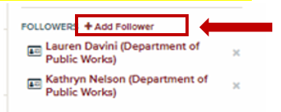

Note: Add Mark Wright as a follower to all Parks and Streets service requests

### Internally (from an email or phone call)

1. Click on the “Create” tab, and then on the drop-down menu, click on “Service Request”.

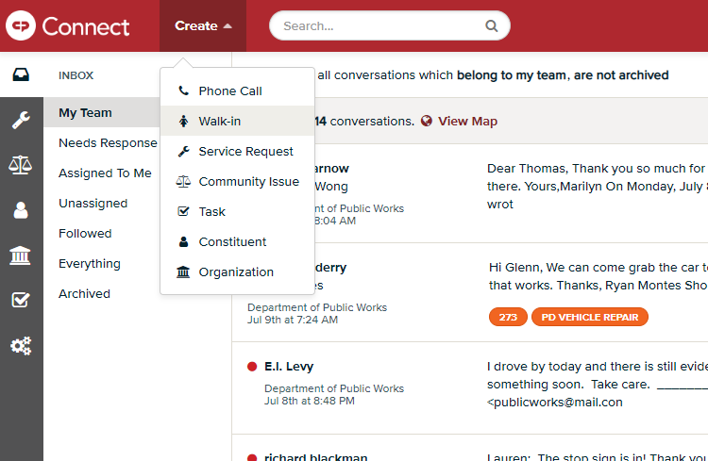

1. 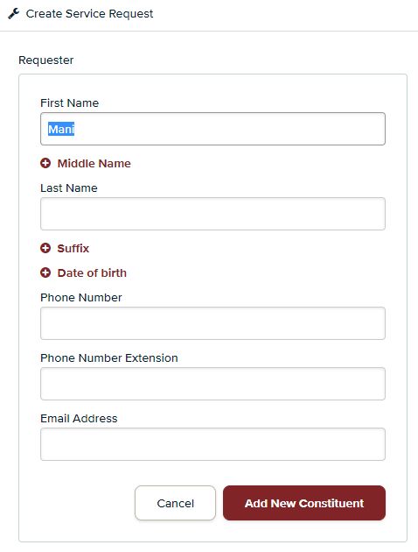A box will pop up. Under “Requestor”, type in their name or phone number (phone number is usually easier). If they have written a request before, their contact information will come up. Click on it. If they have not, add them by typing in their name, scrolling to the bottom of the drop-down menu, and clicking on “Add ____ as a new constituent”. Another form will pop-up; fill it out accordingly. If they are adamant on remaining anonymous, type in “Anonymous Constituent”. 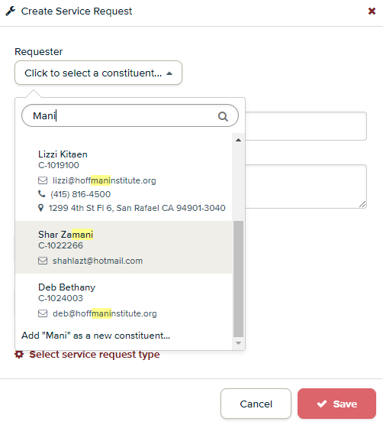
2. Title the service request in the following format: **address of service request – followed by service needed** (i.e. 111 Morphew St – graffiti on building door). Type in any additional or detailed information in the “Description” box.

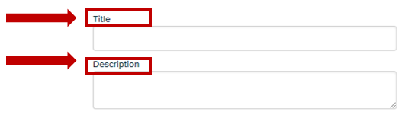

1. Assign to staff member by clicking on the “Select user” drop-down menu – use *Service Request Guide* for guidance.

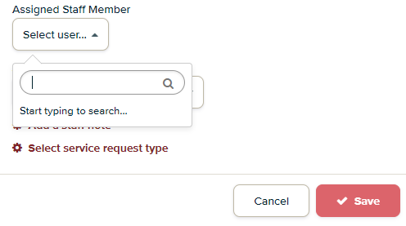

1. Click “Save” to submit service request.

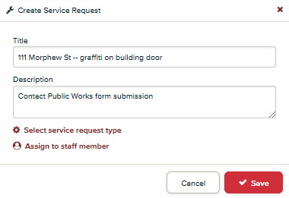

1. After service request has been submitted, you will be taken to this screen. Add appropriate division tag to service request. Division tags are used to generate monthly reports for DPW. Add any additional tags describing the service request (e.g. stop sign request, pothole, vegetation, etc.)

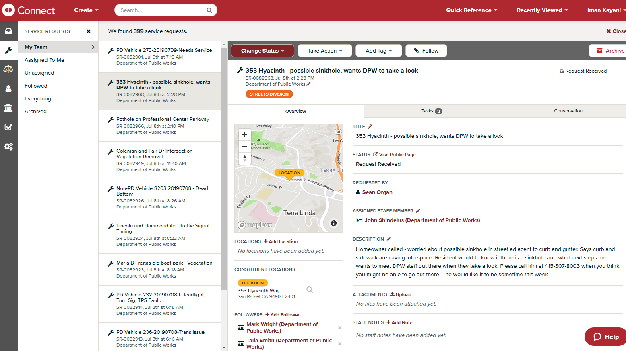

1. 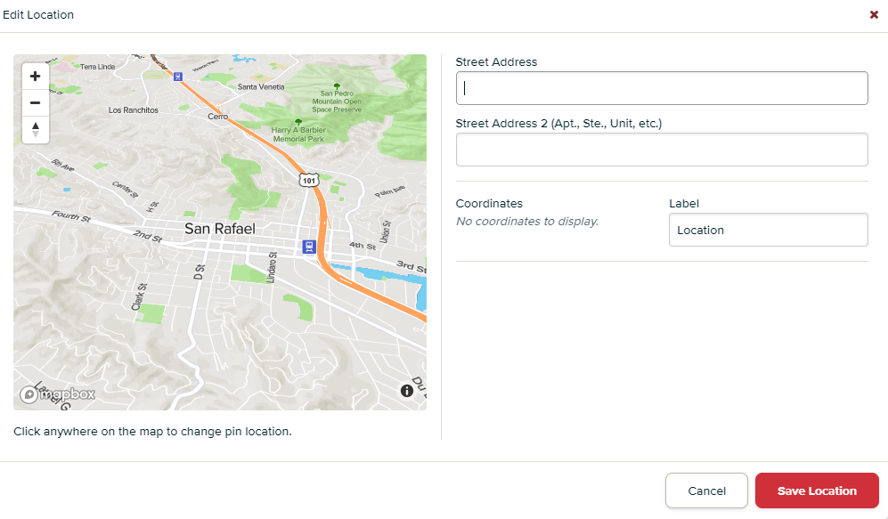To enter a location, click on “Add Location”. A screen will pop up and you can type in the address. Alternatively, you can click on the Map to select a location from there (this is helpful when referencing intersections).
2. Once the service request has been created you and the assigned staff member will automatically be named followers. To add additional followers, click the “+Add Follower” icon located on the lower left side of the service request.
   1. Add Mark Wright as a follower to all Parks and Streets service requests

## Changing Service request Status:

1. If you have received a service request, you must “change status” of the request:
   1. **Request Received** – indicates that the service request was created.
   2. **Work in Progress** – currently working on service request and add notes in the “staff notes” section if the request may take longer than one month.
   3. **Service Completed** – service request has been completed and no follow-up is needed.
      1. If this option is chosen you may now archive the case.

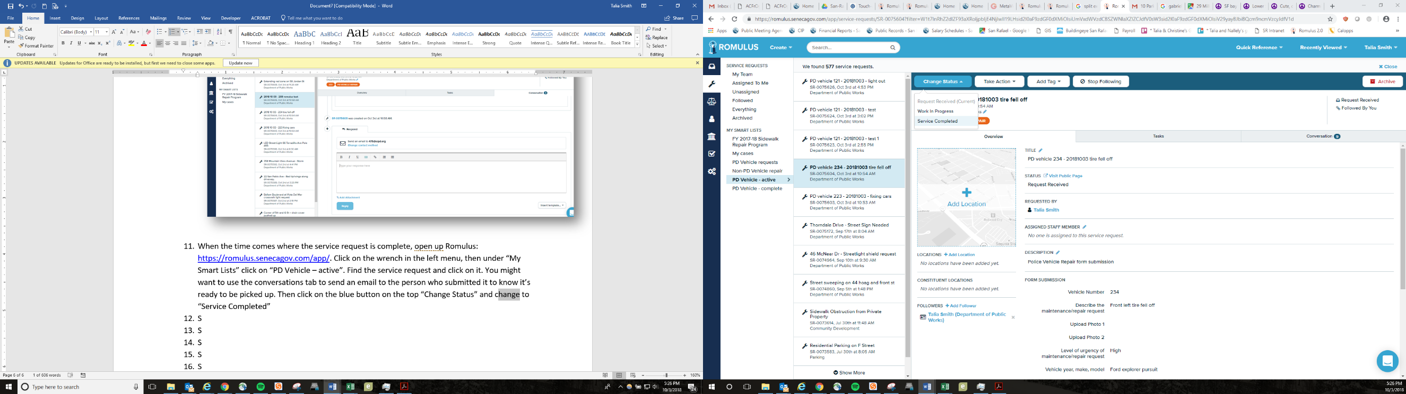

## Using romulus (CP COnnect) for police vehicles:

1. 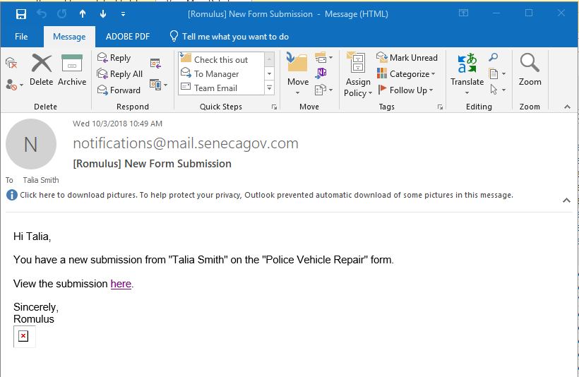Check your email inbox for any new emails “You have a new submission from “NAME” on the “Police Vehicle Repair….”
2. Click on the link under “View the submission here”
3. A window will pop open on the internet that looks like this. You are now viewing the form submission. The conversation will automatically jump to the very bottom of the conversation string.

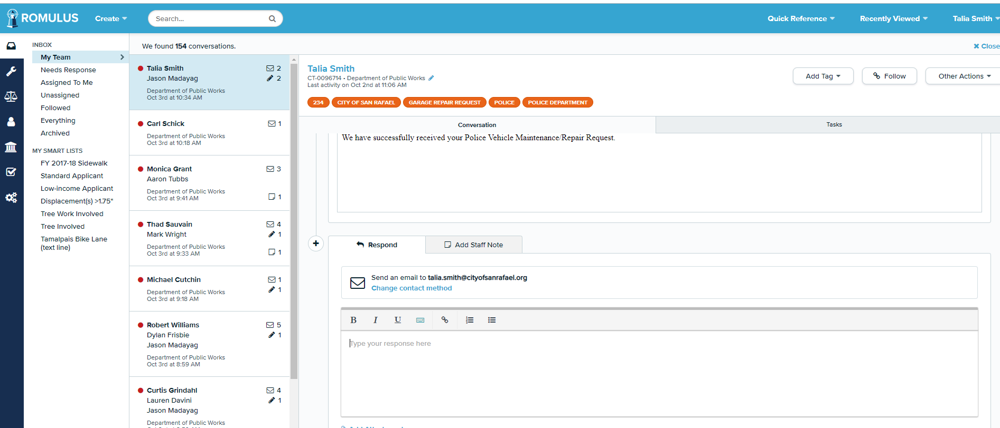

1. To create a new service request click the "add to service request" button.



1. Title the service request in the following format: “**PD vehicle VEHICLE # - YEAR MONTH DAY - short description**”. For example, here I did: “PD vehicle 223 - 20181003 – broken side mirror”.

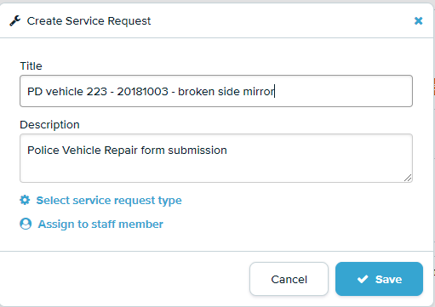

1. If you do not wish to tie the current communication to an existing service request and you simply wish to create a new request, start typing the new title, you'll see an option for "add 'blah blah blah' as a new service request", select this option. Note: If you do not see this option it may be because there are many service requests with the same title. Simply scroll down to the end of the list and you will see “Add ‘…..’ as a new service request.”



1. Click “Assign to staff member”. Click Assigned Staff Member 🡪 Select user 🡪 type “Garage Supervisor”. Hit the blue save button when done.

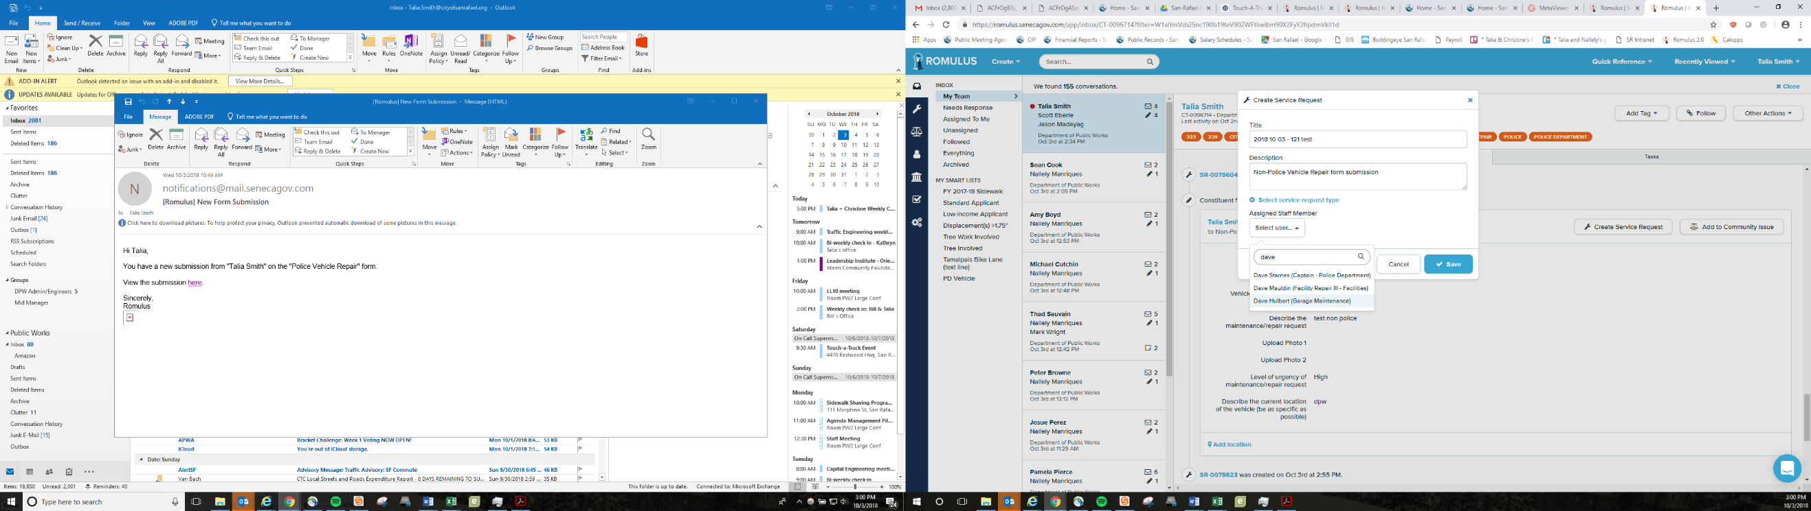

1. A new window will pop up. Click on the wrench icon on the left menu. Under “My SMART Lists” click on the “PD Vehicle – active” list (*or “Non-PD Vehicle - active” list if it was a Non-PD car*). The window will look like window below, and the service request you just made will be at the top:

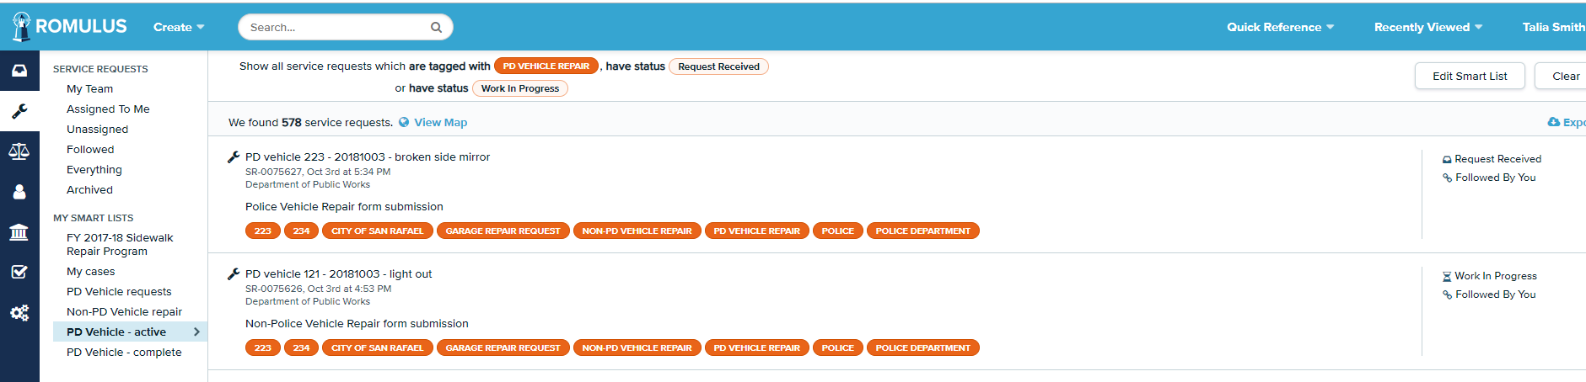

Click on the service request you just made, and the window will look like this:

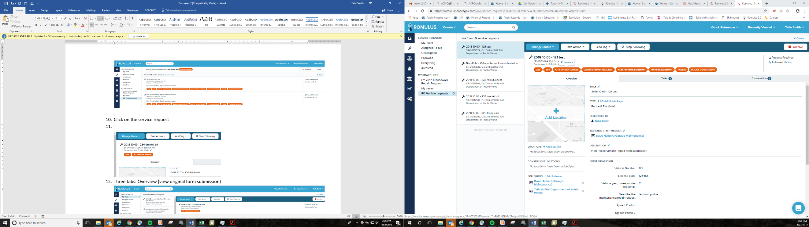

1. All the orange ovals on the top are “tags”. If someone submitted the form who has submitted multiple forms in the past, you’ll have to do a little clean up and delete old “tags” that don’t apply to this service request. Delete tags by hovering your mouse over them until a “Remove” button pops up. Delete every tag except the **vehicle number of the current service request** (should be in the name of the service request) **and the tag “PD vehicle repair”** *(or if it’s not a PD vehicle leave the “Non-PD vehicle repair” tag and the Department name tag)*

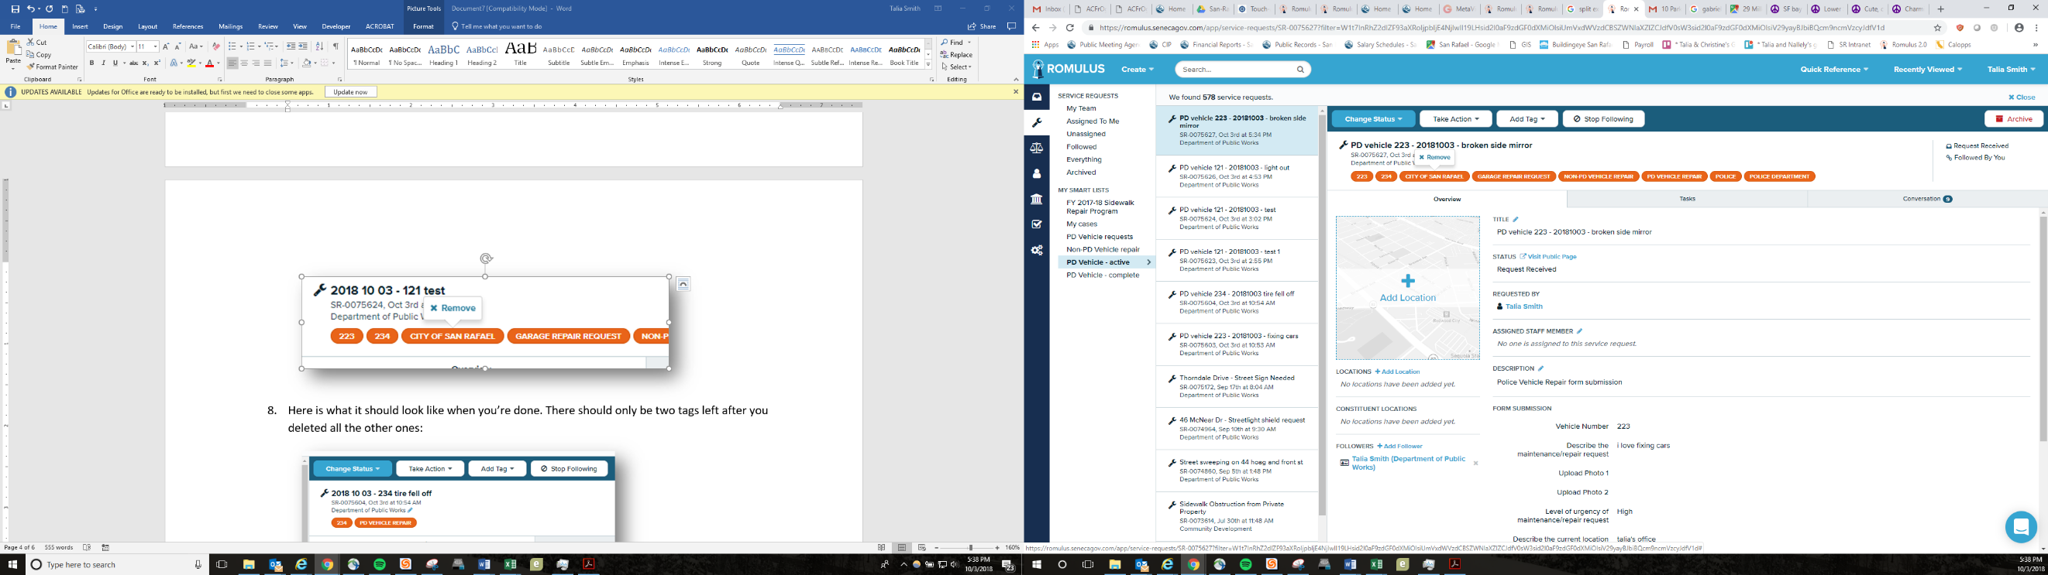

1. Here is what it should look like when you’re done. There should only be two tags left after you deleted all the other ones:

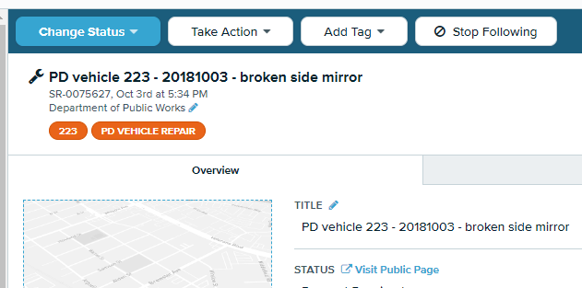

1. Your service request is all set up. There are three tabs: **Overview**, **Tasks** and **Conversation**.

**Overview**: view original form submission. Photos will be here if the person uploaded them  
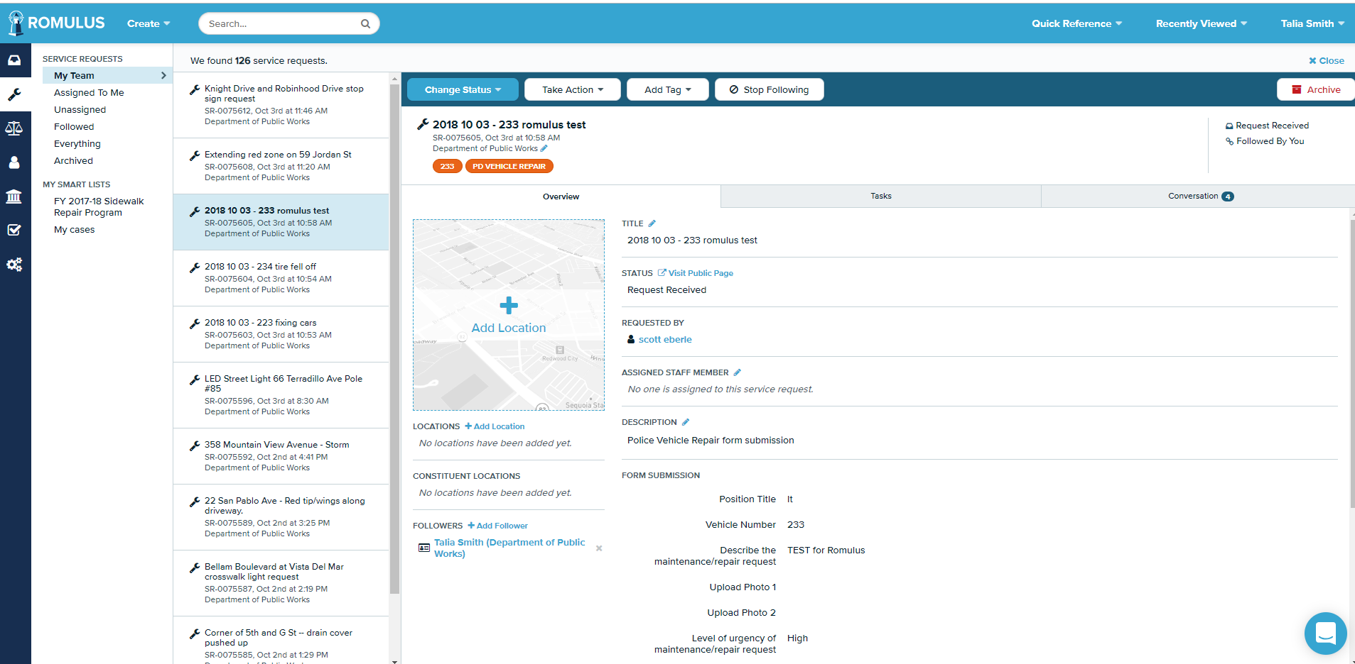

**Task**: Create any checklist tasks associated with the specific service request. Click “+ Create New Task in the upper right”

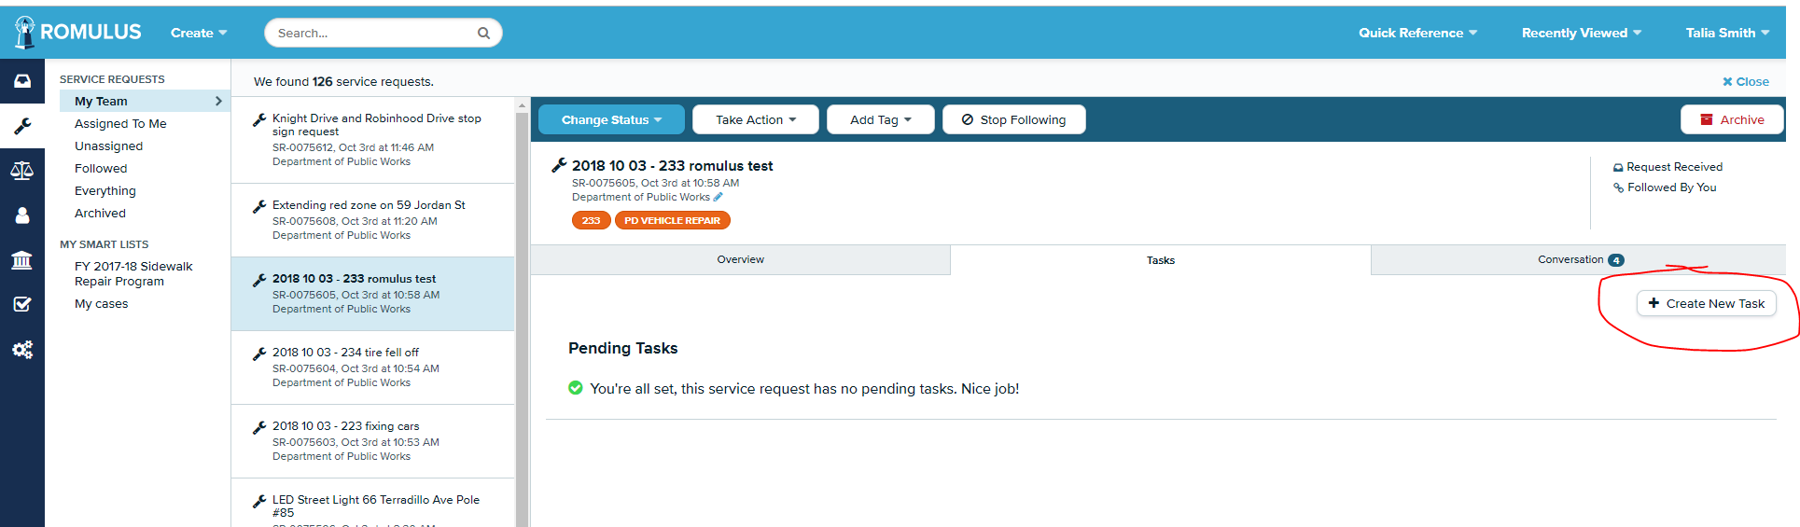

**Conversation**: Communicate with the person who submitted the form here. For example, if you want to write to the person and let them know when you plan on working on the vehicle, or if they write you back with more detail. Note: **all** previous form submissions ever submitted by this person will be in the conversation string here. But you probably will only care about what is at the very bottom of the string.

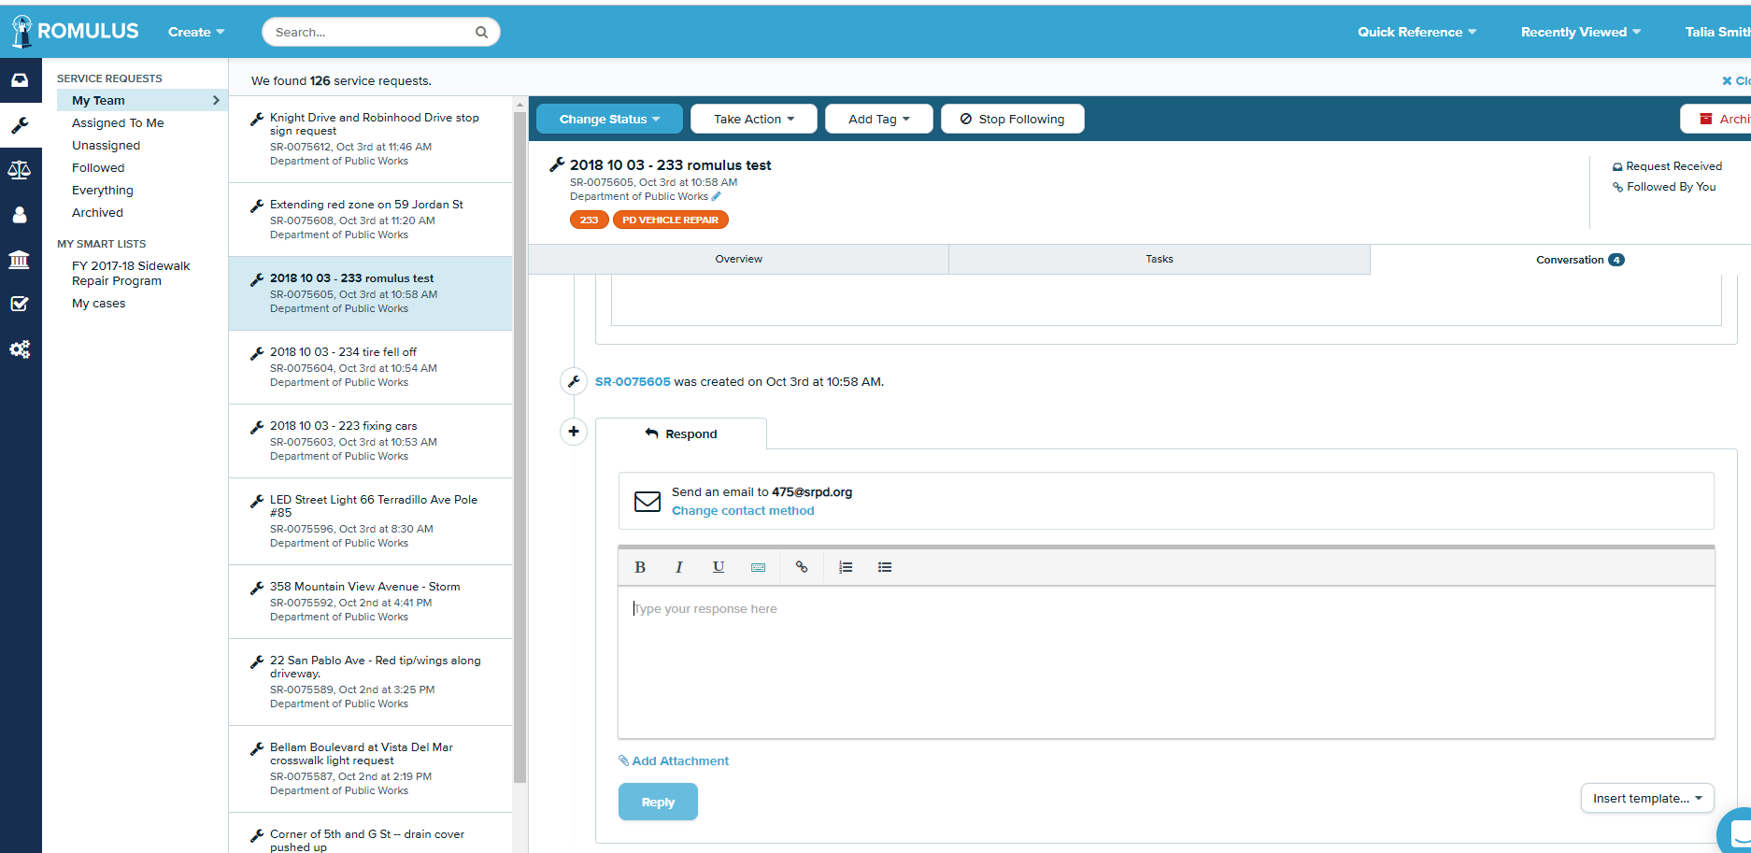

1. When the time comes where the service request is complete, open up Romulus: <https://romulus.senecagov.com/app/>. Click on the wrench in the left menu, then under “My Smart Lists” click on “PD Vehicle – active”. Find the service request and click on it. You might want to first use the conversations tab to send an email to the person who submitted it letting them know it’s ready to be picked up, etc. Then click on the blue button on the top “Change Status” and select “Service Completed”.



## Creating a template:

1. Go to settings
2. Click “Response Templates”

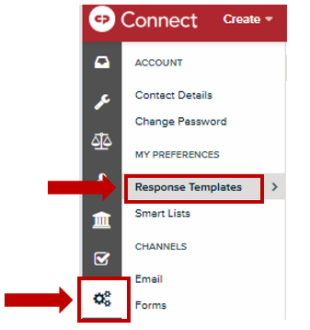

1. 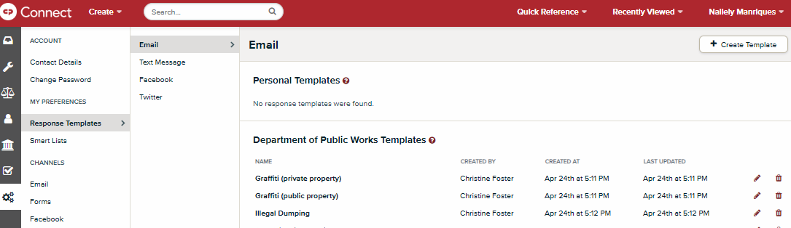Click “Create Template” at upper right-hand corner of screen
2. Title the template

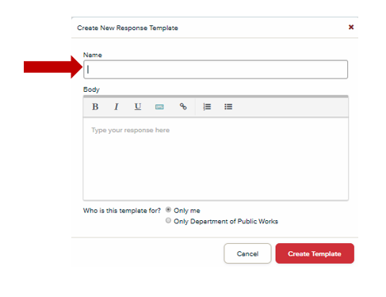

1. Insert the body of the message in the box
2. Click “Only Department of Public Works” at the bottom of the body section to share with DPW Romulus Team or “Only me” if a personal template.
3. Click “Create Template” to save.
4. 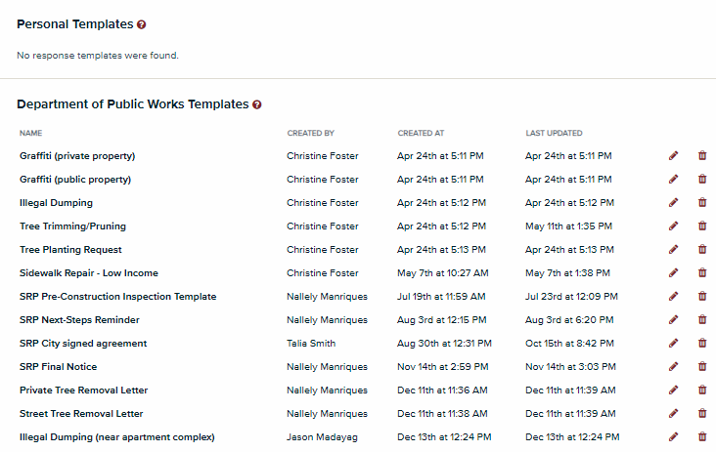The template should appear in the Department of Public Works Templates list. Use the pencil to edit the template should you need to make changes.