Summary
This memo summarizes the status of 1) RHNA 6, which will assign housing target numbers to cities in the Bay Area, and 2) Plan Bay Area/Blueprint, which is a related, long range visioning exercise for the region.
In accordance with State law, every city in California is assigned a housing growth target as part of the Housing Element update process. This target, or Regional Housing Needs Allocation (RHNA), is based on the State’s overall projection for regional growth and then distributed to each jurisdiction in the region through an allocation methodology that will likely weight factors such as access to jobs or good schools, among others. The average city in the Bay Area will see their RHNA increase by 2.3 times compared to the last housing element cycle, with job rich cities potentially seeing allocations ten times larger than last time. ABAG has developed an educational online tool where stakeholders can learn more and explore potential factors https://rhna-factors.mtcanalytics.org/.
The primary method for cities to offer input to the RHNA process is through their designated representatives (see list under RHNA Factors: Methodology Committee, below). Additionally, cities were previously given the opportunity to offer information through a survey, but it was more technical in nature and less about subjective priorities. At this time, there is no formal way for cities to offer input, but some are considering sending a letter to the relevant ABAG staff person. There is no official timeline for sending in correspondence, but the earlier it is in the process, the more likely it will be useful in decision making. Pre-draft numbers are expected in the fall.
Most cities in Santa Clara County will likely need to rezone to accommodate more housing to meet the RHNA numbers, and that rezoning should be happen in conjunction with the housing element update, which has an adoption deadline of January 2023. To meet that schedule, the process should be started as early as possible.
Housing Elements
Background
For many decades, California has not produced enough housing to accommodate population growth. Many cities have prioritized zoning for jobs rather than housing. This has contributed to high housing prices, overcrowding, displacement of residents and suffering as people struggle to pay their rent.
To help address this, the State requires that every jurisdiction update their Housing Element every eight years cities, and to have it certified by the California Department of Housing and Community Development. The Housing Element schedule is different in each part of the state. The deadline for cities in the Bay Area is January 2023, with the adopted plan covering the years 2023-2031.
One of the key sections of the Housing Element is the Inventory of Sites Available for Housing (Sites Inventory). In this section of the Housing Element, cities must document that they have enough land zoned for housing. The key question is how much is enough?

Regional Housing Needs Allocation
In the fall of 2020, each city will receive their pre-draft RHNA or target for the number of housing units, by income category, that they must plan for. Cities must demonstrate, through a parcel specific analysis and review of related development regulations, that there is enough land zoned for housing to accommodate their RHNA, with appropriate standards and practices to facilitate new development, especially to serve lower income households.
There are two parts to the RHNA: the number for the nine-county Bay Area region, and then each jurisdiction’s specific share. If one thinks of RHNA as a pie, the amount for each jurisdiction will be based on how big the pie is, as well as the size of their slice.
The number for the region was released in June 2020 and is 2.3 times larger than last cycles. The income category targets are a similar percentage to last cycle. ABAG chose not to appeal this number, so it is final. The number is larger than previous cycles of technical changes in the State’s methodology (e.g., changing assumptions that better account for existing overcrowding.) The average Bay Area city will be expected to plan for a little under 20 percent population growth by 2030. This number is based on natural increase (births minus deaths), migration (people moving in minus people moving out) and the size of households.
The numbers are summarized below.
Income Category | Housing Unit Need | Percent
Very Low Income (0-50% AMI*) | 114,442 | 26%
Low Income (50-80% AMI) | 65,892 | 15%
Moderate Income (80-120% AMI) | 72,712 | 17%
Above Moderate Income (120%+ AMI) | 188,130 | 43%
TOTAL | 441,176 | 100%

The other variable is the city-specific allocation (the size of the slice). This will be determined by a committee that ABAG has convened called the Housing Methodology Committee, with their recommendation then approved by the ABAG Executive Board. Most of this memo will focus on the factors that the Methodology Committee is considering for the methodology which will ultimately shape their recommendations.
Plan Bay Area
There is a parallel process that MTC/ABAG is facilitating called the Plan Bay Area/Blueprint (PBA or Blueprint for short). This long term, 30-year visioning exercise imagines what the Bay Area might look like if cities and the region made specific policy choices. However, the scenarios imagined through PBA do not obligate cities to take action. Local jurisdictions still retain land use authority. The RHNA methodology must be “consistent” with Plan Bay Area. The draft Blueprint was released in early July 2020 and the final Blueprint is expected in December 2020.
Plan Bay Area affects the Housing Elements in several ways:
- Setting the maximum RHNA for each jurisdiction. A city’s RHNA cannot be higher than the growth projected in Plan Bay Area. However, since PBA is a 30 year document and Housing Elements are eight year documents, it is not too likely that this cap will come into effect.
- Potentially determining the RHNA for each jurisdiction – The Housing Methodology Committee may decide to use the maps created by Plan Bay Area to completely determine each city’s RHNA or use it in combination with other factors.
The draft Plan Bay Area forecasts rapid growth in Santa Clara County. This is due to a variety of factors including strong job growth and more large redevelopment opportunities. The document authors report they attempted to compensate for changes to the region due to the pandemic, including assuming 1/3 of office workers would work from home.
Timeline
Available HCD releases number for the region
Available Draft Blueprint (which may affect RHNA allocations)
Fall 2020 Draft methodology / hints at allocations
Dec 2020 Final Blueprint
Spring 2021 Final methodology / draft allocations
Winter 2021 Final allocations
Jan 2023 Housing Elements due

RHNA Factors
Methodology Committee
The Housing Methodology Committee is charged with dividing the number supplied by the State between each jurisdiction. They will use factors to do this. For example, their methodology might weight access to jobs and good schools heavily. The committee meets monthly through October 2020. Santa Clara County’s representatives are Neysa Fligor, Vice Mayor, City of Los Altos; Michael Brilliot, Deputy Director for Citywide Planning, City of San Jose; Aarti Shrivastava, Assistant City Manager/Community Development Director, City of Mountain View.
The Methodology Committee will issue its recommendations to the ABAG’s Regional Planning Committee and Executive Board for final approval in 2021.
Requirements
There are a number of statutory requirements that must be followed when distributing the RHNA. If it does not meet these objectives, the State will not accept the methodology.
- Objective 1: Increasing the housing supply and the mix of housing types, tenure, and affordability in all cities and counties within the region in an equitable manner.
- Objective 2: Promoting infill development and socioeconomic equity, the protection of environmental and agricultural resources, the encouragement of efficient development patterns, and the achievement of the region’s greenhouse gas reductions targets.
- Objective 3: Promoting an improved intraregional relationship between jobs and housing, including an improved balance between the number of low-wage jobs and the number of housing units affordable to low-wage workers in each jurisdiction.
- Objective 4: Allocating a lower proportion of housing need to an income category when a jurisdiction already has a disproportionately high share of households in that income category.
- Objective 5: Affirmatively furthering fair housing.
Factors
ABAG is currently considering basing each jurisdiction’s RHNA on its population, and then adjusting that based on one or more factors. The factors were developed based on comments from the Methodology Committee. However, it is important to remember that this is not a final list of factors and it is likely to change dramatically. It should be used as an educational tool to understand how factors influence the process generally, rather than a prediction of likely outcomes.
One potential way for cities to offer input is to specify which of these factors would most fairly distribute the RHNA, though it is difficult because the conversation tends to be highly technical.
Potential factors are summarized below:
- Access to High Opportunity Areas – More housing units allocated to jurisdictions with the most access to opportunity (e.g. good schools, low poverty, etc.).
- Divergence Index – More housing allocated to jurisdictions that are more segregated compared to the rest of the region.
- Job Proximity – More housing allocated to jurisdictions with easy access to regional job centers.
- Vehicle Miles Travelled (VMT) – More housing allocated to jurisdictions with a high number of vehicle miles travelled per worker.
- Jobs-Housing Balance – More housing allocated to jurisdictions with a high number of jobs relative to the amount of housing.
- Jobs-Housing Fit – More housing allocated to jurisdictions with a high number of low-wage jobs relative to the number of low-cost rental units.
- Future Jobs – More housing allocated to jurisdictions with a higher share of projected jobs.
- Transit Connectivity – More housing allocated to jurisdictions with existing and planned transit infrastructure.
- Natural Hazards – More housing allocated to areas with low natural hazard risk.
Taking into account the above, At the June meeting, the committee voted to give higher allocations to jurisdictions that 1) have more jobs than housing or are near job centers and 2) have high opportunity areas. High opportunity areas are defined based on factors such as quality of schools and low crime.
Implications for Santa Clara County
It is difficult at this point to predict what the outcome of the RHNA process will be for Santa Clara County jurisdictions. That said, we know that the overall regional growth projection will be close to 20% over the eight-year period. Without any weighting, this would correspond to more than doubling the previous RHNA for Santa Clara County jurisdictions.
However, State law requirements, best planning practices, and comments from Housing Methodology Committee members imply that the allocation for Santa Clara County may be much higher. There are a few categories of cities that are more likely to have significantly higher RHNA numbers. These include:
- Job rich cities – Cities may be expected to close some or all of their jobs/housing imbalance as part of the RHNA process. Many members of the RHNA methodology committee have said that they want employment to be the primary driver of RHNA. The current visualization tool does not reflect this desire, but this may change. See Appendix A for a list of job rich cities.
- Small towns near job rich cities – In Southern California, the methodology greatly increased RHNA numbers for small, residential towns near job centers. For example, West Hollywood’s RHNA increased from 77 to 3,460. Currently, the visualization tool does not predict this, but it is a possibility.
- Cities with good public transportation networks – ABAG may choose to put more RHNA near cities with access to public transportation to reduce greenhouse gasses.
- Cities with opportunity areas – Housing methodology committee members have also expressed a strong interest in having more housing in areas of high opportunity (low poverty, good schools, etc.) This would most significantly affect northern Santa Clara County and West Valley cities. See Appendix B.
Interested stakeholders are encouraged to learn more by using ABAG’s visualization tool, https://rhna-factors.mtcanalytics.org/. Keep in mind, the tool is educational in nature and not predictive.

Appendix A

New Units Needed to Close Jobs/Housing Gap (Job Rich Cities Only)
 | Jobs | Employed Residents | Potential RHNA if Cities Are Expected to Close Job/Housing Gap | Existing RHNA
Campbell | 31,825 | 24,010 | 5,582 | 933
Cupertino | 40,658 | 29,575 | 7,916 | 1,064
Los Altos | 16,880 | 15,415 | 1,046 | 477
Los Gatos | 20,425 | 16,795 | 2,593 | 619
Milpitas | 51,500 | 42,440 | 6,471 | 3,290
Mountain View | 95,309 | 64,710 | 21,856 | 2,926
Palo Alto | 99,420 | 45,650 | 38,407 | 1,988
Santa Clara City | 165,255 | 70,500 | 67,682 | 4,093
Sunnyvale | 97,170 | 82,330 | 10,600 | 5,452
Notes: Uses city jobs data when available and ABAG projections when not. Employed Residents based on ABAG projections. Assumes 1.4 employees for household. Cities with more housing than jobs not shown. These data will be updated with the release of full jurisdiction-level projections from Plan Bay Area 2050.

Appendix B
The dark blue and lighter blue represent areas with high Opportunity Index scores, which may correspond to higher RHNA numbers.
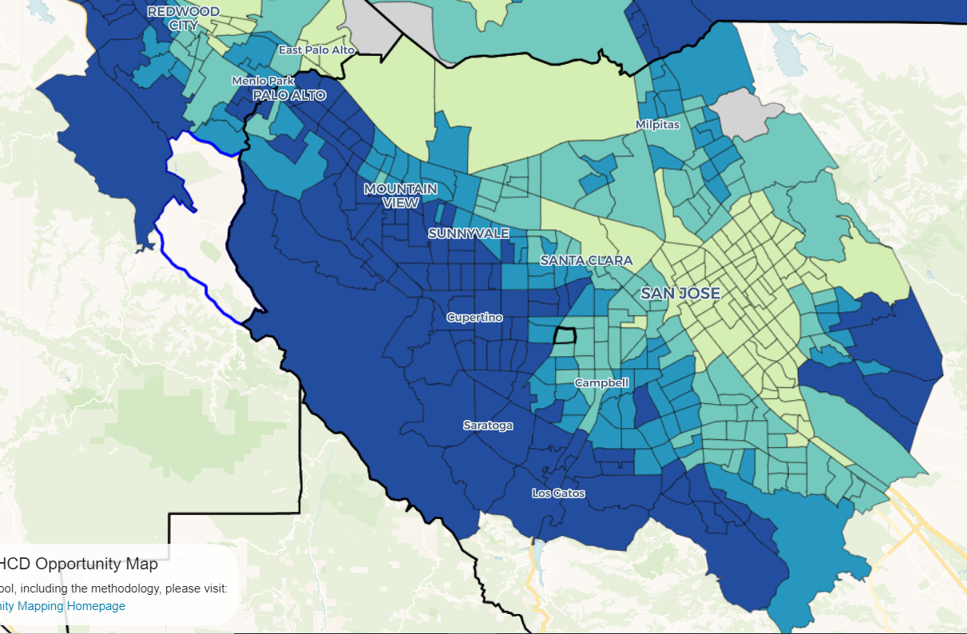
Source: https://www.treasurer.ca.gov/ctcac/opportunity.asp
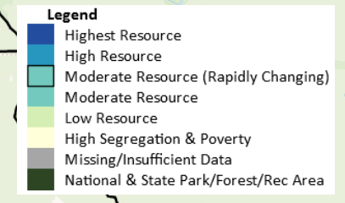
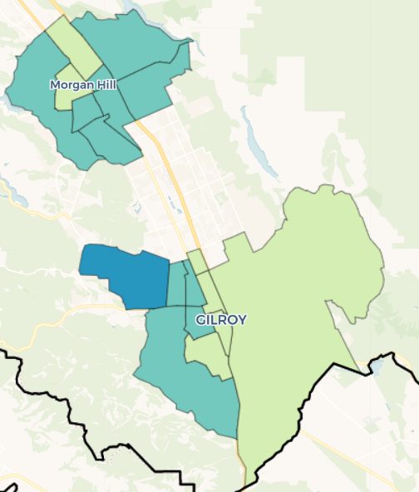

Pronounced REE nah
The Fall 2020 number is considered pre-draft, but will be a good indication. Final numbers are due Spring 2021.

