What is Affordable Housing in Santa Clara County (X Jurisdiction)?
When we all have safe, healthy, affordable homes we create opportunities for everyone to have a bright future, but our region’s housing shortage has made it increasingly harder for people to call Santa Clara County home. Many working and middle-income families cannot afford housing priced at market rates, and there aren’t nearly enough affordable housing options. Purchasing a home is out of reach for many low income and middle class families while renters face some of the highest rental rates in the country. There’s no single cause that has led us to this housing shortage and there’s no magic bullet that will solve it. Fortunately, there are a variety we can come together to address the need for affordable housing options for all members of the community.
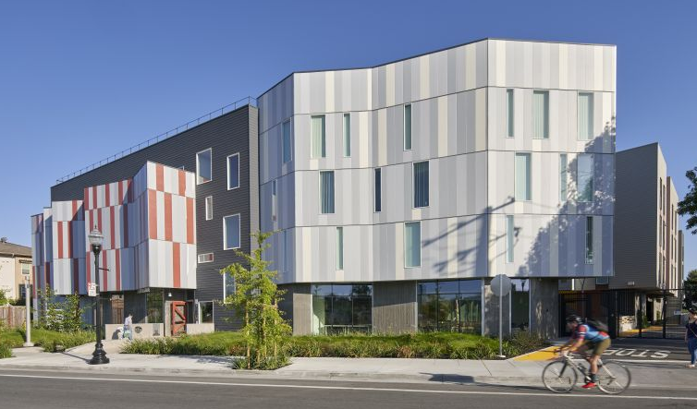
  - Together, we can rise up to this challenge.
Santa Clara County will need to produce 129,927 housing units for the eight-year period between 2023 to 2031, with 73,199 of them being for lower and moderate-income residents. Improving and expanding housing options is imperative in advancing social, racial, and economic equity and inclusion goals across Santa Clara County. All communities across the County and the state will have to do their part in producing affordable housing and welcoming new residents to achieve housing for all. If we don’t produce enough affordable housing, the lack of housing options will result in longer commute times for workers, gridlocked traffic, and increased pollution. By creating affordable housing options, we’ll create robust and diverse communities that support a strong quality of life and welcome people of all generations, families with children, and single adults who will bring their talents and skills to Santa Clara County. This also includes having homes that match the diversity of incomes in our community and are available for the workers we rely on as a community.
Affordable Housing Development Edwina Baker Plaza in Sunnyvale. Source: David Baker Architects.
  - What is affordable housing?
When we talk about affordable housing, we mean homes that are rented or sold at rents or sales prices that are lower than prevailing market rates. Affordable housing means your favorite hairstylist, your child’s teacher, or the friendly medical assistant at your doctor’s office can live close to their work. A medical assistant and a preschool teacher in Santa Clara County with two children would be in need of affordable housing with their combined average salaries of close to $90,000 a year. A year’s worth of rent would swallow up over 40% of their income, making them rent burdened. Consider a single-earner household of four. A daycare administrator with an average yearly income of about $55,000 heading a household of four. To afford market rent in Santa Clara County, 70% of this person’s income would be directed towards housing costs.
In Santa Clara County, the vast majority of purpose-built affordable housing is built and managed by private and nonprofit developers using a variety of funding and financing sources. Affordable housing programs generally target households who earn 80% or below of the area’s median income, which for Santa Clara County is $112,150 a year for a household of four. Households that pay more than 30% of their monthly income are considered “rent burdened” while families who pay over 50% of their monthly income are considered “severely rent burdened”.
The Wage and Housing Gap
(Based on fair market rent for a one bedroom in Santa Clara County (hcd.ca.gov). Wage information from the California Employment Development Department)
Occupation |  | Mean Annual Wage | % of AMI for 3 person HH | % of Monthly income needed to afford average market rent for a two-bedroom unit
Dishwashers | $30,160 |  | 24% | 127%
Retail Salespersons | $39,987 |  | 31% | 96%
Security Guards | $41,512 |  | 33% | 93%
Daycare & Preschool Administrators | $55,020 |  | 43% | 70%
Police Officers | $130,911 |  | 103% | 29%
Preschool Teachers | $41,563 |  | 33% | 92%
Hair Dressers | $33,384 |  | 26% | 115%
Medical Assistants | $47,846 |  | 38% | 80%
Receptionists and Information Clerks | $39,239 |  | 31% | 98%

Frequently Asked Questions about Affordable Housing
FAQs on affordable housing
- Who builds and manages affordable housing?
  - The vast majority of purpose-built affordable housing is built and managed by private and nonprofit developers using a variety of Federal, State., Local Government and private funding and financing sources.
- Who qualifies for affordable housing?
  - Affordable housing programs generally target households who earn 80% or below of the area’s median income, which for Santa Clara County is $112,150 a year for a household of four. See the tables below for more details on income levels and wages for the County as of February, 2021.
- Who lives in affordable housing?
  - Seniors, families with children, people facing health challenges or disabilities, or those who simply are starting a new phase of life – in short, people of all backgrounds.
- What does affordable housing look like?
  - Affordable housing is built in a wide range of architectural styles and densities. They can be midsize to large multifamily family developments, duplexes, triplexes, quadplexes, granny units, or cottage clusters. Affordable housing must comply with the same zoning codes, restrictions, and design standards as market-rate housing. Often, because affordable housing projects frequently rely on some public money, they have to comply with additional restrictions and higher standards than market-rate housing.
- I’ve heard affordable housing makes traffic worse and brings in crime-- is that true?
  - Affordable housing residents tend to own fewer cars and drive less and many affordable housing developments are located near transit centers. Local governments can also adopt policies that encourage affordable housing developments near job centers so affordable housing can help reduce traffic.
- Will an increase of affordable housing lead to overcrowded schools or affect the quality of our schools?
  - Households living in affordable housing on average have fewer children than those living in single family homes. School staff and teachers can benefit from affordable housing as well since wages for educators have not kept up with rising housing costs. A more robust supply of affordable housing options can be key to retaining talent in our schools. Lastly, children’s educational performance can be affected if they aren’t able to stay in one school for long and are forced to move around due to unstable housing. Affordable, stable housing provides a foundation for children to learn better.

Data and Tables

Santa Clara County AMI Table:
Number of Persons in Household | 30% | 50% | 80% | 100%
1 | $ 33,150 | $ 55,300 | $ 78,550 | $ 99,100
2 | $ 37,900 | $ 63,200 | $ 89,750 | $ 113,300
3 | $ 42,650 | $ 71,100 | $ 100,950 | $ 127,450
4 | $ 47,350 | $ 78,950 | $ 112,150 | $ 141,600
5 | $ 51,150 | $ 85,330 | $ 121,150 | $ 152,950

Source: HCD (hcd.ca.gov), 2020 Income Limits
The Wage and Housing Gap
Occupation | Mean Annual Wage | % of AMI for 1 person HH | % of Monthly income needed to afford average market rent for a one-bedroom unit
Dishwashers | $30,160 | 30% | 98%
Retail Salespersons | $39,987 | 40% | 74%
Security Guards | $41,512 | 42% | 71%
Daycare & Preschool Administrators | $55,020 | 56% | 54%
Police Officers | $130,911 | 132% | 23%
Preschool Teachers | $41,563 | 42% | 71%
Hair Dressers | $33,384 | 34% | 88%
Medical Assistants | $47,846 | 48% | 62%
Receptionists and Information Clerks | $39,239 | 40% | 75%

(Based on fair market rent for a one bedroom in Santa Clara County (hcd.ca.gov). Wage information from the California Employment Development Department)

