Senate bill 9 (sb 9): an overview

What it is and How it Impacts Residential Land Use

Senate Bill 9 (SB 9) is a new California State Law taking effect January 1, 2022.
Similar to previous state legislation on Accessory Dwelling Units (ADUs), SB 9 overrides existing density limits in single-family zones. SB 9 is intended to support increased supply of starter, modestly priced homes by encouraging building of smaller houses on small lots.

SB 9 Waives Discretionary Review and Public Hearings For:

Building Two Homes

on a parcel in a single-family zone
&

subdividing a lot into two
that can be smaller than required min. size

Used together, this allows 4 HOMES where 1 was allowed before.
SB 9 can be used to: Add new homes to existing parcel • Divide existing house into multiple units • Divide parcel and add homes

What it Can Mean for Development of New Homes
Illustrations are based on a preliminary analysis of the law. Details are subject to change and are for informational purposes only.

 | Vacant lot |  |  | Lot with  Single-Family Home |  |  | Lot with  Nonconforming duplex |  |  | Lot with Single-family Home and an ADU
BEFORE | No units |  |  | 1 unit |  |  | Up to 2 units  (nonconforming) |  |  | 1 unit  + 1 ADU/JADU
ADD UNITS,  NO LOT SPLIT | 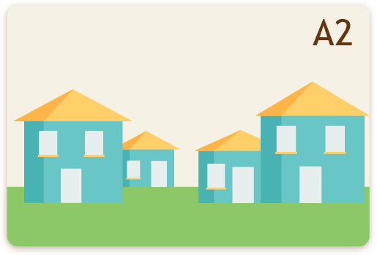  Up to 2 units  + 2 ADUs/JADUs |  |  | 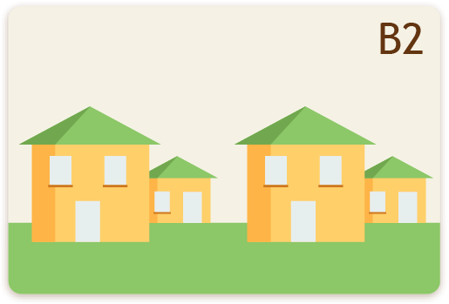  Up to 2 units  + 2 ADUs/JADUs |  |  | No additional units |  |  | 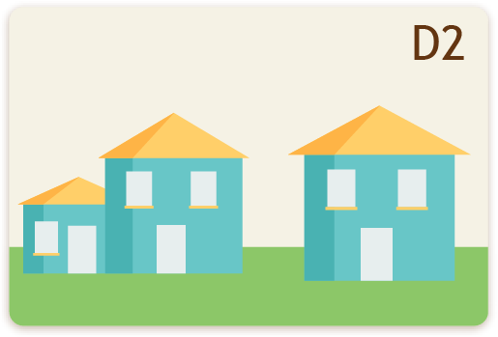  Can add 1 addtl. unit  + 1 ADU/JADU
ADD UNITS, NO LOT SPLIT | 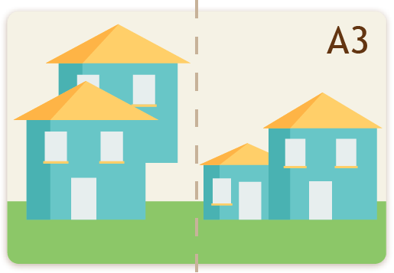  Up to 4 total units |  |  | 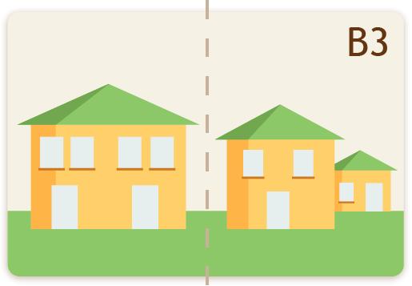  Up to 4 total units |  |  | 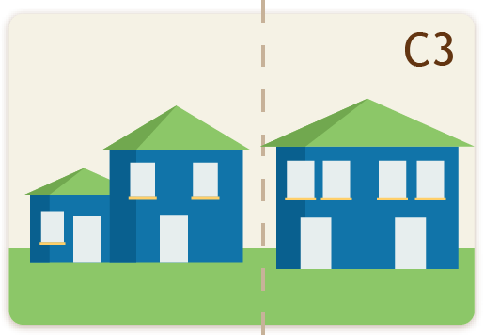  Up to 4 total units |  |  | 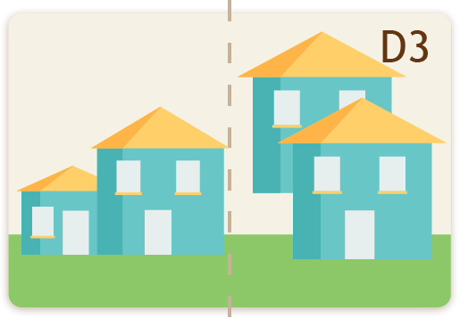  Up to 4 total units

Using SB 9 Without a Lot Split:

- Without a lot split, SB 9 does not limit the number of ADUs or JADUs (B2, D2) – but other laws might.
- SB 9 could be interpreted to allow 2 new units beyond an existing unit (up to 3 units/lot, plus any allowed ADUs/JADUs).

Using SB 9 With a Lot Split:
- SB 9 does not require jurisdictions to approve more than 4 units total, including any ADUs/JADUs.

Single-Unit Developments
SB 9 can be used to develop single units – but projects must comply with all SB 9 requirements.

DOES THE PROPERTY QUALIFY?

2-UNIT DEVELOPMENTS AND LOT SPLITS

Single-family lot (usually R-1)

Located in an urbanized area or urban cluster

Not in state/local historic district, not an historic landmark

Meets requirements of SB35 subparagraphs (a)(6)(B)-(K):

PROPERTY CANNOT BE:

Prime farmland or farmland of statewide importance (B)

Wetlands (C)

Identified for conservation or under conservation easement (I+K)

Habitat for protected species (J)

PROPERTY CANNOT BE (UNLESS MEETING SPECIFIED REQUIREMENTS):

Within a very high fire hazard safety zone (D)

A hazardous waste size (E)

Within a delineated earthquake fault zone (F)

Within a 100-year floodplain or floodway (G+H)

Project would not alter nor demolish:

Deed-restricted affordable housing

Rent-controlled housing

Housing on parcels with an Ellis Act eviction in last 15 yrs

Housing occupied by a tenant currently or in last 3 yrs

Addtl. Qualifications for  2-UNIT DEVELOPMENTS  Project does not remove more than 25% of exterior walls on a building that currently has a tenant or has had a tenant in the last 3 yrs even if the rental unit itself isn’t altered | Addtl. Qualifications for  LOT SPLITS  Lot is split roughly in half – smaller lot is at least 40% of the original lot  Each new lot is at least 1,200ft^{2 ,}  Lot is not adjacent to another lot split by SB 9 by the same owner or “any person acting in concert with the owner”  Lot was not created by a previous SB 9 split

Limitations Applied

2-Unit Devs. and Lot Splits
- Agencies MUST only impose objective zoning standards, subdivision standards, and design standards (they may impose a local ordinance to set these standards)
  - These standards must not preclude 2 units of at least 800ft²
- Projects must follow local yard, height, lot coverage, and other development standards, EXCEPT:
- A local agency MAY NOT require rear or side setbacks of more than 4 feet, and cannot require any setback if utilizing an existing structure or rebuilding a same-dimensional structure in the same location as an existing structure
- Project may be denied if a building official makes a written finding of specific, adverse impacts on public health or safety based on inconsistency with objective standards, with no feasible method to mitigate or avoid impact
- Agency may require 1 parking space/unit, unless the project is:
  - Within 1/2 mile of “high-quality transit corridor” or “major transit stop”
  - Within 1 block of a carshare vehicle
- Agency must require that units created by SB 9 are not used for short-term rental (up to 30 days)
- Agency must allow proposed adjacent or connected structures as long as they comply with building codes and are “sufficient to allow separate conveyance”

- HOAs may restrict use of SB 9
2-Unit Devs | - Without a lot split, agency cannot use SB 9 to limit ADUs/JADUs e.g., lot can have 2 primary units+1 ADU+1 JADU  - Agency must include # of SB 9 units in annual progress report | - For properties with on-site wastewater treatment, agency may require a percolation test w/in last 5 years or recertification within last 10 years
Lot Splits | - Agency may approve more than 2 units on a new parcel including ADUs, JADUs, density bonus units, duplex units  - Project must conform to all relevant objective reqs. of Subdivision Map Act  - Agency may require easements for provision of public services and facilities  - Agency may require parcels to have access to, provide access to, or adjoin public right of way | - Project must be for residential uses only  - Applicant must sign affidavit stating they intend to live in one of the units for 3+ years  - Agency must include number of SB 9 lot split applications in annual progress report  - Agency cannot require right-of-way dedications or off-site improvements  - Agency cannot require correction of nonconforming zoning conditions

Relationships to Other Laws
CEQA Does not apply to 2-unit or lot split approvals
or ordinances implementing 2-unit or lot split provisions
Coastal Act Applies, but no public hearings needed for duplex and lot split coastal development permits
Housing Crisis Act Local ordinances cannot impose restrictions that reduce the intensity of land use on housing sites (including total building envelope, density, etc.)
SB8 SB 9 projects are subject to Permit Streamlining Act deadlines
SB478 Does not apply to single-family zones

Key Decisions for Agencies to Make
Whether to require:  - 1 parking space per unit  - 2-units Septic tank percolation tests  - 2-units Owner-occupancy  - Split Public services/facilities easements  - Split Right-of-way easements  Whether to allow:  - Creation of lots <1,200ft²  - Split >2 units/new lot | Define:  - Objective zoning/subdivision/  design review standards  - “Acting in concert with owner”  - “Sufficient for separate conveyance”  Create:  - Application forms and checklists  - Recording of deed restrictions for short-term rentals and future lot splits  - Owner-occupancy affidavit

Legally constructed but not currently permitted. Check your local ordinance for nonconforming use policies.
Defined by the Census Bureau
See Section 65913.4(a)(6) Exclusions for full details and definitions
Lot can split, then new units added to the lot w/o the Ellis-affected building
Each lot can be smaller than required minimum lot size
This number can be lowered by local ordinance
If min. size is 1,200ft², this requires a 2,400ft² lot, or 3,000ft² if a 60/40 split
This does not apply to previous lot splits taken under usual Map Act procedures
“Objective” as defined by the Housing Accountability Act
See Sections 21155 and 21064.3 of the Public Resources Code for definitions
Unless the applicant is a land trust or qualified non-profit

