SWIMMING POOL AND SPA
PROJECT REQUIREMENTS
AND PLAN NOTES
Revised 6/25/2018
Effective 1/1/2018

THE REQUIREMENTS LISTED BELOW SHALL BE INCORPORATED INTO THE WORK UNLESS MORE RESTRICTIVE REQUIREMENTS ARE OTHERWISE SHOWN OR SPECIFIED ON THESE APPROVED PLANS.

GENERAL NOTES
- Outdoor swimming pools and spas shall be located not less than five feet from a side or rear property line. [Sonoma Municipal Code Chapter (SMC) 19.40.110.C.3.h.].
- Swimming pools and spas shall not be located within recorded easements unless specifically allowed by said easements.
- Swimming pools and spas shall not be located under overhead electrical conductors unless the requirements of section 680.8 of the CA Electrical Code is met.
- All outdoor swimming pool and spa equipment (i.e. pumps, motors, filters, heaters, etc.) shall be located not less than 3 feet from a property line. [SMC 19.40.110.C.3.c.i.].
- All outdoor swimming pool and spa equipment shall not exceed a height of four feet, measured from the finished grade at the base of the unit unless the equipment is setback from the property line as required for buildings. [SMC 19.40.110.C.3.c.ii.]
- Outdoor, in-ground swimming pools and in-ground spas shall be located not less than the maximum depth of the pool or spa plus 2 feet away from a wall of a building, unless pool structural engineering and a geotechnical report is provided to support a closer distance.
- All swimming pools and spas shall comply with the following codes:
- 2016 California Building Code (CBC)
- 2016 California Mechanical Code (CMC)
- 2016 California Electrical Code (CEC)
- 2016 California Plumbing Code (CPC)
- 2016 California Energy Code (Energy)
- 2016 CALGreen (CALGreen)
- Sonoma Municipal Code (SMC)
- The contractor shall provide the consumer notice of the requirements of the State of California Swimming Pool Safety Act (CA Health and Safety Code Sections 115921 – 115929). [NOTE: SB 422 Revisions Effective 1/1/2018.]
- Pool cover vaults and backwash drains shall not drain to the public storm drain system. Provide an approved gravel filled drywell not less than 18 cu. ft. (2.5 ft. x 2.5 ft. x 3 ft.) to drain pool cover vaults and backwash drains unless some other approved drainage method is designed and approved by the Building Department.
NON-SITE-SPECIFIC AND TYPICAL EROSION AND SEDIMENT CONTROL
BEST MANAGEMENT PRACTICES (BMP’S)

Excavation and trenching for all swimming pools and spas shall comply with the following Non-Site-Specific and Typical Erosions and Sediment Control Best Management Practices (BMP’s) to the maximum extent practicable for the duration of the project, including the following: [SMC 14.20.100]
- Vehicle and heavy equipment ingress and egress to the construction site shall be limited to paved or reinforced entrances. Reinforced entrances shall be designed, built, and maintained so as to prevent sediment from “tracking-out” into the public right-of-way on vehicle and heavy equipment tires.
- All dirt or sediment tracked into the public right-of-way shall be promptly removed as soon as feasible and no less frequently than at the end of each working day. Dry sweeping methods are to be used for sweeping.
- Existing vegetation shall be preserved wherever feasible to minimize disturbed soil area and associated erosion.
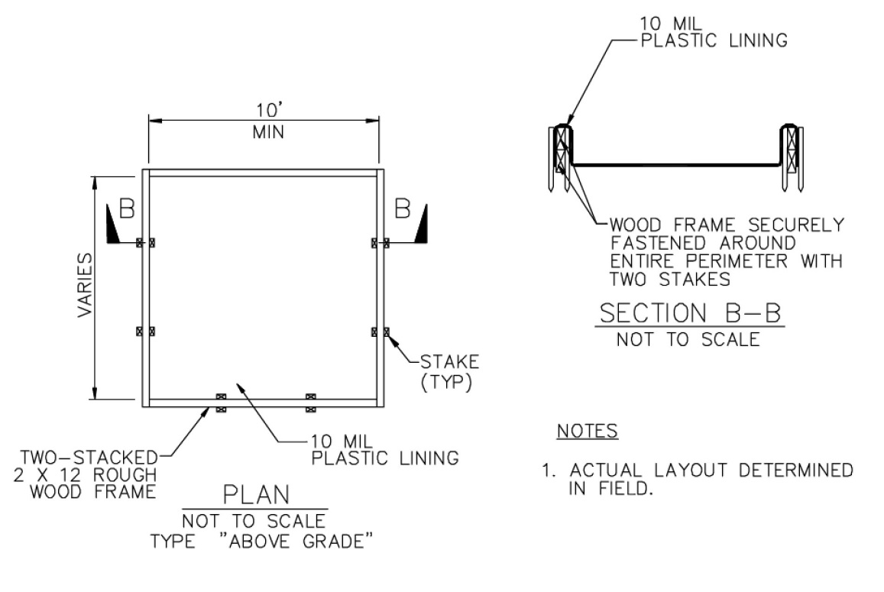
- All construction products including uncured paint, concrete, stucco, drywall mud, and mortar shall be protected from run-on during precipitation and wastes disposed of properly in a designated washout.

Typical Washout Facility

- All stockpiles of erodible materials shall be provided with erosion and sediment controls to prevent erosion and dust generation.
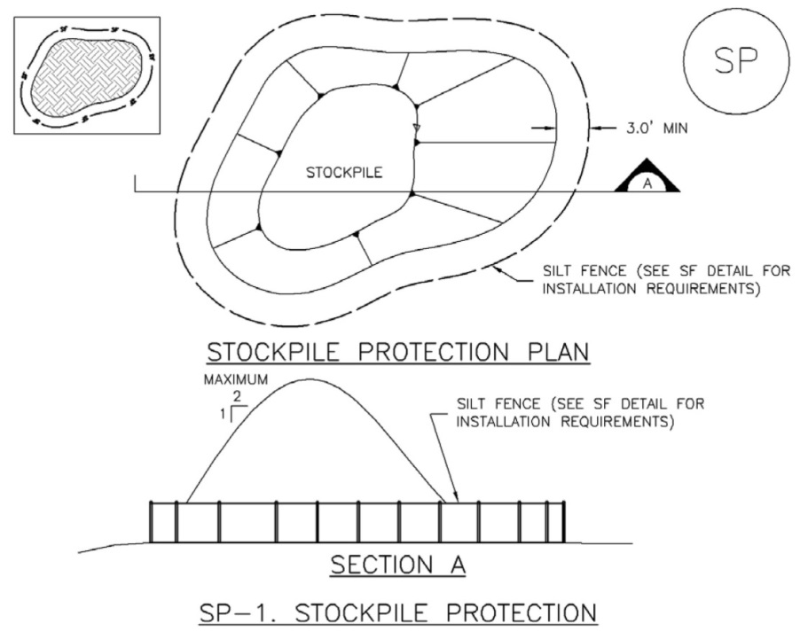
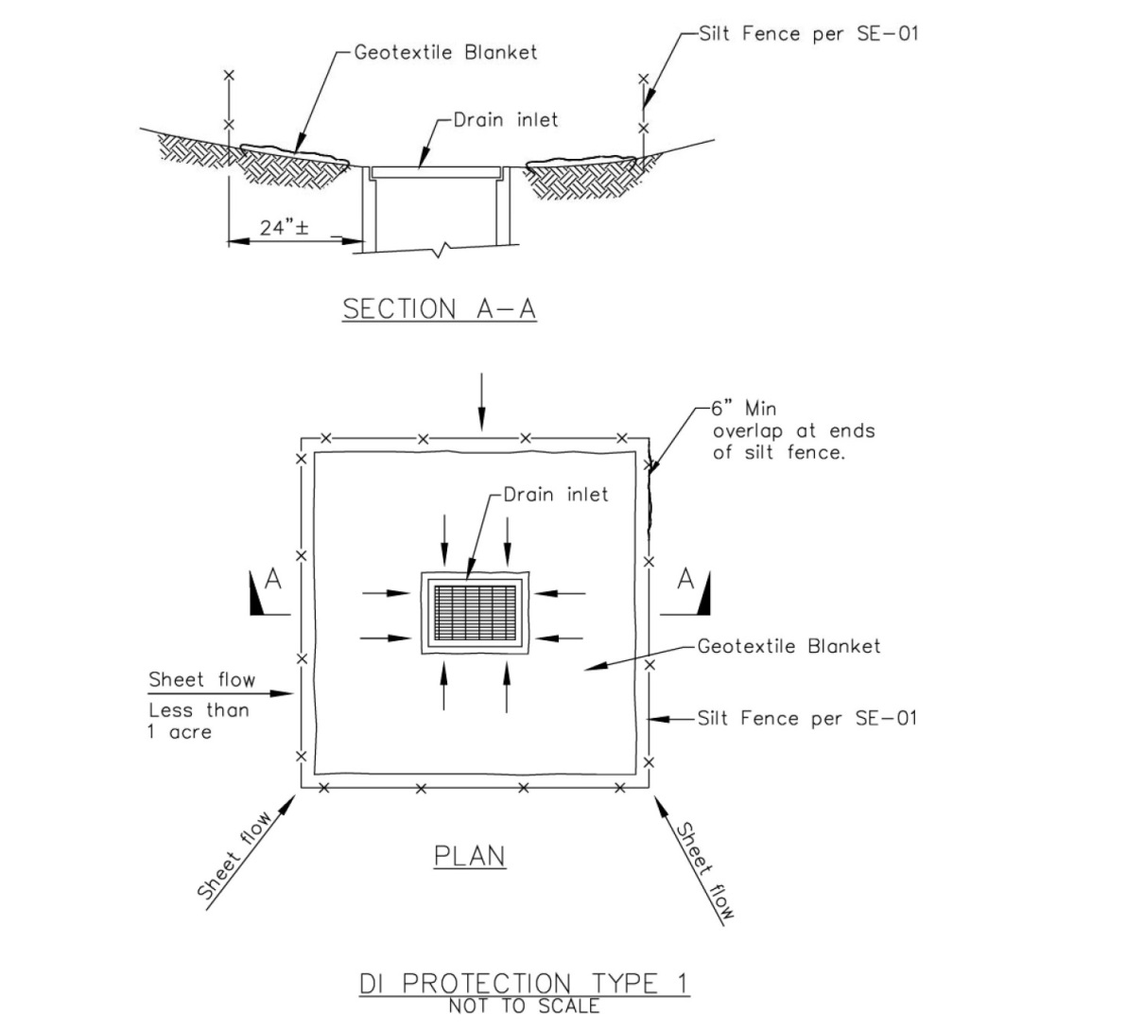
- All storm drain inlets on the site or receiving direct discharges of stormwater from the site shall be protected from sediment-laden discharges using appropriate BMP’s.
DROWNING PREVENTION AND ENTRAPMENT AVOIDANCE

- Drowning Prevention Safety Features. The pool and/or spa shall comply with the State of California Swimming Pool Safety Act and CBC sections 3109.4.4 through 3109.5. The swimming pool and/or spa shall be equipped with at least two (2) of the following seven (7) drowning prevention safety features as checked below: [CBC 3109.4.4.2. superseded by H&SC 115922(a) – Effective 1/1/18]

  - Fencing or Structure Enclosure. The pool and/or spa shall be isolated from access from the private single-family home (habitable or occupiable spaces) by an enclosure that meets the requirements of CBC Section 3109.4.4.3. [CBC 3109.4.4.2.1] [See Required Characteristics for Pool & Spa Enclosure Fencing or Structures below.]
  - Removable Mesh Pool Fencing. The pool shall and/or spa incorporate removable mesh pool fencing that meets American Society for Testing and Materials (ASTM) Specifications F 2286 standards in conjunction with a gate that is self-closing and self-latching and can accommodate a key lockable device. [CBC 3109.4.4.2.2.]
  - Approved Safety Pool Cover. The pool and/or spa shall be equipped with an approved safety pool cover that meets all requirements of the ASTM Specifications F 1346-91.. [CBC 3109.4.4.2.3 and 3109.4.4.5.2.]
  - Exit Alarms. Exit alarms shall be provided on the private single-family home’s doors that provide direct access to the swimming pool or spa. The exit alarm may cause either an alarm noise or a verbal warning, such as a repeating notification that “the door to the pool is open. [CBC 3109.4.4.2.4.] [See exit alarms below for further requirements.]
  - Special Doors. All doors providing direct access from the single-family home to the swimming pool or spa shall be equipped with a self-closing, self-latching device with a release mechanism placed no lower than 54 inches above the floor. [CBC 3109.4.4.2.5.]
  - Swimming Pool Alarms. Swimming pool and spa alarms that, when placed in pools, will sound upon detection of accidental or unauthorized entrance into the water. These pool alarms shall meet and be independently certified to the ASTM Standard F 2208 "Standards Specification for Pool Alarms" which includes surface motion, pressure, sonar, laser, and infrared type alarms. For purposes of this article, "swimming pool alarms" shall not include swimming protection alarm devices designed for individual use, such as an alarm attached to a child that sounds when the child exceeds a certain distance or becomes submerged in water. [CBC 3109.4.4.2.6.]
  - Other Approved Means. Other approved means of protection, if the degree of protection afforded is equal to or greater than that afforded by any of the devices set forth in items 3109.4.4.2.1 through 3109.4.4.2.4, and have been independently verified by an approved testing laboratory as meeting the standards for those devices established by ASTM or ASME. [CBC 3109.4.4.2.7.]

- Entrapment avoidance. Suction outlets shall be designed and installed in accordance with ANSI/APSP-7 and all of the following:
  - The suction outlets of a new pool or new spa for which a permit is issued shall be equipped to provide circulation throughout the pool or spa by installing at least two circulation suction outlets per pump that shall be hydraulically balanced and symmetrically plumbed through one or more “T” fittings, and that are separated by a distance of at least three feet in any dimension between the suction outlets; or be designed to use alternatives to suction outlets including, but not limited to, skimmers or perimeter overflow systems to conduct water to the circulation pump. The circulation system shall have the capacity to provide a complete turnover of pool water as specified in Section 3124B of Chapter 31B of the California Building Standards Code. [CBC 3109.4.4.8.1, 2 & 3.]
  - Suction outlets shall be covered with anti-entrapment grates as specified in the ANSI/APSP-16 performance standard or successor standard designated by the federal Consumer Product Safety Commission, that cannot be removed except with the use of tools. Slots of openings in the grates or similar protective devices shall be of a shape, area and arrangement that would prevent physical entrapment and would not pose any suction hazard to bathers. [CBC 3109.4.4.8.4.]
  - Any backup safety system that an owner of a new swimming pool or spa may choose to install in addition to the requirements set forth in CBC Sections 3019.4.4.8.1 through 3019.4.4.8, shall meet the standards as published in the document, “Guidelines for Entrapment Hazards: Making Pools and Spas Safer,” Publication Number 363, March 2005, United States Consumer Products Safety Commission. [CBC 3109.4.4.8.5]
  - Whenever a building permit is issued for the remodel or modification of any existing swimming pool, toddler pool, or spa, the permit shall require that the suction outlets of the existing swimming pool or spa be upgraded so as to be equipped with anti-entrapment grates, as specified in the ANSI/APSP-16 performance standard or successor standard designated by the federal Consumer Product Safety Commission. [CBC 3109.4.4.8.6]
  - Any person entering into an agreement to build a swimming pool or spa, or to engage in permitted work on a pool or spa covered by this subsection, shall give the consumer notice of the requirements of CBC Section 3109.5.[CBC 3109.4.4.4]
ELECTRICAL (2016 California Electrical Code)
- Outlets supplying pool pump motors connected to single-phase, 120 through 240 volt branch circuits, rated 15 or 20 amperes, whether by receptacle or by direct connection, shall be provided with ground-fault circuit-interrupter protection for personnel. [2016 CEC 680.21(C)]
- At least one 125-volt receptacle shall be located not less than 6 feet from, and not more than 20 feet from the inside wall of the pool. The receptacle shall be located not more than 6 feet 6 inches above the floor or grade serving the pool. [2016 CEC 680.22(A)(3)]
- Switching devices shall be located at least 5 feet horizontally from the inside wall of the pool or spa, unless separated by a solid fence, wall or permanent barrier. [2016 CEC 680.22(D)]
- All convenience receptacles on the property shall be not less than 6 feet from the pool or spa. [2016 CEC 680.22(A)(2)]
- All 125-volt receptacles located within 20 feet of the pool or spa shall be protected by a Ground Fault Circuit-Interrupter (GFCI). [2016 CEC 680.22(A)(4)]
- A ground fault circuit-interrupter (GFCI) shall be installed in the branch circuit supplying underwater light fixtures. [2016 CEC 680.23(A)(3)]
- Other Electrical Receptacle Outlets. Other electrical receptacle outlets shall be not less than 10 feet from the inside walls of the pool. FPN: Other outlets may include, but are not limited to, remote-control, signaling, fire alarm, and communications circuits. [2016 CEC 680.22 (D)]
- Outdoor pool equipment (i.e. pumps, filters and heating equipment) shall be located not less than 3 feet minimum from a property line. [SMC 19.40.110.C.3.c.i.]
- Maintenance Disconnecting Means. One or more means to simultaneously disconnect all ungrounded conductors. Each disconnecting means shall be located at least 5 feet horizontally from the inside walls of a pool, spa or hot tub. [2016 CEC 680.12]
- Equipotential bonding shall be provided for pools and spas to reduce voltage gradients in the pool area [2016 CEC 680.26]. See the attached drawings for further clarification.
FUEL HEATED POOLS (2016 California Energy Code)
- The following items must be installed in conjunction with any fuel heated swimming pool pursuant to the State of California Energy Code [2016 California Energy Code Sections 110(a) and (b)]:
  - The thermal efficiency of the equipment must comply with the appliance efficiency regulations. No electric resistance heating is allowed.
  - A readily accessible heater On-Off switch mounted on the outside of the heater for easy access to allow shutting off the operation of the heater without adjusting the thermostat.
  - A permanent weatherproof plate, easily readable, giving instructions for the energy-efficient operation of the swimming pool or spa heater and for the proper care of pool or spa water when a pool cover is used.
  - A 36-inch minimum length of plumbing between the filter and the heater, to allow for future solar heating equipment.
  - Outdoor fuel heated pools and spas shall be provided with a pool cover.
  - A time clock shall be provided and equipped so that the pump can be set to run in the off-peak electric demand period (unless required to operate an active solar pool heating system) and for the minimum time necessary to maintain the water in a clear and sanitary condition in accordance with public health standards require 24-hour operation, time clocks are not required.
  - Pools shall be provided with directional inlets to provide adequate mixing of pool water.

REQUIRED CHARACTERISTICS FOR POOL & SPA FENCING OR STRUCTURE ENCLOSURES
Fencing or an enclosure for a pool or spa shall have all of the following characteristics:
- Gates. Any access gates through the enclosure shall open away from the swimming pool, and be self-closing with a self-latching device and release mechanism placed no lower than 60 inches above the ground. All access gates shall comply with the requirements of Sections 3109.4.4.3.2 through 3109.4.4.3.5. [CBC 3109.4.4.3.1.]
- Height. A minimum height of 60 inches measured on the side of the barrier or enclosure that faces away from the swimming pool. [CBC 3109.4.4.3.2.]
- A maximum vertical clearance from the ground to the bottom of the enclosure of 2 inches. [CBC 3109.4.4.3.3.]
- Gaps or voids, if any, do not allow passage of a sphere equal to or greater than four (4) inches in diameter. [CBC 3109.4.4.3.4.]
- An outside surface free of protrusions, cavities, or other physical characteristics that would serve as handholds or footholds that could enable a child below the age of five years to climb over. For the purposes of this subsection, the following fencing materials shall be considered free of protrusions, cavities, or other physical characteristics that would serve as handholds or footholds that could enable a child below the age of five years to climb over [CBC 3109.4.4.3.5.]:
  - Solid barrier surfaces. Solid barriers do not have openings, indentations or protrusions except for normal construction tolerances and tooled masonry joints.
  - Closely spaced horizontal members. Where the barrier is composed of horizontal and vertical members and the distance between the tops of the horizontal members is less than 45 inches, the horizontal members shall be located on the swimming pool side of the fence. Spacing between vertical members shall not exceed 1.75 inches in width. Where there are decorative cutouts within vertical members, spacing within the cutouts shall not exceed 1.75 inches in width.
  - d) Widely spaced horizontal members. Where the barrier is composed of horizontal and vertical members and the distance between the tops of the horizontal members is 45 inches or more, spacing between vertical members shall not exceed 4 inches. Where there are decorative cutouts within vertical members, spacing within the cutouts shall not exceed 1.75 inches in width.
  - Chain link and other wire fence dimensions. Maximum mesh size for chain link fences shall be a 1.75 inch square (44 mm square) unless the fence is provided with slats fastened at the top or the bottom which reduce the openings to no more than 1.75 inches. The maximum horizontal width of openings in other wire fencing shall be 1.75 inches. Wire fencing other than chain link shall be welded at each cross wire unless otherwise approved by the building official.
  - Diagonal members. Where the barrier is composed of diagonal members, the maximum opening formed by the diagonal members shall be no more than 1.75 inches.
  - Pool structure as barrier. Where an above-ground pool structure is used as a barrier or where the barrier is mounted on top of the pool structure, and the means of access is a ladder or steps, then the ladder or steps either shall be capable of being secured, locked or removed to prevent access, or the pool shall meet one of the safety feature requirements set forth in section 3109.5. When the ladder or steps are secured, locked or removed, any opening created shall not allow the passage of a 4-inch-diameter sphere.
  - Other physical barriers. The building official may approve other permanent physical barriers that will prevent a child below the age of five years to access the pool.

EXIT ALARMS
- “Exit alarms” means devices that make audible, continuous alarm sounds when any door or window, that permits access from the residence to the pool area that is without any intervening enclosure, is opened or is left ajar. Exit alarms may be battery operated or may be connected to the electrical wiring of the building. The exit alarm may cause either an alarm noise or a verbal warning, such as a repeating notification that “the door to the pool is open.” Where a wall of a habitable or occupiable building serves as part of the enclosure or barrier for a pool, doors with direct access to the pool through that wall shall be equipped with an exit alarm that produces an audible warning when the door and/or its screen, if present, are opened. The exit alarm shall be listed in accordance with UL 2017. The audible alarm shall activate within 7 seconds and sound continuously for a minimum of 30 seconds after the door and/or its screen, if present, are opened and be capable of being heard throughout the house during normal household activities. The alarm shall automatically reset under all conditions. The alarm shall be equipped with a manual means, such as touchpad or switch, to temporarily deactivate the alarm for a single opening. Such deactivation shall last for not more than 15 seconds. In dwellings not required to be accessible to disabled individuals the deactivation switch shall be located 54 inches or more above the threshold of the door. In dwellings required to be accessible to disabled individuals the deactivation switch(es) shall be located at 54 inches maximum and 48 inches minimum above the threshold of the door.

g:\_departments\building\forms\_active - forms and handouts\_original web handouts & forms\swimming pool plan notes\swimming pool and spa plan notes.docx

