HISTORY OF VERIZON COMMERCIAL CELL SITE APPLICATIONS
FROM 2017 - 2019

2017

- September 12, 2017 – Seventeen Use Permit applications were filed by Verizon Wireless for installations of cell sites throughout the City. Seven of the 17 applications were subsequently withdrawn by Verizon leaving 10 proposed sites (7 residential and 3 commercial sites). Applications are processed from that date forward under the provisions of the City’s telecommunications ordinance then in effect which is codified as Chapter 5.32 of the Sonoma Municipal Code

2018

- June 14, 2018 – Verizon re-submitted revised application materials.

- July 26, 2018 – City requested additional information regarding Verizon’s wireless service in the City in addition to other items. City provided a tolling agreement extending the time period to make a determination on the wireless Use Permit applications pursuant to the FCC “Shot Clock” provisions. A tolling agreement was signed by both the City and Verizon on August 6, 2018. The tolling agreement stipulates that technical review will proceed in accordance with the terms of Chapter 5.32. See attachments

- August 9, 2018 – In a letter from Planning Department staff (see attached), the City requested that Verizon explore the feasibility of providing components of the three sites in underground vaults as required by the Municipal Code, section 5.32.110 (B) and explore options to reduce the proposed antenna/antenna canister size, as well as explore options to minimize the visibility of the site’s cabling and cabling connections. See attached letter, dated August 9, 2018 from Aaron Hollister to Christy Beltran at The CBR Group.

- August 29, 2018 – An amendment to the August 6, 2018 agreement between the City and Verizon was executed. The amendment provided for a revised schedule regarding decisions on the applications and provided that the Planning Commission would first consider the commercial applications on November 8, 2018.

- September 11, 2018 – In a letter from Planning Department staff (see attached), the City requested that Verizon remove one of the three frequency bands (the 700 MHz band) since 700 MHz coverage appeared adequate in the City. The removal of one band would result in 2 radios being needed rather than 3 as originally proposed. Further, design revisions were suggested to minimize the visibility of the radios and other equipment in response to the applicant’s concern that an underground vault would not be feasible.

- October 11, 2018 – Verizon submitted revised application materials and plans in response to the City’s design comments, as well as an “underground vaulting feasibility analysis” dated October 3, 2018, concluding that the use of underground vaults would not be feasible. The October 10, 2018 cover letter states that Verizon needs sites because the community’s demands for data are increasing exponentially. Verizon also states that for these reasons it is required to go more closely into areas where people use their phones, such as neighborhoods, urban areas and commercial complexes. No data or other information is submitted supporting the statements that the community’s demands are increasing and that as a result it will need to go more closely into areas such as neighborhoods, urban areas, and commercial complexes.

- October 31, 2018 – Verizon submitted revised photo-simulations, revised Radio Frequency Exposure data and other technical data/plans regarding each of the three commercial sites. The revised plans did eliminate one frequency and thus one radio and reduced the antenna size from 4 feet to 2 feet. The City’s technical consultant did verify through its independent analysis that the revised designs did meet the federal RF emissions standards.

- October 2018—The City’s technical consultant, CTC, submits a report finding in summary: 1) the proposed sites are receiving consistent 4G coverage through the 700 Mhz band from Verizon’s 3 macro tower sites providing Verizon service within the City; 2) adequate coverage for 700 Mhz coverage exists for the City of Sonoma as a whole. During all on-site tests conducted by CTC there were no disconnects or interruptions in coverage. Coverage remained at 4G LTE even when signal strength was low.; 3) the 3 macro tower sites provide Verizon service to the City at a speed typical of Verizon’s macro tower sites in other cities; 4) On site field tests demonstrate adding PCS and AWS band coverage would increase the capacity and signal strength in the vicinity of the proposed sites. CTC characterizes Verizon’s application as being intended to enhance performance of LTE which is the industry standard to provide more AWS and PCS coverage. AWS and PCS coverage is limited to areas within one half mile or less of the 3 macro tower sites serving the City, PCS coverage being generally 1/3 the range of coverage from 700 Mhz. Approval of the three Use Permits would provide additional capacity and increased signal strength to users not currently having access to PCS and AWS within the vicinity of the sites. The applications would reduce the wireless transmission load on Verizon’s 3 macro sites by allowing the sites to off-load transmissions that are within reach of the signals coming from the proposed sites. CTC also concluded that the decision as to whether to place radio equipment in underground vaults would not materially affect coverage from the proposed sites.

- November 8, 2018 – The Planning Commission conducted a public hearing on the three “original Use Permit sites” proposed by Verizon whereat the Planning Commission provided feedback to the applicant regarding the proposed designs and their placement in the public right of way. Staff requested the Planning Commission provide direction as to the determination to be made on the applications as proposed at the meeting. At the end of the discussion on the items, the applicant agreed to extend the timelines contained in the agreement between the City and Verizon in order for additional designs to be prepared by the applicant and for them to be submitted to staff outside of the meeting and ultimately finalized and considered in a re-noticed public hearing at a time consistent with the timelines in the agreement. The discussion, comments, and events at the hearing are summarized by the minutes of the meeting. See attachments.

The locations and designs of the proposed wireless telecommunication facilities that the Planning Commission reviewed were as shown below:

- Application Site #-006 - on an existing utility pole near 500 Fifth Street West.

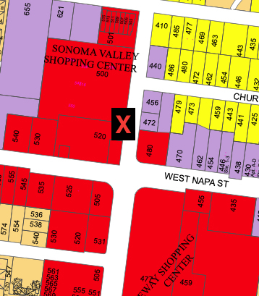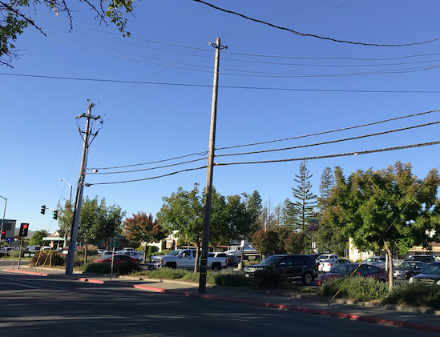

“Use Permit 006” – 500 West Fifth Street
The design of this site utilizes an existing wood utility pole measuring 43.25 feet above ground level to which the equipment would be attached. The utility pole is located within the public right of way near the property at 500 Fifth Street West on the west side of Fifth Street West approximately 125 feet north of the intersection of W. Napa Street and Fifth Street West. The cylindrical antenna canister was proposed to be side-mounted via an armature on the pole at a height of approximately 27 feet above the ground, while its associated support equipment was proposed to be mounted on the pole between heights of 7.0 feet and 17.9 feet above ground level.
Design drawings
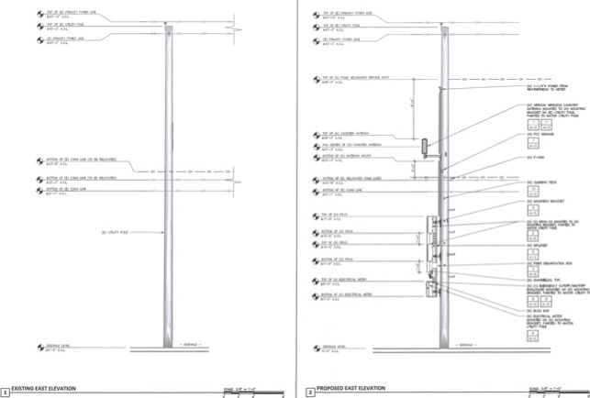

Photo-sims - site #006

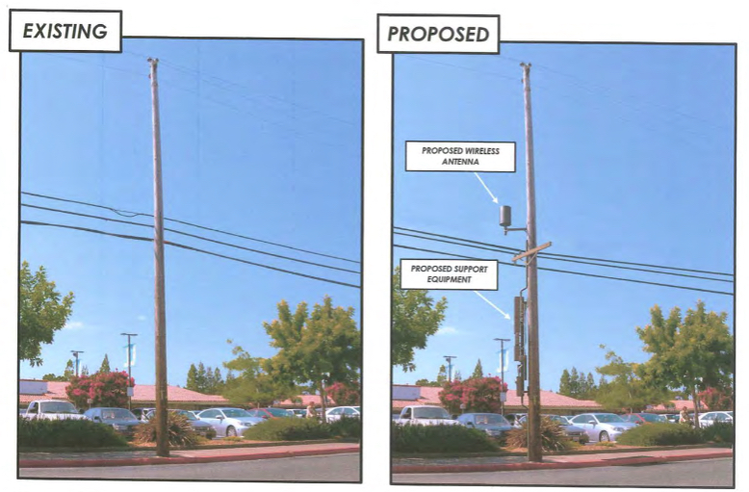

- Application Site #-007 - on a replacement utility pole near 453 Second Street West.

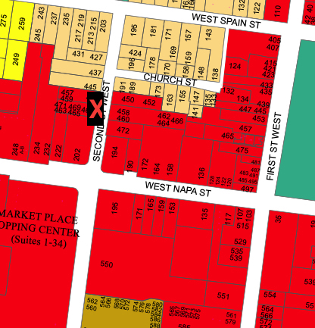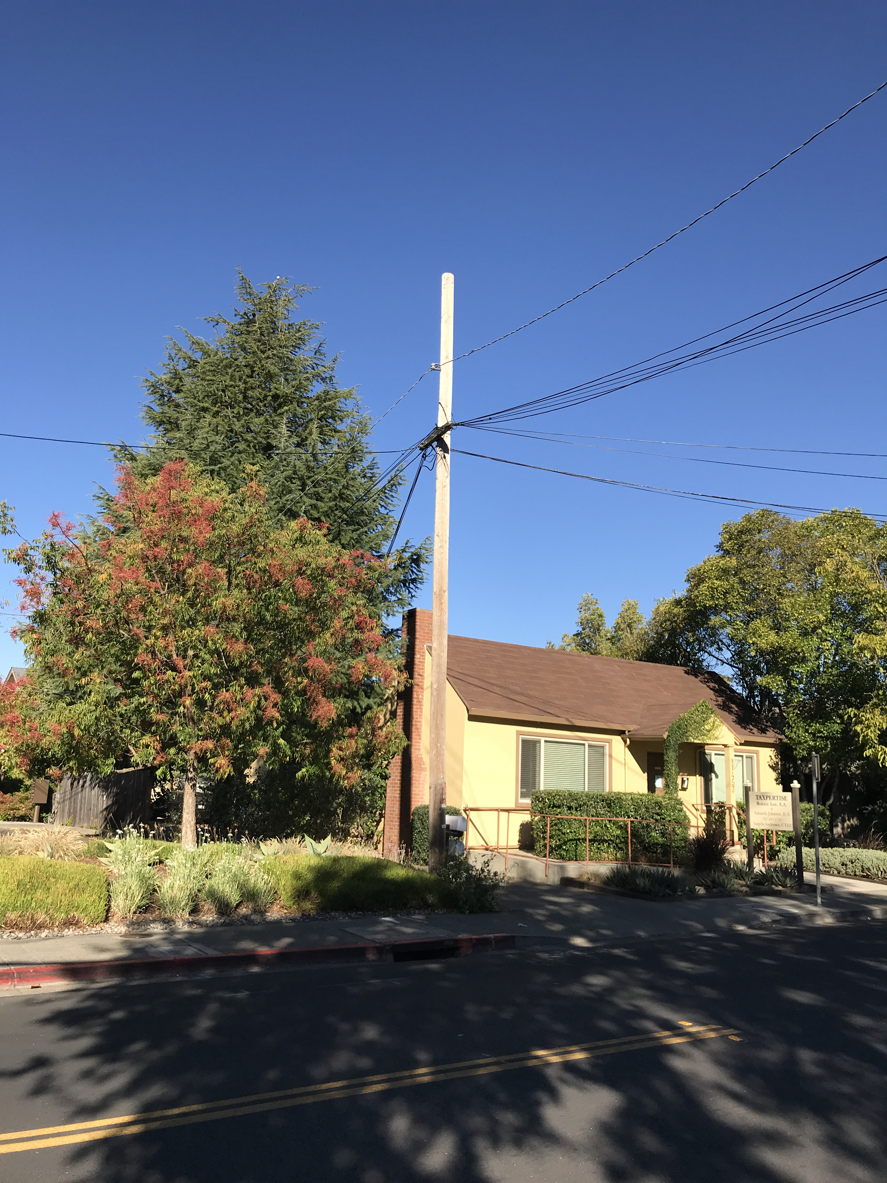

“Use Permit: 007” – 453 Second Street West
An existing 34.5-foot-tall wood utility pole on the west side of 453 Second Street West was proposed to be replaced with a new wood utility pole measuring 43 feet in height above ground level. The site is located approximately 120 feet south of the intersection of West Second Street and Church Street. The antenna would be mounted at the top of the pole with a maximum height of 45.3 feet. The associated support equipment was to be mounted on the pole between heights of 7.0 feet and 17.9 feet above ground level.
Design drawings

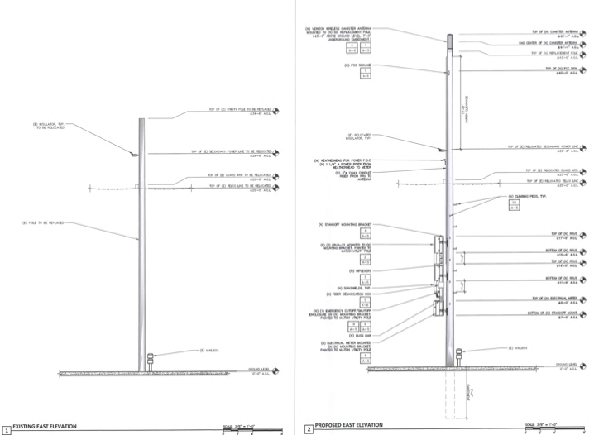

Photos-sims
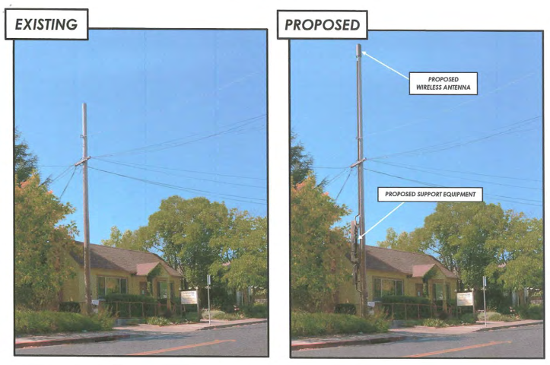

- Application #-012 - on a replacement utility pole near 574 First Street West (northeast corner of First Street West and McDonell Street)

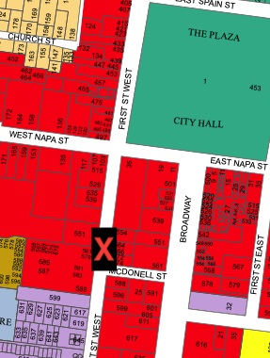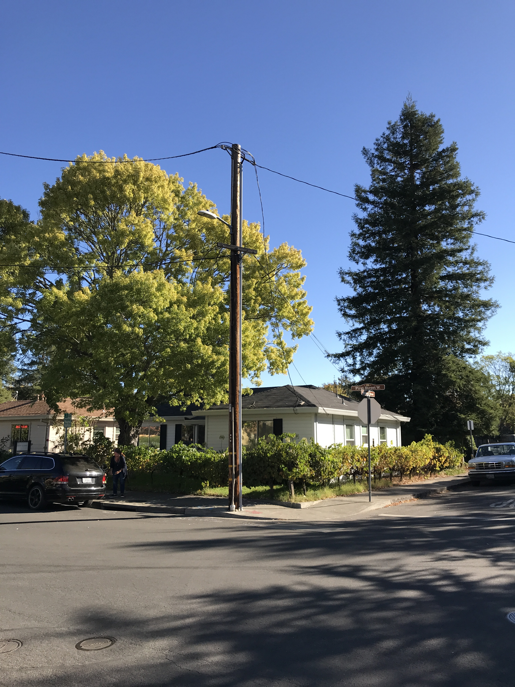

“Use Permit 012” – 574 First Street West
Similar to the Second Street West location, the site proposed for 574 First Street West would replace the existing wood utility pole measuring 33.3 feet in height above ground level with a replacement wood pole measuring 43 feet in height above ground level. The site is located at the northeast corner of West First Street and McDonell Street. The antenna canister would be mounted at the top of the pole with a maximum height of 45.3 feet. The associated equipment would be mounted on the pole between heights of 7.0 feet and 17.9 feet above ground level.
Design drawings
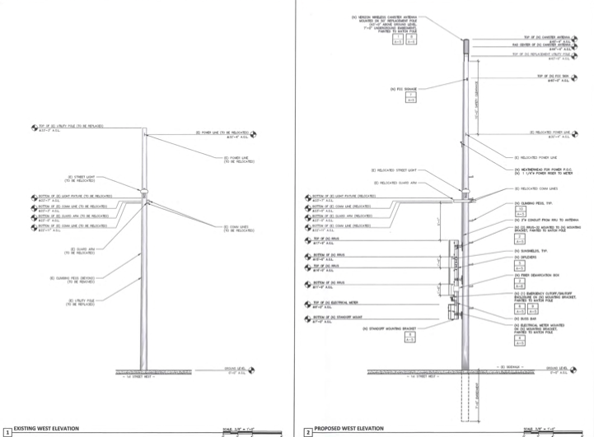
Photo-sims

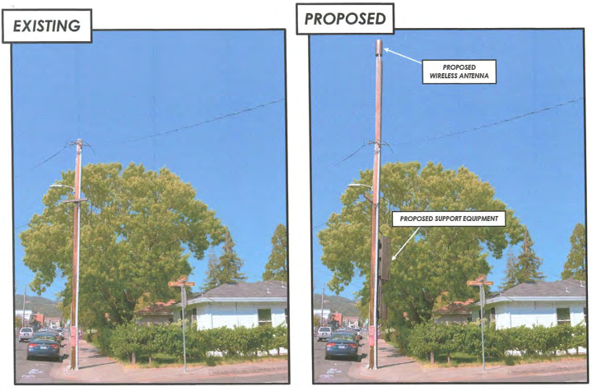

In the designs, all three sites were proposed to contain two antennas concealed in a “stealthing” canister measuring 24 inches in height and 7.9 inches in diameter. Associated support equipment at each site also included two radio remote units (RRUs), a utility disconnect switch, electrical meter, and coaxial cable that would be contained in conduit running up the pole. Generally, the antenna for each site was to be mounted at a higher location on each of the respective poles, while the RRU’s and other equipment were to be located at lower elevations on the pole on a mounting bracket. All components at the respective sites were to be painted to match the respective pole on which they were to be located.
The plans and materials included a two-band frequency system at each of the three proposed sites thereby decreasing the number of antennas in each of the respective canisters from three to two and reduced the number of RRUs from three to two from previous designs submitted to the City. Further, the size and dimensions of the antennas were reduced from 48 inches in height and 14 inches in diameter to 24 inches in height and 7.9 inches in diameter. The associated cabling was to be located in conduit and the cable connections to the equipment screened via sunshields.
- December 14, 2018 – CBR/Verizon submitted re-designs to staff, which included revised antenna designs, cages, boxes and streetlight design along with new locations at or near the original sites. No designs were provided that included the undergrounding of any support equipment. The applicants and staff (along with Chair Felder) met following the re-submittals on January 4, 2019. Based on feedback, the applicant indicated a desire to subsequently submit even newer updated design alternatives to the full Planning Commission to receive its feedback/input prior to preparing and submitting final designs.

2019

- April 1, 2019 – Staff requested CBR/Verizon to consider a smaller underground vault option with sealing to resist water intrusion and geothermal cooling design for heat dissipation (“Smart Vault”) and provided information from the vendor (“Syndeo”) located by the City’s technical consultant for placement of radios within vaults.

- April 26, 2019 - Staff provided additional feedback to applicants in meeting at City Hall. Attorneys present. Applicants requested a Planning Commission Study Session which was scheduled for July 11, 2019.

- May 1, 2019 - City’s counsel provides Verizon’s counsel with specific contact name and information for Syndeo to be contacted regarding the Smart Vault design referenced by staff’s April 1, 2019 communication with CBR/Verizon.

- May 20, 2019 – City’s counsel requested Verizon’s counsel to consider smaller radio design no base option and reviewed information gathered by City technical consultant from Verizon’s vendor. On May 31, 2019, Verizon’s counsel responded that Verizon Wireless would not be including the smaller radio no base option in the alternatives submitted for the study session as it would require more sites than were currently being proposed and would not provide flexibility to alter the site locations.

- June 3, 2019, City’s counsel responded that the City believes that the design should be included in those submitted for the study session as the smaller base and pole would be a better design than the large base designs shown the City by Verizon.

- On June 7th, 2019, CBR/Verizon submitted a package consisting of 10-11 re-designs per application (specifically for site #006 = 11, site #007 =10, and site #012 = 10, total of 31) showing photo simulations of the various design concepts it is considering for its final applications. CBR/Verizon desired to receive the Planning Commissioners’ feedback/input on these various design concepts at the study session in order for CBR/Verizon to determine the final design that it will propose for each of its applications. Under the Agreement, the final design, including the engineering plans and submittals for each application, were to be submitted to the City following the study session and by no later than the date of August 9, 2019. Also under the terms of the agreement, the Planning Commission would not be taking any action on the design alternatives at the study session. The designs submitted by CBR/Verizon for the study session included some of those designs previously submitted and reviewed by the Planning Commission at the earlier public meeting in November 2018, and in addition included designs placing equipment on new streetlight poles, stand-alone poles, adding street receptacles for housing of equipment next to the poles, and the placement of facilities at substitute/alternative locations. The applicant chose not to submit designs that included underground vaults for any of the support equipment nor provide any updated site specific radio frequency analysis.
July 11, 2019 — The Planning Commission held a Study Session and reviewed a total of 31 alternatives. The Planning Commission provided feedback to the applicant after public input. In addition to the re-submittal of the October 3, 2018 “undergrounding vaulting feasibility analysis” an internal email was provided by the applicant dated June 7, 2019, responding to the City’s communications on April 1 and May 1, 2019, referring the applicant to the “Smart Vault” which design included a sealed vault to resist water intrusion and a geothermal cooling loop for heat dissipation. The applicant’s response identified a few pro’s and several con’s with the “Smart Vault” design in the form of a bullet-point list. The meeting minutes summarize the comments, input, and feedback given by the Planning Commission, staff, and the public during the Study Session to the various designs being considered by Verizon for its application.
The locations and designs of the proposed wireless telecommunication facilities that the Planning Commission reviewed at the Study Session were as shown below:

“Sonoma 006” - 11 x new designs:
- Alternative Design A - 3 Radios, Wireless Mid Mount Antenna and standard ground cabinet.
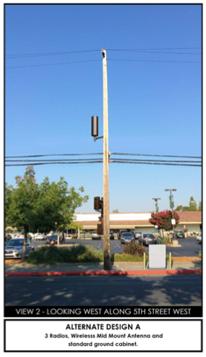
- Alternative Design B – 3 Radios and Support Equipment and Antenna all on pole, no Ground Cabinet.
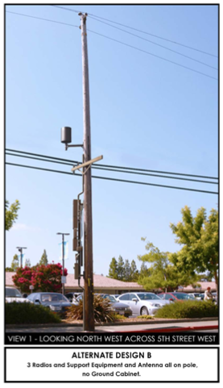

- Alternative Design C – Mid mount “Air” Antennas and support equipment on Pole, no ground cabinet.
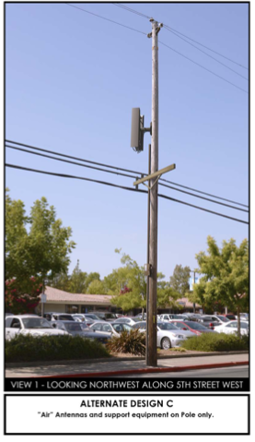
- Alternative Design D –Antenna mid mount and equipment inside “Caged” cabinet.
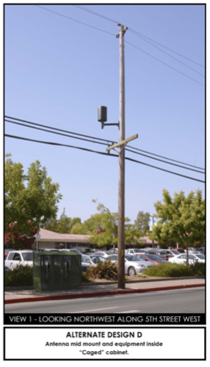
- Alternative Design E - Proposed Antenna mid mount and equipment inside “Mailbox” cabinet.
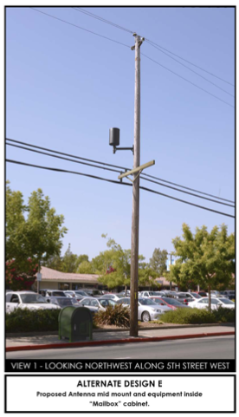

- Alternative Design F - Proposed new site location, across the street from original site location, with a proposed new street light with wireless antenna on top and support equipment on pole.
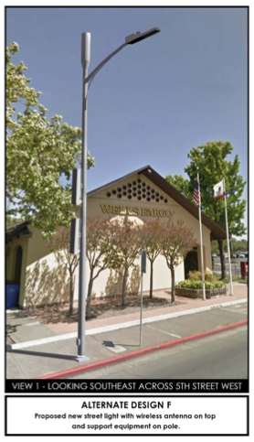
Proposed Alternative Location -Moved on 5th St. West (nearly Studley St. by US Bank)
- Alternative Design G – Proposed New Light Pole with Antenna on Square Base (“Cupertino” Design) to house equipment
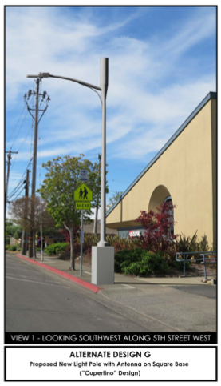
- Alternative Design H – New Light 20” Integrated Light Pole with antenna on top and equipment housed in a Cylinder Pole Base.
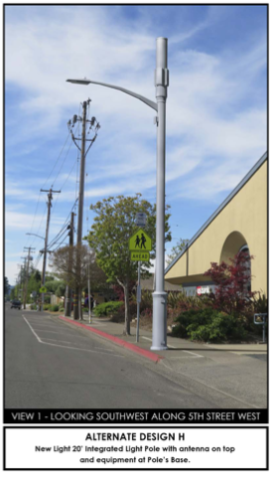
- Alternative Design I - New Light 18” “Integrated” Light Pole with antenna on top and equipment at Pole’s Base.
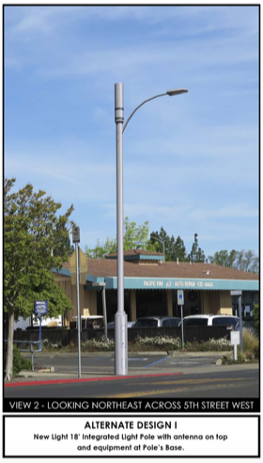
- Alternative Design J – New” Slim” Light Pole and Antenna on top.
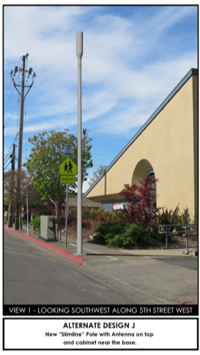
- Alternative Design K - New “Slim” Light Pole with Antenna on top and cabinet near the base.

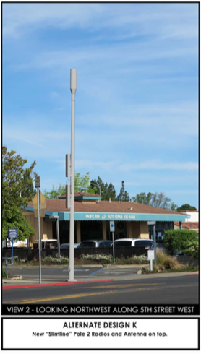

“Sonoma 007” – 10 x new designs
- Alternative Design A - 3 Radios, Associated Equipment, Wireless and Antenna on top of pole. No Ground Cabinet.
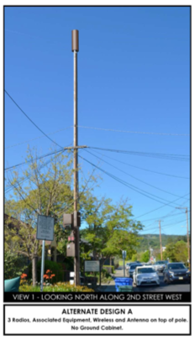

- Alternative Design B – 2 radios, associated equipment, wireless and antenna on top of pole - no ground cabinet.
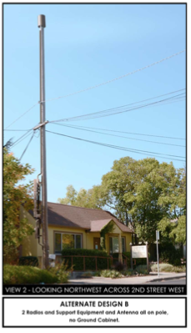
- Alternative Design C –Antenna on Pole Top and equipment inside “Caged” cabinet.
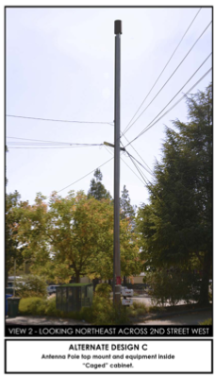

- Alternative Design D - Proposed Antenna mid mount and equipment inside “Mailbox” cabinet.
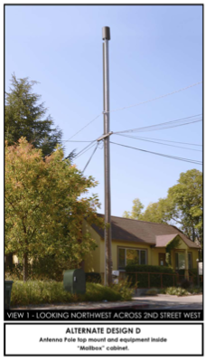
Proposed Alternative Location Moved to 3rd St. West (near 303 West Napa Street) –Existing Site View and Map
- Alternative Design E – Proposed New Light Pole with Antenna on Top and Associated equipment on Pole.
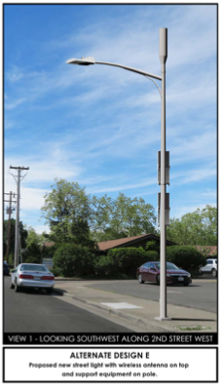
- Alternative Design F – Proposed New Light Pole with Square Base to house equipment “Cupertino” Design.
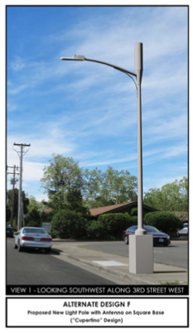
- Alternative Design G – New Light 20” Integrated Light Pole with antenna on top and Cylinder Base to house equipment.
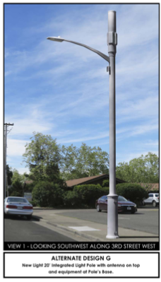

- Alternative Design H - New Light 18” “Integrated” Light Pole with antenna on top and equipment at Pole’s Base.
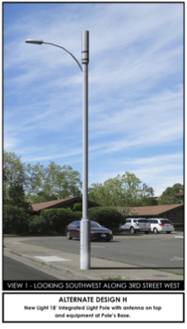

- Alternative Design I – New “Slim” Light Pole 2 “4455” Radios and Antenna on top
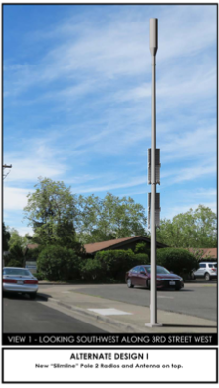

- Alternative Design J - New “Slim” Light Pole with Antenna on top and cabinet near the base.
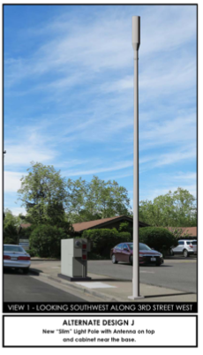
“Sonoma 012” – 10 x new designs
- Alternative Design A - 3 Radios, Associated Equipment, Wireless and Antenna on top of pole. No Ground Cabinet.
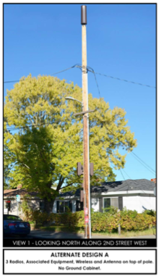
- Alternative Design B – 2 Radios, Associated Equipment, Wireless and Antenna on top of pole. No Ground Cabinet.
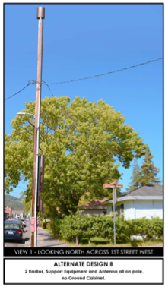
- Alternative Design C –Antenna on Pole Top and equipment inside “Caged” cabinet.
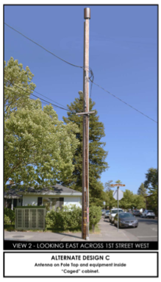

- Alternative Design D - Proposed Antenna on Pole and equipment inside “Mailbox” cabinet.
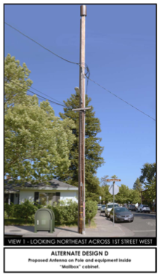
New Site Location moved to 1st St. West (Existing Site View and Map)
- Alternative Design E – Proposed New Light Pole with Antenna on Top and Associated equipment on Pole.
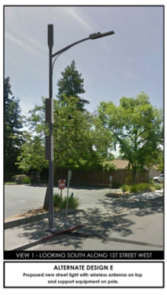
- Alternative Design F – Proposed New Light Pole with Square Base to house equipment “Cupertino” Design.
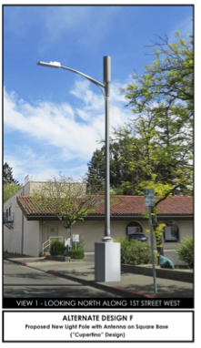
- Alternative Design G – New Light 20” Integrated Light Pole with antenna on top and Cylinder Base to house equipment.
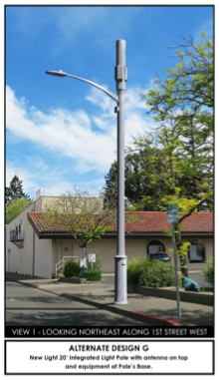

- Alternative Design H - New Light 18” “Integrated” Light Pole with antenna on top and equipment at Pole’s Base.
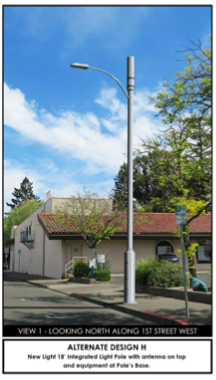
- Alternative Design I – New” Slim” Light Pole 2 “4455” Radios and Antenna on top.
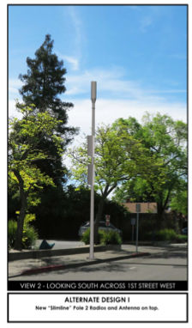

- Alternative Design J - New “Slim” Light Pole with Antenna on top and cabinet near the base.

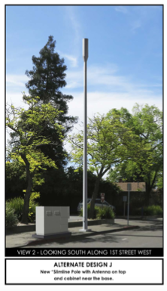

August 9, 2019 —Verizon submitted final designs and plan/drawing sets for each of the 3 commercial applications that were presented to the Planning Commission on September 12, 2019. Staff provided the following observations about the applicants’ latest submittals:

1. New Street light designs were proposed based on street light design of “Broadway” lights – but about 5 feet taller than existing “Broadway” lights)
2. Minor changes to locations – still in Commercial zones.
3. No above ground “boxes”, “cages” or utility boxes were submitted.
4. Reduced height of wireless facilities – lower by approximately 20 feet.
5. No underground vaults for support equipment.
6. Did not include scalloping/ornamentation per recommendation of Planning Commission at the study session.
7. The applicant provided updated site-specific radio frequency analysis for the sites.

September 12, 2019 — Planning Commission Public Hearing – feedback was received by the applicant from the Planning Commission after a public hearing. The locations and designs of the proposed wireless telecommunication facilities that the Planning Commission reviewed were as shown below and did not include any underground vaulting for the support facilities. CTC submitted a report for the public hearing setting forth the following findings and conclusions: 1) Each of the sites were receiving consistent 4G coverage through the nearest macro tower; 2) Coverage of Verizon’s existing 3 macro towers serving the City were approximately 1-2 miles while coverage within the PCS and AWS bands would be approximately ½ mile from each of the proposed sites; 3) in most cases signal strength was sufficient for data transfer at high speed; 4) on site field tests demonstrated that adding PCS and AWS bands through the proposed sites would both increase capacity and substantially increase the signal level in the vicinity of each of the sites; 5) download and upload speeds for existing service within the City achieved 4G capability; and 6) reiterated the statements in its earlier report that there were no disconnects or interruptions in coverage and so coverage remained at a 4G LTE level.

- Site # 006 located on the west side of 5th Street West approximately 200 feet south of West Napa Street, near 574-552 Fifth Street West.

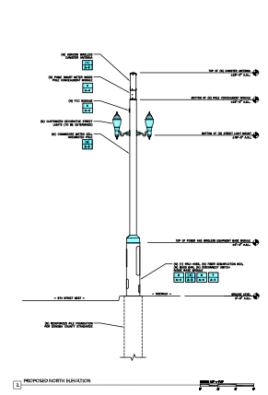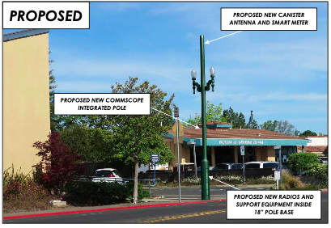

- Site #007 – located on the west side of Third Street West on a replacement utility pole near 453 Second Street West

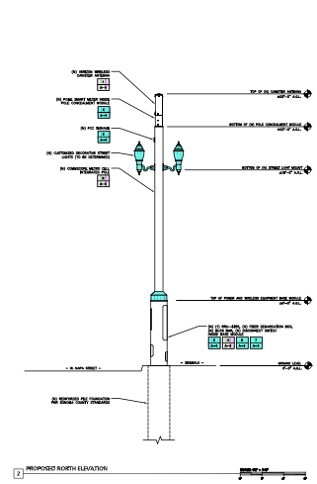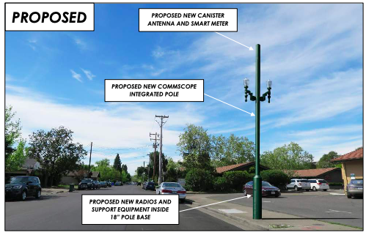

- Site #012 – located on the south side of McDonell Street, between First Street West and Broadway, near 25 McDonell Street.

