FOR IMMEDIATE RELEASE: June 13, 2018
Free Advance Care Planning Workshop July 17
After the fire disaster in October, Sonoma County residents know it is wise to be prepared for a future flood, earthquake, or fire. There is potential for any of these.

And there is one "natural disaster" that is assured for every one of us: death. Yet when it comes to preparation for serious illness and death, only 23% of us in California have prepared ourselves and our families by completing an advance health care directive.

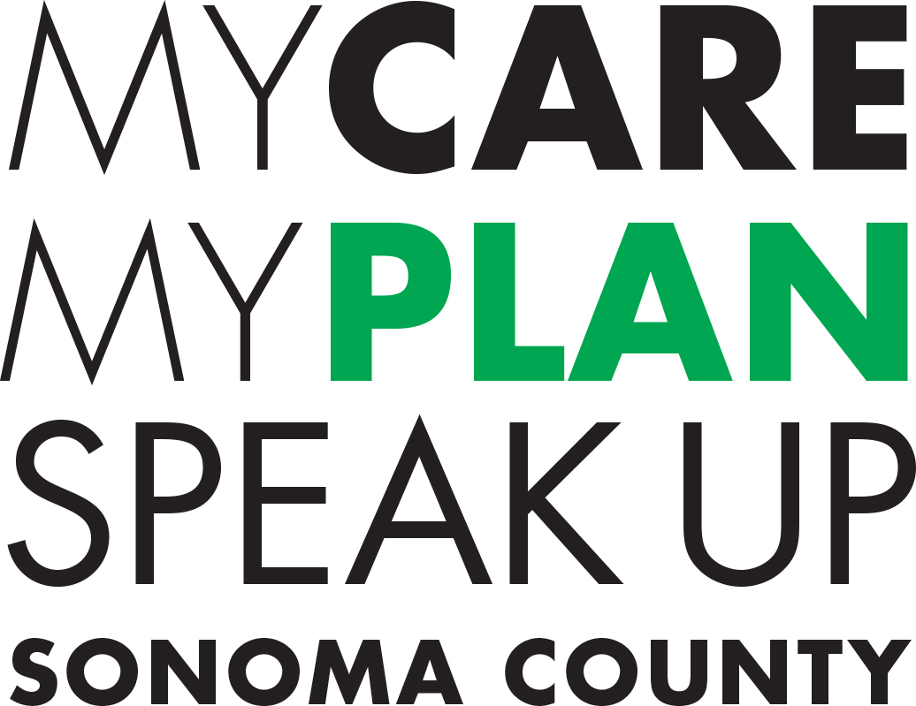
To help residents prepare, My Care My Plan: Speak Up, Sonoma County will host a free advance care planning workshop, Who Will Speak for You If You Can't Speak for Yourself? on Tuesday, July 17, 2:00-4:00 p.m., at the Redwood Credit Union Community Room, 3033 Cleveland Avenue, Santa Rosa. Register online at MyCareMyPlanSonoma.org under Events, by phone at (707) 565-5950, or by email to aasecretary@schsd.org.
"Or imagine another kind of disaster: a car accident that leaves you with a head injury. An injury severe enough that you might not be able to move around or express yourself, and you might need 24/7 care for the rest of your life. It's not that uncommon! Being prepared means thinking about what you would want, putting it in writing, and talking about it with your family and your doctor," says Brad Stuart, MD, former Santa Rosa internist, now chief medical officer for the Coalition to Transform Advanced Care (C-TAC) in Washington, D.C.
"Life as we know it can change when we least expect it, says Nina Arbour, Community Relations and Volunteer Services Manager, Hospice Services of St. Joseph Health. "I've witnessed this over and over again in my 36 years with Hospice. An advance health care directive serves as a 'quality of life road map' that enables our loved ones and healthcare providers to honor our choices about medical treatment and end of life care."
Stuart and Arbour will lead the July workshop, designed for anyone over age 18. Participants consider the type of care they would want in a health crisis, and how to make their wishes known through thoughtful advance care planning and clear, written, advance health care directives. Presenters will also offer ideas for how to talk with family, loved ones, and healthcare providers about medical treatment options, tradeoffs, and wishes.
My Care, My Plan: Speak Up, Sonoma County’s (MyCareMyPlanSonoma.org) vision is for every adult in the county to become educated and empowered to express his/her wishes about end-of-life care, to have the opportunity to do so, and to have their wishes honored in a medical crisis.
This is an initiative of the Committee for Healthcare Improvement and Sonoma County Health Action, which mobilize community partnerships and resources to achieve equity and improve health for all in Sonoma County. MCMP is a collaborative of organizations and individuals from the private, public, nonprofit, and volunteer sectors, as well as local healthcare and social service organizations and other community partners. Support for the initiative is provided by the Sonoma County Human Services Department.
# # #
Free Workshop on Advance Care Planning
Who Will Speak for You If You Can't Speak for Yourself?
Tuesday, July 17, 2:00-4:00 p.m.
Redwood Credit Union Community Room, 3033 Cleveland Avenue, Santa Rosa Reservations: MyCareMyPlanSonoma.org / (707) 565-5950 / aasecretary@schsd.org
Media Contact:
Kris Montgomery | Communications Manager
Sonoma County Human Services Department
(707) 565-8085 (office) | (707) 495-6999 (cell)
kmontgomery@schsd.org
www.sonomacounty.ca.gov/Human-Services/

