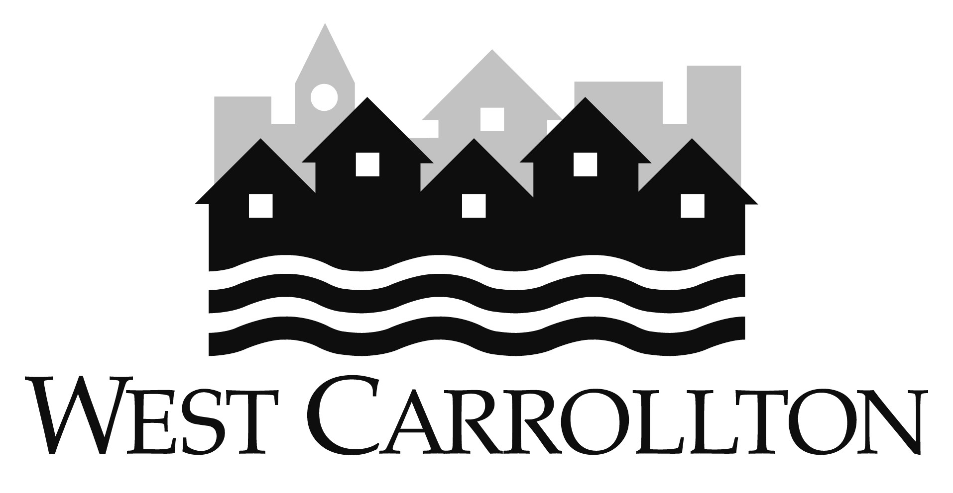
CITY OF WEST CARROLLTON
Part-Time Employee Benefits Summary
(as of 12/2/15)

Retirement - Ohio Public Employees Retirement System
- employee contribution 10%
- employer contribution 14%

Dental – Principal Dental
- Employee Pays: $10.22/per pay for employee
$32.59/per pay for employee, spouse, children

Optical - Principal (VSP)
Employee Pays: $3.78/per pay for employee
$6.36/per pay for employee + spouse
$6.49/per pay for employee + child(ren)
$10.27/per pay for family

Voluntary Life Insurance, Principal

- Guaranteed issue of up to $100,000 for employee during initial enrollment period. Can also obtain limited guaranteed coverage for spouse and dependents. Premiums are based on employee age and are fully paid by employee.

Critical Care Insurance, Principal

Guaranteed issue of up to $15,000 for employee during initial enrollment period. Can also obtain limited guaranteed coverage for spouse and dependents. Premiums are based on employee age and level of benefit and are fully paid by employee.

AFLAC - Contact Daniel Banks, Representative for further information
(937) 684-2380; daniel_banks@us.aflac.com

Ohio Deferred Comp - Contact Shana Sellers, Representative for further information
(937) 206-2258; sellers2@nationwide.com

