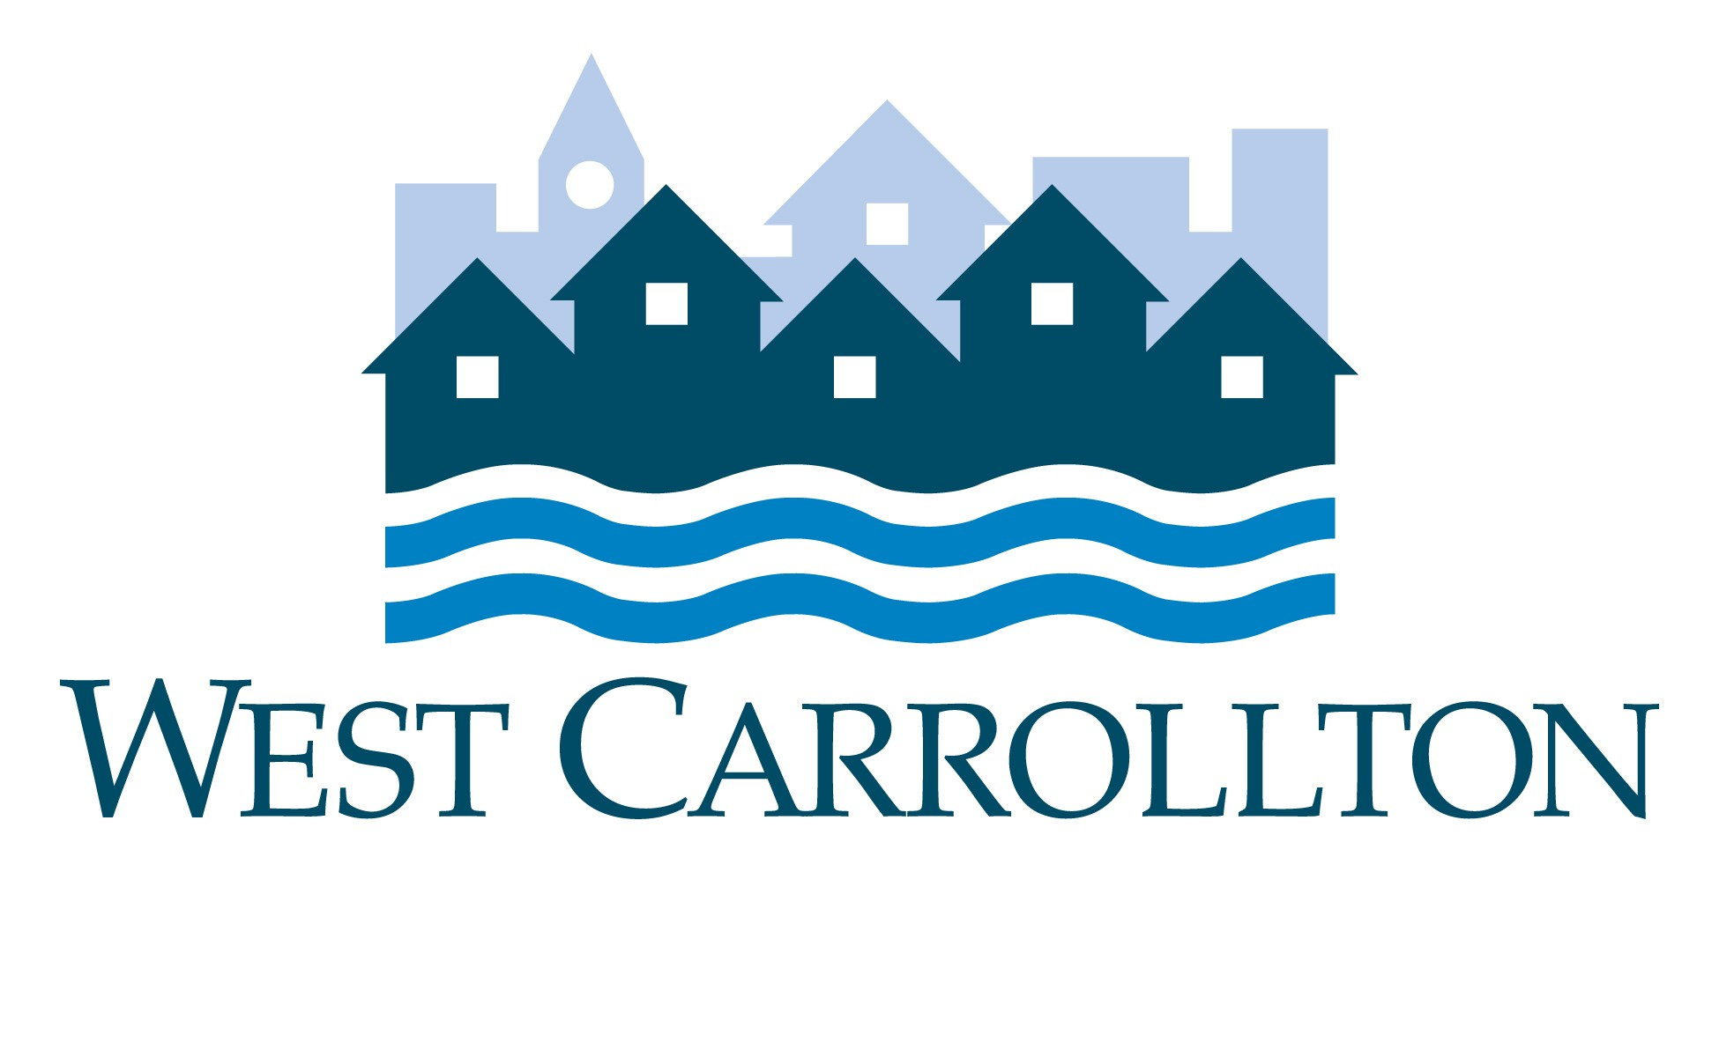

CITY OF WEST CARROLLTON
BOARD OF ZONING APPEALS
AGENDA

August 12, 2021 – 6:30 p.m.
City Council Chambers
Civic Center – 300 E. Central Avenue

- CALL TO ORDER

- BOARD OF ZONING APPEALS TRAINING:

Steve McHugh, Coolidge Wall Co. L.P.A.

- ADJOURNMENT

