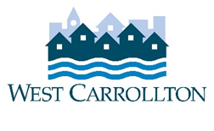
CITY OF WEST CARROLLTON
PLANNING COMMISSION

AGENDA

September 2, 2021

6:30 p.m.
City Council Chambers
Civic Center - 300 E. Central Avenue

- CALL TO ORDER

- PLEDGE OF ALLEGIANCE

- ROLL CALL

- APPROVAL OF AGENDA

- APPROVAL OF MINUTES AND RESOLUTIONS
  - Minutes of July 1, 2021 meeting

- PUBLIC HEARINGS
  - M-21-1, PUD 06-1 MOD 8/21 – Rezone Portion of OD Olde Downtown to PUD 06-1
  - M-21-2, Rezone Portion of OD Olde Downtown to R-2 Single Family Residential District
  - T-21-1, Amendment to 154.03.05(E) of the Zoning Code (Multiple Principal Buildings on a Lot)

- DECISION ITEMS
  - South Alex Road PUD – Amendment to Detailed Final PUD Site Plan, 1625 S. Alex Rd. (signage)

- DISCUSSION ITEMS
- Report by Director
- Briefing by City Council representative(s)
- Unscheduled business
- Next meeting: October 7, 2021

- COMMENTS BY THE AUDIENCE

10. ADJOURNMENT

