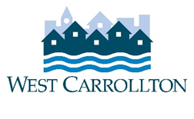

**CITY OF WEST CARROLLTON**

**PLANNING COMMISSION**

**AGENDA**

**February 3, 2022**

**6:30 p.m.**

**City Council Chambers**

**Civic Center ‑ 300 E. Central Avenue**

1. CALL TO ORDER
2. PLEDGE OF ALLEGIANCE
3. ROLL CALL
4. APPROVAL OF AGENDA
5. APPROVAL OF MINUTES AND RESOLUTIONS
   1. Minutes of December 2, 2021 meeting
6. PUBLIC HEARINGS
7. DECISION ITEMS
   1. SP-21-2, 740 Royal Ridge Dr. (new commercial building)
   2. Election of 2022 Officers
8. DISCUSSION ITEMS
9. Report by Director
10. Briefing by City Council representative(s)
11. Unscheduled business
12. Next meeting: March 3, 2022
13. COMMENTS BY THE AUDIENCE

10. ADJOURNMENT