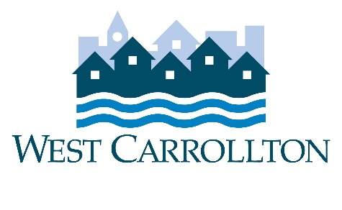

CITY OF WEST CARROLLTON
PLANNING COMMISSION

AGENDA

April 7, 2022

6:30 p.m.
City Council Chambers
Civic Center - 300 E. Central Avenue

MEETING CANCELLED

- CALL TO ORDER

- PLEDGE OF ALLEGIANCE

- ROLL CALL

- APPROVAL OF AGENDA

- APPROVAL OF MINUTES AND RESOLUTIONS

- PUBLIC HEARINGS

- DECISION ITEMS

- DISCUSSION ITEMS

- COMMENTS BY THE AUDIENCE

10. ADJOURNMENT

